June 16, 2023

Littleton Community Development Department
2255 West Berry Avenue
Littleton, CO 80120

Letter of Intent

To Whom It May Concern:

Our company, Westwood Professional Services, on behalf of the property owner, Toll Southwest, LLC (Brad Dixon), is proposing to amend the Santa Fe South Final Plat for planning review within City of Littleton.
The proposed amendment will capture a variety of updates, the first will be revising the location of the Englewood easement along Santa Fe Drive. Another will be the addition of four tracts; Tract T will be subdivided to include the drainage limits of Pond D and the proposed parcel for the Englewood Pumphouse. Lot 261 will be subdivided to include a Metro District Directors Parcel tract and Lot 262 will be subdivided to include a tract for the drainage limits of Pond A.
Enclosed are the required documents for the amendment to the Final Plat, we look forward to continuing to work with City of Littleton staff on this project.

Sincerely,

Westwood Professional Services, Inc.

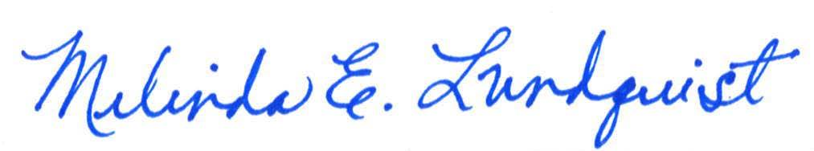

Melinda E. Lundquist, PE
Director, Private Development Colorado
Melinda.lundquist@westwoodps.com
720-249-3539

