August 26, 2022

Matt Knight, Development Services Manager
City of Littleton
2305 W. Berry Ave.
Littleton, CO 80120

Re: | 7875 S Santa Fe Dr  Santa Fe Park South  Final Plat (MAJ21-0001) – 2nd Submittal  Civil Construction Document (MAJ21-0001) – 2nd Submittal

Dear Mr. Knight:

Westwood has considered comments from Littleton Public Works, City of Littleton Civil CD, Littleton Community Services, Denver Water, Toll Brothers, Mile High Flood District and CDOT for the referenced project. We have restated the comments below and addressed them per the italicized responses.

LITTLETON PUBLIC WORKS
Carolyn Roan, Water Resources Manager
Matt Knight, Development Services Manager
Gary Welp, Development Review Engineer
Aaron Heumann, Transportation Engineering Manager
General Comments
- Comments on the SDP and Preliminary Plat (PPlat) were issued on 9/7/2021. This current submittal of the Final Plat and Civil CD’s was made during the review period for SDP and PPlat. Comments made on the SDP and PPlat shall be addressed and incorporated into resubmittals of the Final Plat and Civil CD’s. It is recommended that a resubmittal of the SDP be held until later submittals of the Final Plat/Civil CD’s to incorporate all final changes. The SDP cannot be recorded until after the Final Plat is approved and is also a recorded document, so construction shall exactly match the approved, recorded SDP.
R: Acknowledged.
C: Comments from the last SDP submittal still apply.
Response: Acknowledged. The PPlat has since been approved. The SDP resubmittal has been submitted concurrently with the Final CDs.
- Driveways to Parcels C & G: One of the outstanding plan review comments on the Santa Fe Park South SDP and Preliminary Plat deals with multiple driveway access points to Parcels C and G, highlighted in yellow. Littleton Public Works has provided review comments on the number and proximity to other intersections and will support 1 access point where there are currently 2 side- by-side driveway pairs shown. The applicant’s prior response referenced two access points are required to provide life safety access to these parcels. Littleton Public Works staff consulted with Chip Kerkhove, Assistant Fire Marshal, from South Metro Fire Rescue regarding these driveways. Based on our discussion, it is not anticipated that two access points will be required to serve these parcels. Additionally, due to the close proximity of the side-by-side driveways, these would likely not meet the separation requirements to qualify as separate access points. Therefore, only one access point will be permitted where there are currently shown as 2 side-by-side. On S Platte River Parkway, the driveways closest to the roundabout shall be removed and on Phillips Avenue, the driveway closest to Santa Fe shall be removed. All agencies will review the need for 2 access points upon formal submittals of Site Development Plan applications, based on the proposed use and Fire Code.

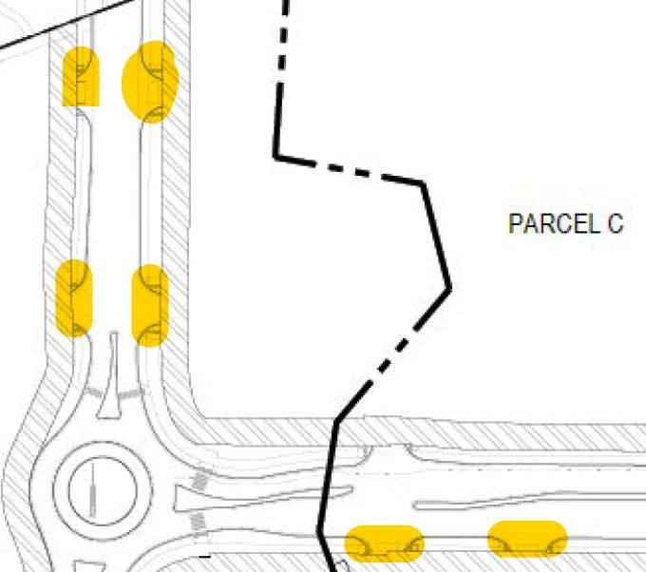
R: Three access points have been removed as directed and discussed during the 9/30 city meeting.
C: Comment addressed.
- It is the applicant’s responsibility to obtain all offsite easements identified on this plan. For easements shown on City property, City Council approval will be required after all associated technical items have been addressed.
R: Acknowledged.
C: Comment addressed.
- Storm sewer system – Currently, all storm sewer is proposed to be owned/maintained by the Metro District. It is recommended that segments in the public ROW and/or associated with the public roadway shall be dedicated as public for City of Littleton ownership/maintenance. The city will work on identifying those segments that would be accepted as public and will provide under separate cover. Subsequent submittals shall incorporate this notation for portions that will be public.
R: Notes have been added to the plan accordingly.
C: Sheets 2.4, 2.5, and 2.6 have been redlined to show the portions of the storm network that shall be dedicated to the City. These ownership assignments shall be clearly shown on all utility plans, and profiles. Notation shall also be included in the SDP. An exhibit showing all stormlines and associated ownership/maintenance responsibilities shall be prepared and provided as an exhibit to the Subdivision Improvement Agreement.
Response: Completed, redlines have been addressed to clearly show ownership assignments. A note has been added to the SDP Utility Plan. This note generally states that all storm drain within ROW shall be public and all storm drain within Tract G shall be privately owned, unless otherwise noted. These notations are per the City’s redlines. An exhibit for the SIA has been prepared, and will be submitted with the SIA.
- Prior to the dedication of public ROW, the applicant shall demonstrate that it has fee simple title of the Property, provide title insurance for the full value of the property to be dedicated, free and clear of all liens, encumbrances and claims.
R: Acknowledged.
C: Comment addressed. The comment will be a condition of the Subdivision Improvement Agreement.

- A Phase I Environmental Assessment for the land to be dedicated as public ROW shall be submitted, demonstrating that the property is free from any contamination, hazardous waste or toxic materials on or below the surface.
R: A Phase I Environmental Assessment has been included in the plan submittal. Communication with City of Littleton staff did not clarify if additional assessment is required for ROW dedication. If necessary, an additional Phase I Environmental Assessment will be conducted and submitted.
C: Public Works confirmed with the Applicant on 12/8 that additional reports are not required and that the 2020 ERO report was adequate.

- The following items were not submitted, but required for review:
  - Bridge plans for roadway bridge crossing Dad Clark Gulch, including structural design
R: Structural design is in progress and submission will be forthcoming.
C: Bridge and Structural plans will be required prior to approval of the Civil CDs.
Response: Bridge and structural plans are included within this submittal.

  - Traffic signal plans for W Phillips Av and S Santa Fe Drive
R: Design is in progress and submission will be forthcoming.
C: Traffic Signal design will be required prior to approval of the Civil CDs.
Response: Acknowledged. Toll Brothers is working with the City of Littleton, as they are the CDOT access permittee. Traffic signal design is provided with this submittal.
  - Roadway lighting plans
R: Lighting plans have been included.
C: Received.

  - Pavement designs – Pavement design for S Platte River Parkway and W Phillips Av shall be coordinated with Quad Road design and property owner to the north.
R: Acknowledged.
C: The City’s consultant is continuing to work through the Quad Road design.
Response: Acknowledged.
  - Engineers Cost Estimate for financial surety. Cost estimates shall cover all Public Improvements (including storm sewer and ponds) and Construction BMPs. Cost estimates shall include 25% contingency.
R: To be submitted after the 2nd CD review.
C: Financial Surety amount shall be determined prior to approving the Civil CDs. Financial Surety shall be posted prior to issuing a Permit.
Response: A draft cost estimate for the SIA is included with the SIA submittal.
  - Stormwater Facility Operation and Maintenance Plans (see comments under Final Drainage Report).
R: Completed.
C: O&M Plan received. Comments herein.
Response: Completed.
- At time of building permit submittals, a detailed grading/plot plan shall be submitted with each building permit application.
R: Acknowledged.
C: Comment addressed.
- It is our understanding that while several subsets of the Civil CDs were submitted, it is intended that the sheet numbering represents a comprehensive set of Civil CDs. Please provide a full Index of sheets to create the Civil CDs with the resubmittal.
R: Please see the separate document which lists all civil sheets.
C: Master index received. Prior to final approval of the CDs, one compiled document shall be prepared and submitted to the City.
Response: Acknowledged.
- City of Littleton Standard Notes shall be included in the front end of the Civil CD plan set. List of standard notes to be included under separate cover.
R: Completed.
C: City of Littleton Standard Notes are attached to this memo and shall be included in the front of the Civil CDs.
Response: Completed. Notes have been added to the cover sheet.
- Comment: The site shall conform to the Sight Distance requirements of LMC 10-4-1 (Rep). Triangles will need to be shown on the next submittal of the Site Development Plan.
Response: Completed, all sight distances conform to AASHTO’s requirements.

Lighting Plans:
- Comment: Base maps of the lighting plans are not current and do not match actual site layout. For example, removed driveways on Platte River Parkway are shown.
Response: Basefiles updated.

- Comment: Label dimensions between lights on Platte River Pkwy and Phillips Ave.
Response: Dimensions added.
- Comment: All lighting on Platte River Parkway and Phillips Avenue shall be 250 Watt equivalent.
Response: Fixtures shown are the Xcel Energy replacement for the 250W HPS lamps

Final Plat Comments:
See comments on attached redlines. Comments below are not exhaustive of redlines. Some redline comments on the Plat are duplicate/carryover from the Preliminary Plat.
- The full plan set shall receive a QC Review before resubmitting. Not all easements, property lines, and legends were labeled or updated correctly. Most missing information was flagged in the redline comments, however it is the Applicant’s responsibility to make sure the plan set is appropriately prepared.
R: Acknowledged.
C: There continues to be easements and linework missing appropriate labels. Please review redlines and document prior to resubmitting.
Response: Please refer to the latest final plat that was resubmitted March 18, 2022.
- Pages 27 through 50 were not reviewed. These sheets shall be merged with the rest of the plan set. If there is a reason that they are separate, please explain.
R: Pages 27 through 50 are details of easements that cannot be properly detailed within the 1st half of the plat set.
C: Due to the detail of the easements, duplicated viewports are acceptable; however, callouts of lots and easements need to be consistent. For example, the first set of views shall label all lots, and the second shall label all easements. It was noted in the redlines that some easements are labeled twice within the plan set. Duplicating information creates the concern that there could be conflict between dimensions and callouts.
Response: As discussed, we have consolidated annotation and removed several sheets from the plat.
- Provide a sheet showing the full site. See Community Development comments for what should be shown.
R: Completed.
C: Comment addressed.
- Dedicated easements, ROW, and Vacations that are exclusive to an individual owner require additional signatures by the grantee. This plat shall be generated in such a way that only Littleton is signing the Plat. All easements to other districts and owners shall be dedicated by separate instrument. Proof of vacated easements shall be provided prior to approving the Final Plat.
R: Acknowledged, all easements to other districts and owners will be dedicated by separate document. Reception number lines added to said easements.
C: Similarly to dedicated easements, easements vacated through this project shall be done by separate instrument. Recording of such vacation shall be referenced, by number, on the Final Plat.
Response: As discussed, there are several easements dedicated to SWMWSD and Englewood separately. These are noted as such on the plat. Reception number blanks have been removed, as discussed, to allow for the plat to be recorded in advance of these separate easements been recorded. CDOT ROW is now being dedicated to Littleton, as discussed with both Littleton and CDOT.
- Comment: Add this note to the Cover Page: “A Utility and Roadway Purposes Easement is hereby conveyed to the City of Littleton for purposes to construct, reconstruct, operate, remove, repair utilities and maintain traffic signalization, signage, and all reasonable and necessary appurtenances, and for the purpose of clearing, laying, constructing, and reconstructing sidewalk, trails, multi-use paths, curb and gutter, handicap ramps, roadway pavement and related appurtenances, on, through, and under the easement shown on this Plat. The Property Owner, its heirs, successors and assigns, agrees that it shall not, in any manner, prevent said improvements or interfere with the above stated objects, nor disturb, injure or molest the clearing, laying, construction, reconstruction, operation, removal or repair of same.”
Response: This note has not been added to the plat, as the right-of-way dedicated to Littleton for Platte River Parkway and Phillips Avenue allows Littleton to conduct the listed activities. Any disturbance within the ROW not permitted by Littleton will be in violation. As such, this note is not necessary.

Roadway and Drainage Construction Plans:
Also see comments on attached redlines. Comments below are not exhaustive of redlines.
- Identify the roadway design speeds for each roadway type. Verify compliance with AASHTO standards for horizontal curves, vertical curves, and stopping sight distance.
R: All proposed roadways are signed at 25 MPH, with the exception of Phillips and Platte River Parkway are 30 MPH and were designed per 35 MPH.
C: Signage plan needs to be modified to specify where “SPEED LIMIT 25” signs and “SPEED LIMIT 30” signs are located.
Response: Completed.
- Utility Plans 2.1 to 2.6: Per “Table 8E Manhole Requirements” of the Littleton Drainage Criteria Manual several of the manholes appear to undersized and should be increased from 5-foot to 6- foot or from 6-foot to box based either due to pipe sizes or having multiple pipes entering the same manhole.
R: Manhole sizes have been updated.
C: Sheets 7.1 to 7.14: Evaluate the following manholes as they appear to need to be upsized (#19, #23 #37 from 4-foot to 5-foot) (#15, #16, #27, #53, #61 from 5-foot to 6-foot) (#5, #7, #24, #47, #63 from 6-foot to box based). Additionally, add manhole sizes to plan view on Sheet 7.3.
Response: All manholes have been checked for proper sizing and updated as needed.

- Sheet 2.4, 2.5, 7.16 and 7.17: The outfall line from Pond D to STMH-41 as it runs adjacent to South Platte River Parkway will need to have a wider easement (see Figure 801) due to the depth of the pipe trench. Given that portions of this pipe trench is approximately 20-feet deep any repairs could have significant impacts to South Platte River Parkway. Although, Dad Clark Gulch is generally intended to be a “dry” gulch the designer should confirm that the pipe will not be prone to “floating” during a storm event and confirm that channel scour is not a concern.
R: Easement has been increased from 20 foot minimum to 30 feet.
C: Comment addressed.
- The deep storm sewers (i.e. listed above) or those in or near ground water will need to have “water tight” or “leak resistant” joints and the manholes will need to waterproofed both inside and outside.
R: Completed.
C: Comment addressed.
- Sheets 2.6 and 3.6 - Pond outfall shows conflicts with “existing trail” in South Platte Park. It is likely this is the access easement for SW Metro Sanitary Line. The proposed Drainage and Utility Easement conflicts with the existing easement. Approval of encroachment is required from SW Metro W&S District.
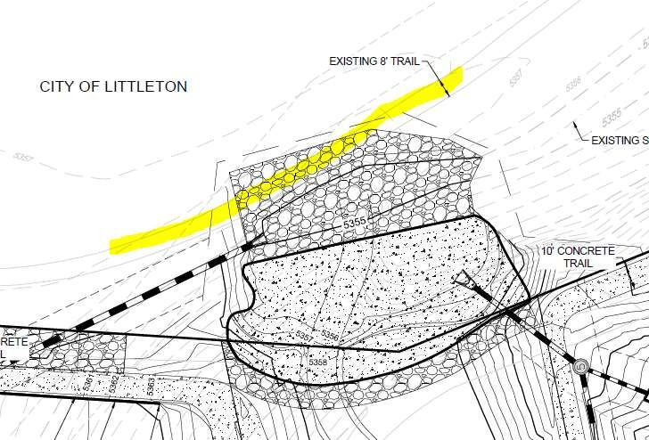

R: This is an existing 2-track and not a gravel access path.
C: Provide approval from SW Metro.
Response: We have provided a license agreement legal description and exhibit to the district on 02-28-22, and are actively working with them to reference the proper contact information on the agreement.
- Sheet 3.7 – The access from W Phillips onto S Santa Fe Dr should provide concrete curb return through radii at a minimum (or further as required by CDOT).

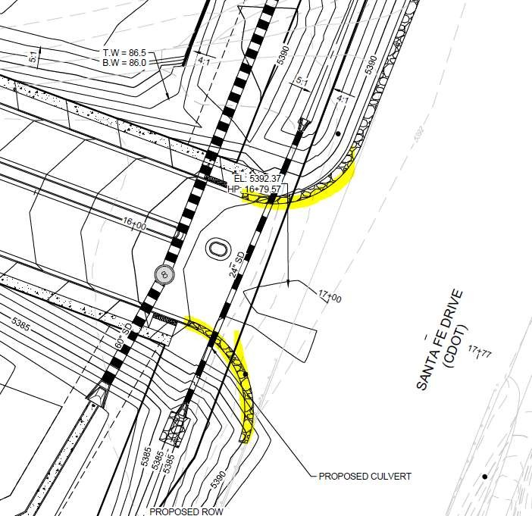

R: There is no concrete curb on Santa Fe Drive, so this should not be necessary.
C: Curb and gutter should be continued around radii. Where no curb is provided, other protection is necessary for the signal poles.
Response: As requested by CDOT, the curb and gutter ends at the handicap ramps. Asphalt shoulders are proposed at the returns.
- Sheets 4.1 to 4.23: The alley sections show an inverted crown with 3-percent cross-slope. Evaluate this design as it could be more prone to icy conditions.
R: This design is required from a grading, drainage and ADA perspective.
C: Noted. Comment addressed.
- Sheets 4.12 to 4.19: The private alley to private road transition looks difficult to implement and could lead to flow into lots as inverted crown section is all being directed to one side with a mountable curb transiting from 4-inches to 0-inches. It is recommended to transition to a zero inverted crown at the back of sidewalk to create a sheet flow condition (ex from Castle Rock) or if directed to one side a mountable curb that ends in a 45-degree chamfer thereby directed concentrated flow across the sidewalk.
R: [No response provided.]
C: Provide a response on how concentrated flow from the alley across the sidewalk has been prevented or mitigated.
Response: The inverted crown transitions in advance of the sidewalk to a sheet flow condition. In this transition, the mountable curb also diminishes. Please refer to the detail on the Civil CDs.
- Sheet 4.21
  - The titles to the two cross sections appear to be switched.
R: The titles now match the correct cross sections.
C: Comment addressed.
  - Revise cross-section to 80’ ROW Platte River Pkwy.
R: Completed.
C: Comment addressed.
  - The cross slopes of the driveways where the sidewalk or multipurpose trail cross needs to be ADA compliant.
R: Additional spot tags have been added to demonstrate 2%.
C: Slope labels not provided on Sheet 4.21.
Response: Completed.

  - The truncated domes for the pedestrian ramp in the northwest corner at Platte River Pkwy and Canyon Ave should be perpendicular to the sidewalk.
R: Revised.
C: Truncated domes shall be modified.
Response: Completed.

  - Align the west curb line along Platte River Pkwy north and south of Canyon Ave. The taper for southbound traffic should either occur prior to or after the intersection, but not through the intersection.
R: Revised.
C: Include a Platte River Pkwy center raised median on the south side of Canyon Ave to guide vehicles through transition and around median on north side of intersection.
Response: Completed.
  - Add mountable center median on Chestnut Ave west approach to Platte River Pkwy to narrow the residential entrance while still allowing truck turnaround.
R: As discussed during the 9/30 city meeting, the applicant has elected not to provide this median since pedestrians are crossing farther west.
C: Given that S Platte River Parkway has sidewalk adjacent to the road within the Right of Way, the City would like a pedestrian crossing across Chestnut Ave, in addition to having a mountable median.
Response: We have added a pedestrian crossing at the intersection of Chestnut Ave and Platte River Parkway however we did not include a raised median. We excluded the raised median so that if a large truck were to accidentally travel down this section of Platte River they have an easy back up path to exit the site, please see our Turning Radius Exhibit for more detail.
- Sheet 4.22
  - Remove the first driveway on the east and west sides of Platte River Pkwy immediately north of Phillips Ave.
R: Revised.
C: Comment addressed.
  - No pedestrian pass through or ramps are shown on the east and north side splitter islands for the roundabout.
R: Revised.
C: The trail approaches need to be designed with sweeping curves and the crossing as straight through the center median. See sketch on Sheet 6.1 for reference.
Response: Completed, updated sidewalk so that is crosses straight through the median.
  - Roundabout standard cross section does not identify the curb height between the truck apron and the center landscaped area.
R: A cross section of the round-a-bout has been added.
C: Comment addressed.
- Sheet 4.23- Phillips Av at Santa Fe Drive
  - Slope shall be revised to provide maximum of 3% slope, 200’ from intersection for a Collector approaching an arterial/highway. Also, pending and comments from CDOT.
R: Profile has been updated and exhibits have been provided and signed off on by the city per emails on 11-1-21.
C: Littleton approves of this design. Any comments from CDOT still apply.
Response: Acknowledged.
  - Review vertical curve at Santa Fe to provide minimum K value (crest) per AASHTO standards.
R: Profile has been updated and exhibits have been provided and signed off on by the city per emails on 11-1-21.
C: Littleton approves of this design. Any comments from CDOT still apply.
Response: Acknowledged.
  - Remove the first driveway on the south side of Phillips Avenue closest to Santa Fe Dr.
R: Revised.
C: Comment addressed.
  - The sidewalk along the north side of Phillips Ave should end at the pedestrian ramp similar to on the south side.
R: Revised.
C: Comment addressed.
  - The 94’ cross section does not accurately represent Phillips Ave immediately east of the roundabout. Need to see a potential design for two westbound lanes extended through the roundabout.
R: Westwood has discussed this potential condition through several email exchanges with the City. Two westbound lanes are not warranted at this time. If and when they are, there is now ample right-of-way to accommodate the extra lane and transportation easement to cover the adjusted sidewalk. Exhibits have been shared and approved by City staff via the aforementioned emails for the design of this potential, future infrastructure.
C: Easement geometry has been approved through prior exhibits. The proposed easement for these improvements shall be labeled as a Utility and Roadway Purposes Easement.
Response: Acknowledged.
- Sheet 5.1 - The design of the southbound right turn decelerations lane along Santa Fe Dr should be designed assuming there is no acceleration lane from Nichols Ave to the north in which to connect.
R: The extent of proposed pavement will accommodate both a right turn lane and an acceleration lane from future Nichols Avenue. It is our understanding that this improvement is pending. If at the time of construction, the project to the north is not actively developing, this area can be restriped for just a right turn lane, while providing ample pavement for the future, anticipated condition.
C: Comment addressed.
- Sheets 5.2 and 5.3 depict a significantly deep ditch in CDOT ROW adjacent to S Santa Fe Drive. The need for guardrail should be evaluated. Also, pending CDOT review.
R: The adjacent slopes to the right turn lane are 4:1, which does not typically warrant a guard rail. Once review comments from CDOT are received, this area may be re-evaluated.
C: Comment addressed pending comments from CDOT.
Response: Acknowledged.
- Sheet 6.0 Signage - Overall Development
  - Some sign locations are indicated with a symbol and others simply by an arrow or the hexagon sign number. Provide sign symbols for each location to verify where signs are to be placed.
R: Sign symbols have been added in all locations.
C: See additional redline comments regarding signs on Sheet 6.0.
Response: Completed.
  - Modify striping for westbound Phillips Ave outside lane to be dots from Santa Fe Dr to necessary deceleration length for the right turn lane, where the paint stripe should become solid.
R: [No response provided].
C: Comment still applies and needs to be addressed.
Response: Completed.
  - Add “RIGHT LANE MUST TURN RIGHT” sign along westbound Phillips Ave where striping changes from dots to solid, prior to driveway.
R: Added.
C: Sign not shown.
Response: Completed.
  - Add lane utilization sign for two left turn lanes and one right turn lane along eastbound Phillips Ave where “SPEED LIMIT 25” sign is currently shown.
R: Added.
C: Comment addressed.
  - Relocate “SPEED LIMIT 25” sign along eastbound Phillips Ave to the west part way between Platte River Pkwy and the first driveway.
R: Revised.
C: Make sure sign is revised to “SPEED LIMIT 30”.
Response: Completed.
  - Identify dimensions of on-street parallel parking stalls along Platte River Pkwy.
R: Added.
C. Parallel parking stalls shall be 8’x20’ minimum. Revise parking layout.
Response: Completed.
  - Because on-street parking is permitted in some sections of Platte River Pkwy, need to sign the remainder of the roadway with “NO PARKING” signs.
R: Added.
C: Signs on Platte River Parkway are provided. Additional signs are needed on the wide section of Chestnut Ave just west of Platte River Pkwy.
Response: Completed.
  - Need to sign the two crosswalks for crossing Platte River Pkwy immediately north of Canyon Ave and south of Chestnut Ave with pedestrian signs 10 and 11 (without the “AHEAD” plaque).
R: Added.
C: Crosswalk signs are not provided at the crossing south of Chestnut Ave.
Response: Completed.
  - Are “ADVANCED PEDESTRIAN CROSSING” signs proposed to be provided along Platte River Pkwy prior to the two crosswalks across Platte River Pkwy?
R: A response from the traffic engineer is forthcoming.
C: Response not yet received, and signs are not shown. Include for crossing north of Canyon Ave as shown on Sheet 6.0.
Response: Completed.
  - The Sign 10 arrow plaque should be W16-7P and indicated as 24”x12”.
R: Added.
C: Comment addressed.
  - Sign 11 should be separated from the “AHEAD” plaque, and in the legend should be referenced as just “PEDESTRIAN CROSSING W11-2” without the “ADVANCE”. In addition, this sign should be indicated to be 30”x30”. The arrow plaque (10) and “AHEAD” plaques should not be used together at the same location.
R: Revised.
C: Need to include the “AHEAD” plaque also, just separately.
Response: Completed.
  - Stripe crosswalk and crossbike markings for the multiuse trail along the east side of Platte River Pkwy across all of the driveways.
R: Revised.
C: No such striping has been shown and detailed with green paint.
Response: Completed.
  - Show pedestrian ramps and crosswalk for the west approach to the Platte River Pkwy and Chestnut Ave intersection.
R: Not applicable, per 9/30 meeting discussion, pedestrians are crossing farther west.
C: Given that S Platte River Parkway has sidewalk adjacent to the road within the Right of Way, the City would like a pedestrian crossing across Chestnut Ave, in addition to having a mountable median.
Response: Completed.
  - Add “SPEED LIMIT 25” sign along northbound Platte River Pkwy north of Chestnut Ave.
R: Revised.
C: Comment addressed.
  - Move the “SPEED LIMIT 25” sign along southbound Platte River Pkwy immediately south of Canyon Ave to the north immediately south of the bridge over Dad Clark Gulch and north of the driveway to the parking lot.
R: Revised.
C: Comment addressed.
  - Street name signs (2) must match Littleton standard, show example.
R: Revised.
C: Did not see sign detail in plans.
Response: Completed.
  - Where is the “NO OUTLET” sign (4) proposed to be used?
R: Located west of alley on the western limit of Canyon Drive and the western limits of Elmhurst Ave.
C: Neither location is necessary due to the distance from the intersection to the end of the roads.
Response: Removed the signs.
  - The number of parking stalls within the lot immediately north of Canyon Ave is not indicated, nor are any dimensions provided for the layout. Clearly label stalls that are for ADA access.
R: Completed.
C: Parking stalls are not dimensioned nor is a count provided on Sheet 6.0. Also, need to sign ADA stalls and compact stalls. Clearly sign and label the van accessible stalls.
Response: Completed.
  - Include appropriately sized box around the roundabout with a note indicating to reference roundabout inset.
R: Completed.
C: Comment addressed.
- Sheet 6.0 Signage - Roundabout Inset
  - Do not place a “SPEED LIMIT 25” sign on southbound Platte River Pkwy as vehicles are entering the roundabout.
R: Removed
C: Comment addressed.
  - Move the “KEEP RIGHT” sign for southbound Platte River Pkwy to the north to the end of the center median.
R: Completed.
C: See redline comments on the signage sheet.
Response: Completed.
  - Why is a “STREET NAME” sign indicated in the sidewalk in the southeast corner of the intersection?
R: Completed.
C: See redline comments on the signage sheet.
Response: Completed.
  - Move the “SPEED LIMIT 25” sign along westbound Phillips Ave to the east closer to Santa Fe Dr.
R: Completed.
C: Still needs to be moved further east as indicated on Sheet 6.0.
Response: Completed.
  - Add dot extensions for the roundabout across access approaches along with shark teeth markings prior to entering roundabout on all three approaches.
R: Completed.
C: Still not shown on plans.
Response: Completed.
  - Remove “ONE WAY” signs (6) around the roundabout and just use the chevrons (8).
R: Completed.
C: Signs still shown on plans.
Response: Completed.
  - Replace the “PEDESTRIAN CROSSING” signs (11) on the east side of the roundabout for the crosswalk on either side of the splitter island to be W11-15 with a bicycle and pedestrian symbol and a size of 30”x30”.
R: Completed.
C: Still not corrected on plans.
Response: Completed.
  - Stripe crosswalk and crossbike markings for the multiuse trail across Phillips Ave on the east side of the roundabout.
R: Completed.
C: Still not corrected on plans.
Response: Completed.
  - What is the “4” in a block under sign 8 on the detail?
R: “4” has been removed.
C: Comment addressed.
- Sheet 6.1
  - All crosswalk markings should be 9’ long by 2’ wide.
R: Completed.
C: Still incorrect on plans.
Response: Completed.
  - None of the striping around the roundabout is labeled.
R: See newly added annotation.
C: There is still additional striping that has not been labeled.
Response: Completed.
  - The striping along Platte River Pkwy north of the splitter island for the roundabout is incorrect. Some of the lines that should be labeled “8” SOLID WHITE STIPE” are labeled as “DOUBLE 8” CENTERLINE YELLOW STRIPE” and vice versa. In addition, the striping connecting to the splitter island is incorrect and should connect to both sides of the island.
R: Revised.
C: There are still several corrections needed as identified on Sheet 6.1 of the redlines.
Response: Completed.
  - Some of the centerline double yellow striping is labeled incorrectly as 8” and should be “DOUBLE 4” CENTERLINE YELLOW STRIPE”.
R: Revised.
C: Some have been corrected but other annotations are still incorrect as identified on Sheet 6.1 of the redlines.
Response: Completed.
  - Move the arrow markings in the eastbound and westbound Phillips Ave left turn lanes for the driveways to the center of the storage area.
R: Revised.
C: Still not done.
Response: Completed.

  - The arrow in the westbound left turn lane along Phillips Ave to the driveway on the south side of the roadway is mislabeled as a “RIGHT TURN ARROW” rather than correctly as a “LEFT TURN ARROW”.
R: Revised.
C: Still labeled as RIGHT.
Response: Completed.
  - Neither the striping for the south portion of Platte River Pkwy nor for Canyon Ave and Chestnut Ave are provided.
R: No striping is proposed.
C: On-street parking and crosswalks are proposed.
Response: Completed.
- Sheet 6.2
  - Need to show how striping coordinates with Santa Fe Drive paint markings immediately to the north of the SB right turn lane, and shadowing the NB left turn lane on the north side of the intersection.
R: [No response provided.]
C: Awaiting a response.
Response: Completed.
  - Need to provide a “PHILLIPS AVENUE NEXT SIGNAL” sign for both northbound and southbound Santa Fe Dr.
R: Added.
C: Where are the signs located as they are not on the signing or striping sheets?
Response: Completed.
  - Need to include a “RIGHT LANE MUST TURN RIGHT” sign.
R: Added.
C: Do not see any such signs on the appropriate sheet.
Response: Completed.
  - The southbound right turn lane striping should identify the required deceleration length with a “8” SOLID WHITE STRIPE” and either a taper entering or “8” DOT WHITE STRIPE” as the extension to the north.
R: Revised.
C: Not completed as requested.
Response: Completed.
  - Need to include arrow markings in the appropriate locations within the turn bay following CDOT standards.
R: Revised
C: Additional arrows needed.
Response: Arrows have been added.
  - Label the taper required into the northbound left turn lane.
R: Added.
C: No taper rate provided.
Response: Taper rate now provided on plan.
  - This sheet is not included in the Sheet List Table on the front cover.
R: The sheet index has been revised accordingly.
C: Comment addressed.
- Sheets 7.1 to 7.17: Label the inverts of the outfall pipes.
R: Completed
C: Label the outfall invert on Sheet 7.11.
Response: Invert on Sheet 7.11 has been labeled.
- Sheet 8.1: This should be re-titled as a drainage swale as there is nothing indicated in the design that promotes water quality treatment such as check dams or a flat slope to promote infiltration.
R: The swale follows MHFD criteria for a WQ swale, UD-BMP sheet has been added to the report appendix.
C: Comment addressed.
- Sheets 14.1 to 14.9: The information presented in the sheets is not consistent with the calculations in the drainage report.
R: Sheets and MHFD-Detention has been updated.
C: Comment addressed.
- Sheets 14.1 to 14.9: A trickle channel with an inside width of 3-feet may be hard to clean with most types of equipment and may have to be cleaned by hand. May want to consider the maintenance aspect of the trickle channel.
R: Trickle channel width has been revised, a 8-foot wide v shaped channel will be proposed to also act as a maintenance path.
C: Sheets 14.1, 14.4 & 14.7: Indicate the width and thickness of the concrete in the trickle channel detail.
Response: Trickle channel dimensions have been added to all plan sheets.
- Sheets 14.1 to 14.9: The micropool is generally not recessed below the invert of the outlet pipe. Given the constraints or the site, however, that is acceptable. This may lead to more frequent standing water within the micropool.
R: Acknowledged, this is MHFD criteria/design.
C: Comment addressed.
- Sheet 14.3: The graphic of the outlet structure does not match the calculations as the calculations indicate a flat top inlet box.
R: Detail has been revised.
C: Comment addressed.
- Sheet 14.3: The restrictor plate is no shown on the details.
R: Detail has been added to all sheets.
C: Label the height of the restrictor plate above the invert of the outlet pipe.
Response:The height of the restrictor plate has been labeled.
- Sheets 14.1 to 14.9: WSEL need to be added to the outlet structure details.
R: Summary table with WSELs has been added to each sheet.
C: Update the pond summary table on Sheet 14.7 to match Sheets 14.8 and 14.9.
Response: All pond summary tables have been updated and match calculation sheets.
- Sheets 14.1 to 14.9: The outlet structure micropools are 4-foot inside width and 15+ feet long may want to consider a wider and shorter micropool with a ramp for ease of cleaning and maintenance.
R: Acknowledged, micropools are shaped/sized to be placed in the embankment of the pond at a 4:1 slope per MHFD design.
C: Comment addressed.

- Sheets 14.1 to 14.9: Section J shows a concrete opening at the orifice plate of 12-inches, but orifice plate section appears to be much wider. Please confirm which is correct.
R: This detail has been removed from the sheets to avoid confusion, Detail H has been updated.
C: Comment addressed.
- Sheets 14.1 to 14.9: Confirm and call-out the orifice plate thickness.
R: Orifice plate thickness has been added.
C: Comment addressed.
- Sheet 15.1:
  - Label the bridge as “South Platte River Parkway” in profile view of the channel. The location cannot be “approximate”, so remove that label. Bridge plans for this structure must be submitted for review.
R: Label has been updated. Bridge structures will be submitted separately.
C: Labels added/modified. That portion of comment is completed. However, the requested bridge plans are still pending.
Response: Bridge plans are included with this resubmittal.
- Sheet 15.2:
  - add note: 100-yr water surface on this sheet does not match final floodplain delineation because of topographic “non levee” condition at the location of the ponds.
R: Note added.
C: Note added, Comment completed.
  - The change in cross section (overall side slopes where trail benched into sides) located where the trail crosses the floodplain bottom was not included in the Floodplain Development Permit model; add this to the HECRAS and update WSE profiles, etc. as needed.
R: HECRAS modeling is provided in report appendix.
C: It appears that the change in grading within the proposed channel/floodplain has been incorporated.

  - Confirm how the trail crosses the low flow- it is matching the typical section with 3:1 slope? Is there a pipe? Any changes to the cross section at this location must be included in the HECRAS model. Show the location of the low flow crossing in the channel profile. Label elevation of the proposed crossing and confirm that fall protection or railings are not required.
R: There are 2-2’x8’ RCBC culverts under the crossing as proposed currently.
C: See comment above. It appears that the elements have been incorporated into the model as requested, however will railing be required at this culvert? please confirm. Railing would need to be included as blocked obstruction in the model if so.
Response: No railing is included in the design. A roughened edge (rumble strip) has been added to warn path users.
  - The downstream property fence was not included in the Floodplain Development Permit model; add as a blocked obstruction assuming it accumulates debris. Note; neither the city nor MHFD recommend a fence across a 100-yr floodplain, however, this fence as its designed is required by South Suburban Parks and Recreation District to prevent access to the park at this location, OR the entire channel area must be fenced off at top of channel slopes to prevent access. This would eliminate the trail crossing at this location, and force the regional trail to cross at Platte River Parkway bridge.
R: This discussion is ongoing and will be resolved by CD approval.
C: This issue needs to be addressed before CD approval.
Response: The proposed location of the fence based on conversations will be located at the high point downstream of the final drop structure that is not included in the floodplain. An exhibit is included in model files to show fence location.
- Sheets 16.1-16.4 General:
  - Change references to “urban drainage and flood control district” to Mile High Flood District.
R: Labels have been updated.
C: References to “urban drainage and flood control district” remain on these sheets. Revise the references. See redlines.
Response: Notes have been updated to MHFD
  - Soil riprap or void filled riprap or Type M Riprap labels need to be consistent. City prefers void fill riprap within the bottom of the channel.
R: All riprap within the drop structures are proposed void riprap. Labels have been updated.
C: The labels on the sheets remain inconsistent, not all identify “void filled riprap”. Review and revise the labels as needed. See redlines.
Response: All riprap sections are properly labeled.
  - Add weep drains to the drop structures, and add a typical detail. R: Detail added.
C: Details are added, but weep drains are not shown on the plan views to show where they are to be located. Add this information.
Response: Plan views have been updated to show weep drain locations
- Sheet 16.1 (Drop 1)
  - Clarify where cutoff wall, edge wall, notch wall apply in plan view. Edge wall label in plan view says Detail C, when Edge Wall is detail D.
R: Revised.
C: labels and locations of Cutoff Wall vs. Edge Wall in plan view and details remain inconsistent on all sheets for all Drop structures. Review and update accordingly. See redlines.
Response: All redlines have been address to clarify and add consistency.
  - Clarify 2*D50 thickness of Type M riprap on all details.
R: Revised.
C: It is not evident on the plans that the 2*D50 is the thickness dimension, although that is the
intent. A simple note on each plan stating that Type M Riprap has a D50=12”, and all Type M riprap is to be 24” thick, will suffice. this applies to all Drop structure sheets. See redlines.
Response: All redlines are addressed and notes have been added.
  - Edge wall or notch wall or cutoff wall on downstream end? Make consistent across all details/sections.
R: An edge wall is along the upstream side of the drops, a cutoff wall is along the downstream ends, and a notch wall is above grade on the downstream side fo the drops. All detail sheets have been updated.
C: the labels are not updated or consistent on all sheets for all drops. Review and update. See redlines.
Response: All redlines are addressed and labels have been corrected.
  - Appears to be multiple lines in plan view for section cut lines. Please remove lines that do not apply.
R: Additional lines have been removed.
C: Comment addressed.
- Sheet 16.2 (Drop 2)
  - Clarify where edge wall detail vs. cutoff wall detail apply in plan view.
R: An edge wall is along the upstream side of the drops, a cutoff wall is along the downstream ends, and a notch wall is above grade on the downstream side of the drops. All detail sheets have been updated.
C: See comment 32.
Response: All labels have been corrected to clarify locations and types
  - Clarify 2*D50 thickness of Type M riprap on all details.
R: Revised.
C: See comment 32.
Response: Notes have been added to clarify riprap depths.
  - Edge wall or notch wall or cutoff wall on downstream end? Make consistent across all details/sections.
R: An edge wall is along the upstream side of the drops, a cutoff wall is along the downstream ends, and a notch wall is above grade on the downstream side of the drops. All detail sheets have been updated with more detail.
C: See comment 32.
Response: Details have been labeled to clarify.
- Sheet 16.3 (Drop 3)
  - Clarify extents of Cutoff Wall detail C vs. D in plan view. Clarify where Edge Wall detail applies.
R: An edge wall is along the upstream side of the drops, a cutoff wall is along the downstream ends, and a notch wall is above grade on the downstream side of the drops. All detail sheets have been updated with more detail.
C: See comment 32.
Response: This has been addressed
  - Clarify 2*D50 thickness of Type M riprap on all details.
R: Revised.
C: See Comment 32.
Response: This has been addressed
  - Edge wall or notch wall or cutoff wall on downstream end? Make consistent across all details/sections.
An edge wall is along the upstream side of the drops, a cutoff wall is along the downstream ends, and a notch wall is above grade on the downstream side of the drops. All detail sheets have been updated with more detail.
C: See Comment 32.
Response: This has been addressed.
  - Add riprap around all edges of concrete.
R: Revised.
C: Comment addressed.
  - Both section lines are labeled 1-1 in plan view. Update to show section 2-2. Also appear to be various lines in plan view for the section cut lines. Please remove lines that don’t apply.
R: Revised.
C: Comment addressed.
  - The trail bench coming into the floodplain bottom from the east is constricting flows and may need erosion protection. Is this crusher fines? This constriction in cross section must be added to the HECRAS model to determine impacts. How does the downstream constriction affect drop structure function in larger floods?
R: The pedestrian crossing along the lowflow of the channel has been added to the HECRAS modeling. In the larger flood events the crossing will flood and will not impact the downstream drop structures.
C: Label and show thickness of trail surface material on the drawings. See redlines.
Response: Thickness and material has been added to the plan and detail in accordance with redlines. Details including a headwall have been added to provide erosion protection at the crossing. Modeling indicates that the effective flow will pass through the culverts, and the flood elevations will not be adversely impacted.

  - Label the line going through middle of structure in plan view with “4” inside a circle on east end.
R: This is a sanitary sewer line, it has been removed for clarity in this detail sheet.
C: This feature remains on the plan view, please label it, or remove it.
Response: The drop structure has been relocated so this line no longer passes under it.
- Sheet 16.4 (Drop 4 – downstream end):
  - It appears that flows are forced to make a 90 degree turn at downstream extents of the channel, within the riprap. What type of riprap is this, what is its thickness, and is it sufficient for those velocities/forces. Verify adequate protection of the Sanitary Sewer in this area.
R: Additional analysis (HECRAS 2D) has been run for this area and adequate protection has been provided for velocities/forces in this area.
C: The type of riprap and its thickness has not been added to the plans. See redlines. The 2D analysis does not appear to reflect the proposed grading/contours within this area where water is to turn. Please review and revise as needed. Whether or not this riprap is adequate cannot be determined since the design is not complete and type of riprap here is not identified on plans, and calculations for its sizing is not in the report appendix. This is true of all riprap proposed. There is a sanitary sewer in this area that must also be protected from erosion. The riprap encroaches into that sanitary sewer easement; permission to do so much be obtained by SWMETRO (provide in response to this comment).
Response: The 2d model provided indicates the shear stress downstream of the sculpted concrete structure and not significant and the type M riprap is adequate to withstand the estimated shear stress. This area is included in the O&M plan to be regularly inspected so that any deficiencies can be corrected.
  - Plan view labels for section 1, 2, 3 are not lining up with the section line; correct
R: Revised.
C: Comment addressed.
  - Add riprap around all edges of the sculpted concrete
R: Revised.
C: Comment addressed.
  - Notch wall or edge wall at downstream end? Make consistent. Typical detail A says its edge wall, flow channel profile says edge wall, plan view has 2 different labels of notch wall and edge wallow flow notch detail shows it 6’ “cutoff wall”. Note: only edge wall should have topsoil covered riprap next to it.
R: An edge wall is along the upstream side of the drops, a cutoff wall is along the downstream ends, and a notch wall is above grade on the downstream side of the drops. All detail sheets have been updated with more detail.
C: See comment 32.
Response: All redlines are addressed and labels have been corrected.
  - Clarify extents of cutoff wall, edge wall, and notch wall in plan view. Clarify thick black line versus thick gray line.
R: An edge wall is along the upstream side of the drops, a cutoff wal is along the downstream ends, and a notch wall is above grade on the downstream side of the drops. All detail sheets have been updated with more detail.
C: See comment 32.
Response: All redlines are addressed and labels have been corrected.
  - Flows above about 5358’ within Section 1-1 will spill out to the west outside of the riprap boundary. Indicate what design frequency of flow this is.
R: Riprap has been updated to include these flows.
C: Indicate the design frequency for when flows spill out the west side of riprap and that it will not be erosive when it does so. Ensure the proposed grading is in the 2D modeling – it doesn’t seem to be.
Response: All redlines are addressed and labels have been corrected.
  - Add note to the profile of 10+00-12+00, that at section 1-1 flows turn 90-degree into page
R: Note has been added.
C: Comment addressed.
  - Clarify that all type M riprap thicknesses are 24” or add labels of 2*D50 to correspond to table of drop structure dimensions.
R: Revised.
C: See comment 32.
Response: All redlines are addressed and labels have been corrected.
- Sheet 18.1
  - Not all of the cross sections are labeled with an ID (i.e., A-A, B-B).
R: Cross sections are only labeled on area grading plan, the individual sheet don’t have labels.
C: Comment addressed.
  - There are two cross sections labeled D-D.
R: Revised.
C: Comment addressed

  - Where are the cross sections referenced within the plan set, specifically the Platte River Pkwy D-D, the Phillips Ave D-D, and the Phillips Ave G-G?
R: They are on the cross section sheet.
C: Comment addressed.
- Include truck turning movement diagrams for the Phillips Ave and Platte River Pkwy roundabout, as well as the Platte River Pkwy and Chestnut Ave intersection turn around maneuver.
R: Provided in the SDP.
C: Need to provide updated exhibits for the WB-50 and WB-67 vehicles based on revised design.
Response: Completed.
- Many of the private drives are showing steep profile of 5% at the ends. The steep slope immediately before the sidewalk can be problematic during icy conditions. Please explain why these sections are so steep. Revisions may be required to reduce this slope.
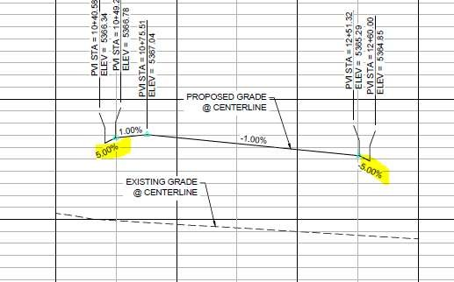
R: Private drives are steep for a short distance to raise the elevation so that the intersection Private Streets contain the entire 100-year storm plus freeboard through their street corridor. This makes sure no water overtops and flows into the Private Drives.
C: See comment 8, above.
Response: Acknowledged.
- Provide a construction detail of the proposed retaining walls. Walls over 2-ft require a separate building permit. Construction details shall specify footers and a reinforcing plan, if applicable. Footings shall be shown in plan view to confirm there are not any utility conflicts.
R: Structural design is in progress and submission will be forthcoming.
C: Design plans and report for Wall 1 were provided. Elevations in the wall profiles shall match the elevations called out on the Grading Plans (C3.7 & C3.10). Retaining walls surrounding Ponds A, B, and D were not provided. Retaining wall typical details shall be provided in the Civil CDs.
Response: Plans have been updated that provide all walls and their heights, it has been included with the submittal.
- Railings shall be provided where there is a drop off of 30 or more inches within 36 inches of a walking surface. If railings are to be included as part of the retaining wall, include this information on the retaining wall structural details.
R: A railing detail has been added and callouts have been included for all retaining walls over thirty
(30) inches.
C: Railing callouts and details were not found in the drawings. Please identify which sheet these are apart of.
Response: Railing callouts have been provided in locations where the wall is 30 inches and higher, a detail of the wall is shown on page 18.6.

- Segments of the internal sidewalks are 5-ft in width. Please clarify where these segments are to be called out in the drawings. These can be labeled on sidewalk/trail drawings, the grading plans, the roadway P&Ps (and associated typical sections). A construction detail of the Curb, Gutter and Sidewalk shall also be included in the plan set.
R: [No response provided].
C: Provide an overall trail and sidewalk plan showing proposed sidewalk widths. This sheet shall be consistent with labels provided on all roadway plan and profile sheets. An exhibit was prepared during the SDP submittal; however, it appears that some sidewalk widths have changed from what was previously approved. The project is responsible for incorporating pedestrian connections to the parks and trails.
Response: A standalone plan sheet indicating sidewalk widths and their connection to recreational amenities will be included with the SDP. Generally, where sidewalks could be widened, e.g. when outside the typical private roadway section that provides parking, they were widened to five feet, from four feet.
- Label existing and proposed index contour lines on all plan views.
R: Completed.
C: Comment addressed.
- Identify where maintenance access to the channel and drop structures is located.
R: Maintenance access will be determined when the pedestrian crossing and fence is resolved.
C: CDs for the channel will not be accepted until adequate maintenance access is depicted in the plans.
Response: An eight foot grass maintenance access path has been provided to the bottom of all drop structures, the maintenance team will also utilize the low flow crossing to gain access to one of the downstream drop structures.
- Add the discharge value (CFS) on the profiles of the 100-yr.
R: Revised.
C: Comment addressed.
- Add the profile of the water surface for the flow channel design discharge, and label with the CFS value.
R: Label updated.
C: Profile of water surface of this flow event is not added, and other labels are not updated. Clarify what this detail is referring to. Are soils “cohesive”? This is a typical detail that needs to be updated for the specific project. See redlines
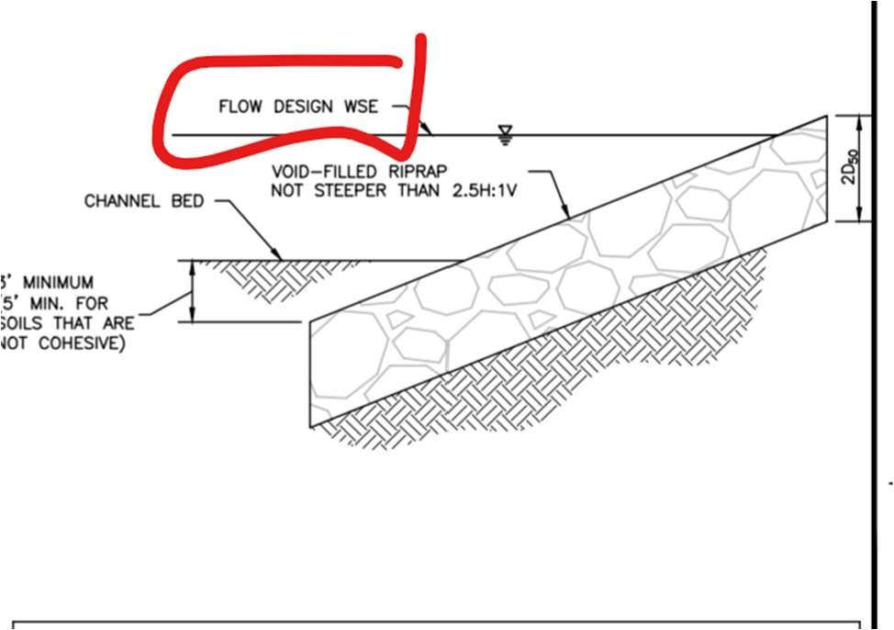
Response: This detail is not considered relevant to the design and has been removed. The effective flow profile has been added to the channel profile sheets.
- Dad Clark Gulch Typical section(s): add discharge values (CFS) for 100-yr and the design discharge (CFS) for the low flow channel sizing.
R: Label has been updated.
C Labels are not updated. Add proper notation to the labels.
Response: These are typical sections that are no longer relevant to the construction of the channel. All proposed grading is shown on the plan sheets. Typical sections have been removed.
- Show all proposed riprap in both plan and channel profile views of Dad Clark Gulch.
R: Riprap is proposed around the areas of high shear per 2D HECRAS model (in the drop structures). No additional riprap is necessary for this channel. HECRAS modeling has been provided with this submittal.
C: Riprap has been shown and labeled on profile and plan views. There remain clarifications needed on what type of riprap goes where. see redlines.
Response: All redlines are addressed and labels have been corrected.
- Missing items:
  - Roadway and sidewalk construction details (i.e. curb and gutter, sidewalk, trails, ADA ramps)
R: Detail sheet has been added.
C: All pedestrian ramps within the Public ROW shall have details showing spot elevations and slopes. Standard notes and details are not sufficient. Ramps will be surveyed for as-built drawings prior to City acceptance.
Response: Spot elevations and slopes have been included at all pedestrian ramps within the Public ROW.
  - SDP Sheet 35 included a phasing plan. The Civil CD’s shall include corresponding plans for phasing unless all infrastructure will be completed first prior to seeking any building permits.
R: The phasing plan has been added to the Roadway & Drainage plan set.
C: Comment addressed.
  - Construction specifications for all work in the public ROW.
R: Contractor shall adhere to the 2019 Arapahoe County Infrastructure design and construction standards.
C: The City is undergoing an adoption of Design Standards which are not currently approved. In the absence of these standards, the City’s preference is for the Public Infrastructure to be constructed according to the City of Englewood’s Design Standards.
Response: Acknowledged, Contractor shall adhere to the City of Englewood’s Design Standards. A reference to these specifications has been added to the cover sheet of the Civil CDs.
Sheets 14.1, 14.4 & 14.7: Comment: Please use a different color for the WSEL for the 100-year, EURV and WQ elevations and add that to the legend.
Response: Pond sheets have been updated to show different colors for the WSEL

- Sheets 14.1, 14.4 & 14.7: 14.2, 14.5 & 14.8: Comment: Reference or add details for the appropriate M&S Standards for the forebay walls, railing, etc.
Response: All headwall and wingwall structures have CDOT M standard number called out.

51.Sheet 14.3: Comment: Label the width of the overflow outlet box (in appear to be 12-feet).
Response: The overflow box structure has been properly labeled.
52.Sheet 14.3: Comment: Label the slope of the outlet structure walls.
Response: Outlet structures have wall slopes labeled.
53.Sheet 14.6: and Appendix C: Comment: Confirm the horizontal width of the overflow weir box. The detention spreadsheet shows 8-feet – the plans show 4-feet.
Response: The width has been corrected in the spreadsheet to reflect design width of 4 feet.
54. Comment: Show and label all dry utilities (Electric, Gas, Communications, etc) on the Utility Plans. No new overhead utilities are allowed.
Response: No overhead utilities are being proposed, gas and electric line will be placed within their easement limits, please see cross section A-A and F-F for more detail on where the easement is located.
55. Comment: Medians shall have the transitional curb height at the front/nose of all medians in the Public Right of Way. See detail in redline drawings.
Response: Acknowledged.

CDOT Access Permit Application:
- Update the approximate date (item 8).
R: Completed.
C: Comment addressed.
- Revise the number of cars (item 17) to reflect the peak hour volume as identified in the traffic study.
R: Completed.
C: Item 17 still indicates a peak hour volume of 8,915. Where does this volume come from as the trips do not appear to represent the generation estimated in either the Combined Traffic Impact Study (February 17, 2021) or the Supplemental Traffic Impact Study (September 27, 2021), and do not appear to be peak hour volumes.
Response: Revised.
- Need to include signature, name, and date on page 2.
R: Completed.
C: The Applicant or Agent for Permittee signature should be the city representative and the Property Owner signature should be the Toll Brothers representative.
Response: Completed.
- Comment: Item 11 indicates knowledge of an existing access permit for this property but does not provide the permit number or a copy.
Response: Permit number has been given.

- Comment: Item 16 only includes single family (260 units) and not the multifamily (264 units) included in the supporting Supplemental Traffic Impact Study (September 27, 2021).
Response: Permit has been updated to include the multifamily units.

CDOT Plan Set:
- Coordinate with comments from the Civil CD’s set (above) and comments from CDOT.
R: Acknowledged.
C: There is still many components missing, including but not limited to: Santa Fe Dr/Phillips Ave signalized intersection design, signage along Santa Fe Drive, complete striping and labeling along Santa Fe Drive.
Response: There is a standalone CDOT plan set that CDOT has been reviewing. We have addressed their review comments with this latest CD resubmittal. Those plan and a comment response letter to CDOTs comments is included herein. The signal plan is included with this submittal.

Final Drainage Report:
- Include the Final Drainage Report Checklist per Section 2.6 (Table 2D) of the Drainage Criteria Manual.
R: A checklist has been added to the end of the report appendix.
C: Comment addressed.
- Text 1.0 C and Appendix A: The report states that approximately 40-percent of the site is Type B soils with the remainder being Type C or D soils. The calculations in the report assume the entire site is Type C soils. The areas of Type B soils are in area of significant fill. Since the fill will probably be import from the area of cut for the site which is Type C soils this assumption appears to be reasonable.
R: Acknowledged, an explanation has been added to the soil report and narrative.
C: Comment addressed.
- 1.0(D) should also reference the past master plan study.
R: Section has been revised to reference the previous OSP. Discussions about the previous master plan are ongoing.
C: A reference to the OSP has been added, but the appendix contains excerpts to a preliminary version of an alternative evaluation, not the final published version that shows the selected master plan design for this section of Lower Dad Clark Gulch. Update the reference and appendix contents. See also comment 12 below. The OSP is a pertinent prior study that needs to be referenced in this report, and that is purpose of this section in the drainage report outline. This report is available from MHFD and is referenced here:
Response: The correct approved OSP has been provided.

- 2.0 (B) should reference the Master plan study not the FHAD study.
R: Section has been revised to reference the previous OSP. Discussions about the previous master plan are ongoing.
C: See above comment 3.
Response: Reference has been updated to the correct document

- 2.0(c) should mention that offsite drainage area includes all of Dad Clark Gulch drainage basin, as released from the reservoir, not only the area between the dam and Santa Fe Drive.
R: Additional text has been added to clarify this, this section also discusses the occasional releases from the reservoir.
C: Comment complete.
- Text 2.0 D and Appendix: The table for the detention ponds does not match the calculations for the weighted imperviousness or the UDFCD spreadsheet calculations.
R: Revised.
C: Comment addressed.
- 2.0 (E) the mentioned maintenance agreement for the downstream areas of S Platte Park must be submitted and executed before approval of the plat and final Dad Clark Gulch channel design.
R: Acknowledged.
C: The City is working with South Suburban Parks and Recreation District to identify the terms of the Maintenance Agreement. Once defined, the City will execute the Agreement with the Metro District(s).
Response: Acknowledged.

- 2.0(e) floodplain development permit has already been obtained, but this does not approve construction. A grading permit application is required.
R: Acknowledged.
C: Grading Permit application is pending final review and approval of the channel design CDs.
Response: The final channel model is provided in the Final Drainage Report.

- Text 2.0 E: The please clarify the responsibility of the Metropolitan District as some the roadways (South Platte River Parkway and Phillips Avenue) may be dedicated to the City of Littleton and the maintenance responsibility needs to be clearly defined. See General Note #4 above.
R: Section updated.
C: Comment addressed. Agreements are being drafted and will be executed with the Metro District(s).

- 3.0(C) please identify in the report the 2-year CFS and the “effective” discharge CFS. Suggest putting these design discharge values into a table.
R: Pond release rates have been listed in the pond summary table in section 2D.
C: The comment is not referring to pond release rates, it is referring to the Dad Clark Gulch channel design values. See comment 12 below. Please include the design values for various flow levels for the proposed channel design in a summary table.
Response: This information has been provided in the report and the model has been updated to show the correct flows.

- Text 3.0 F and Appendix: The table for the proposed major basins A and B does not match the calculations in the Appendix.
R: Appendix and report is updated.
C: Comment addressed.
- 3.0(G) The discussion of the design of the Dad Clark Gulch channel and drop structures needs to be expanded to include, but not limited to, the following: proposed velocities/shear stresses compared with MHFD standards for grass channels, need for riprap and/or riprap sizing or other channel erosion protection measures, drop structure design/are MHFD simplified methods are used, reasoning and documentation of why Army Corps permit not required, why the channel design does not follow that of the master plan, how was sinuous low flow channel layout designed, types of drop structures/materials to be used, how final vegetation provides necessary erosional stability.
R: A section for drop structure and riprap details and calculations has been added to the report in a new section. An Army Corps permit is required and is ongoing with ERO.
C: Design team has previously stated before that a Army Corps permit is NOT required. Has this changed? Clarify. The GeoHECRAS 2.0 description in the drainage report is unclear. Was 10% of 100-yr used for this analysis, even though it also states that the 100-yr was used in analysis? What is the CFS associated with bankfull and/or low flow channel (?) that is referenced and where are those results? The original floodplain study said that low flow channel is designed for 70% of the 2-yr flow. HECRAS output in that study shows 2 other flow values besides the 100-yr value, but does not define what they are representing (see clip below). But this new report also brings up a 10% of 100-yr value used in design. As requested before, list the various design discharges used for the overall composite channel design; a table form would be helpful. And support these various values and their selection with references to MHFD standard criteria and clarify what is actually being used to design the channel elements (100-yr, bankfull, “effective”, low flow channel, etc) The text states that riprap and drop structure calculations are contained in Appendix, but they are not. Riprap calculations to support the design are required.
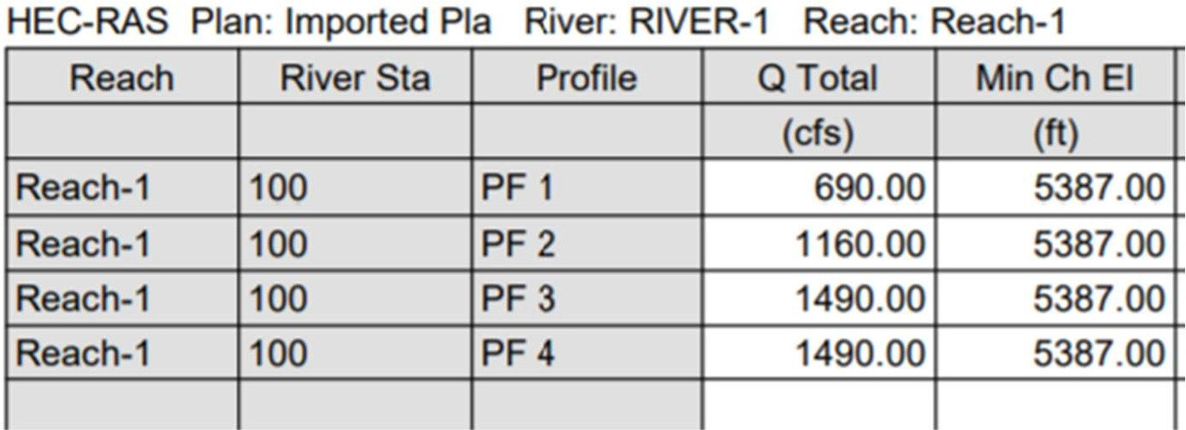
The description of why the channel design is not following that of the 1991 Outfall Systems Study (OSP) study is not included in the report; please add. There are numerous pages included in the Appendix of this Final Drainage Report that are from a preliminary alternatives evaluation that predicated the published 1991 OSP for Lower Dad Clark Gulch, and these materials serve no value. Please include the pages from the published OSP that actually show the selected master plan elements for this segment of Dad Clark Gulch, and reference this when explaining why the proposed design deviates from the OSP design, as mentioned above in this comment.
Response: Additional design information and parameters have been provided in the drainage report.

13. Add to the report that construction specifications for channel and drop structures will follow
those of the Mile High Flood District.
R: Report has been updated.
C: See above discussion.
Response: The most recent note from MHFD has been added to all channel sheets.

14. Add design information for the bridge at Platte River Parkway.
R: Bridge design information will be submitted separately.
C: Bridge design drawings are required. Pending.
Response: Bridge design plans to be submitted in this submittal.

15. Provide a section in the report dedicated to Operations and Maintenance (see Section 3.3.8 of the Littleton
Drainage Criteria Manual) for all detention ponds (see MHF for requirements for full spectrum detention
And EDBs), or provide this in a separate document.
R: Operations and Maintenance manual will be provided with CD approval, all ponds will be privately owned and maintained.
C: Comment addressed.
16. There are numerous inconsistencies between plans (Sheets 3.1 to 3.9, 7.1 to 7.17 and 14.1 to 14.9), report and calculations relative to the WSEL associated with Pond A, B and D. Check that all references are consistent.
R: All HGLs and WSELs have been updated between calculations, report, and CDs.
C: Comment addressed.
Final Drainage Report Appendix:
- Floodplain study information (in appendix) needs to be updated based on changes that have occurred since the approved Floodplain Development Permit: the trail crossing of the channel and associated grading modifications/constriction of the hydraulic section, and the downstream property fence. See Comments regarding Sheet 15.2 below.
R: Discussion about the downstream property fence is ongoing.
C: Add a section in the final drainage report that explains the changes and refinements to the Dad Clark Gulch channel/floodplain design SINCE the floodplain development permit was conditionally approved. The corresponding additional calculations/HECRAS model revisions/floodplain map updates/etc must be included in this drainage report. See comment 17 below.
Response: This information and updated model information has been added to the report. The flood map sheets in the CDs have been revised to the most recent model information.

- HECRAS output should also include the “effective” discharge used for low flow channel
design.
R: An updated HECRAS output has been added to the appendix. Explanation of flows used are in the narrative.
C: HECRAS output shows other profiles (flow values) but there is no corresponding explanation in the report text of what those values are representing. The text discussion has various terms used such as “effective” , low flow, 70% of 2-yr, 10% of 100-yr, etc and these need to all be clarified as to how they are used and how it corresponds to the flow sin the HECRAS model. See comment 10 above.
Response: The model has been updated to show the latest channel geometry and both effective and base flood flows.

- Add the drainage basin maps to the report appendix. Any information referred to it the report or appendices should be shown on the drainage maps in this appendix.
R: Drainage maps have been added to the appendix.
C: Comment addressed.
- Include SDI (Stormwater Detention and Infiltration) spreadsheets for all detention ponds.
R: SDI sheets have been added.
C: Comment addressed.
- Include the updated Wetland Areas and Water Demand Calculations in the appendix (see comments on SDP20-0007).
R: Wetland areas and water demand calculations for this area are provided by ERO, their calculations and report are provided in Appendix A of this report.
C: The water demand calculations that support the hydrology supply to the wetlands, and edits/clarifications previously requested by the city, are not included in Appendix A. This is the basis of outstanding comment 18 on the 9/2/21 city review of SDP20-0007. Comment is on next page:
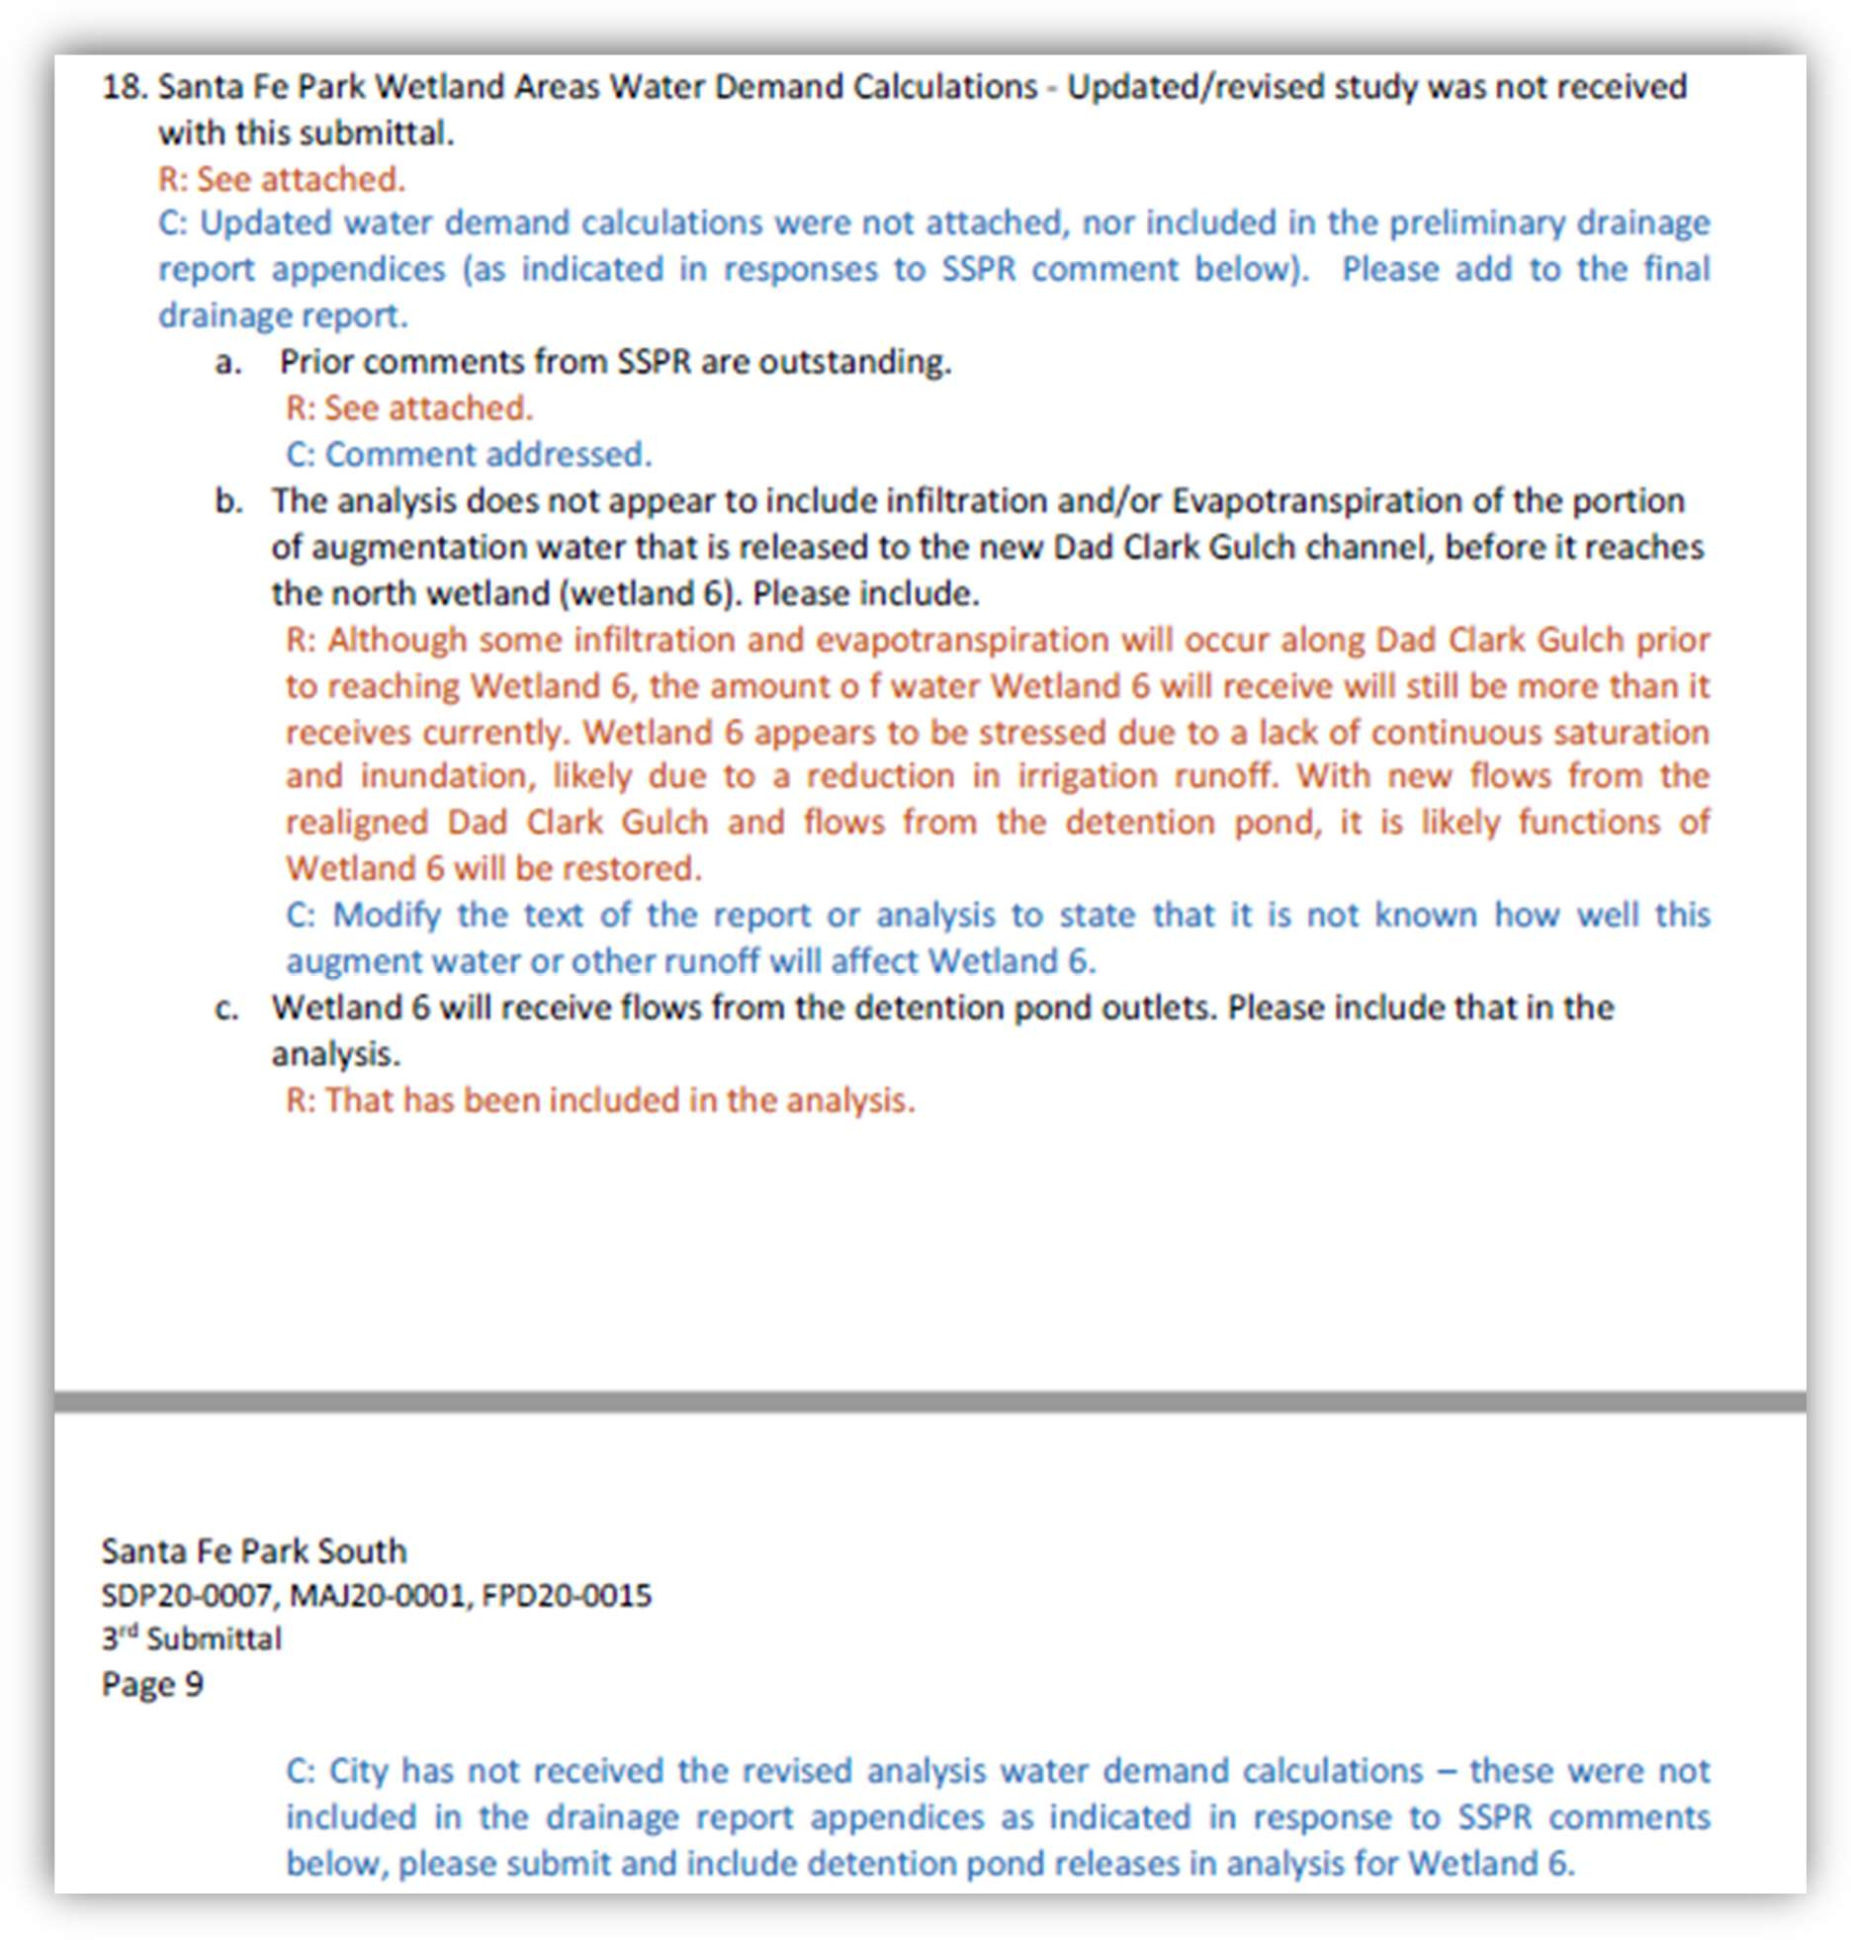
Response: The updated calculations have been provided by ERO. Since this information was obtained, the City of Englewood has indicated that all augment water flow will be directed to the revised channel based on their legal responsibilities.

- Submit updated HECRAS files to the city. R: HECRAS files have been submitted.
C: Electronic HECRAS 1D files have not been submitted. These are required when the HECRAS-1D floodplain model is updated/modified.
Response: HECRAS files will be provided.

- Appendix: The values calculated in the percent imperviousness calculations do not match those used in the detention pond and EDB calculations for all three ponds.
R: MHFD-Detention sheets and percent imperviousness has been updated.
C: Comment addressed.

- Appendix: The values shown as inlet flow in the rational calculations do not match the “known” flows in the inlet calculations (especially major basin A and D).
R: The inlet known flows are matching the Q (Intercept) flows calculated in the rational method.
C: Please confirm all flow from inlets is being accounted for the system (it appears SDIN40 and SDIN44 were not included).
Response: All inlet flows have been updated to rational method calculated flows.

- Appendix: Include a schematic map for each StormCAD run.
R: An overall map has been added to the appendix.
C: The plan the shows on the storm sewer schematic is very helpful and so a comprehensive view of the system. Please include the schematic from Storm CAD as the pipe numbers are not shown for reference and pipe run cannot be fully evaluated or revise the conduit table so the upstream and downstream manholes are listed (same format as used for Basin A& D).
Response: The maps have been revised to show labels for all pipes and structures.

- Appendix: Include “conduit table” for the storm lines in major basin A and D.
R: Table has been added.
C: Comment addressed.
- Appendix: The tables need to include what is being the loss coefficient is each junction, not just what the amount of loss is at each junction. This will require the standard table to be customized to include the loss coefficient.
R: The system is set to run for HEC 22 Third edition, this accounts for entrance loss, additional structure losses and exit loss. This is customized within the system so it is not calculated by hand for ever structure.
C: Confirm the manhole loss coefficients are in accordance with MHFD Chapter 7 Section 4.4 especially Table 7.11. The standard or HEC-22 energy may not replicate the same results. There are areas of abrupt manhole changes in direction. A greater change in HGLs would be expected. Headloss coefficients do not need to be hand calculated and can be entered as a Kj (manhole junction loss coefficient). Add a column to the headloss and headloss coefficient to the manhole table.
Response: The HEC 22 Third Edition (2009) is the method referenced in MHFD Chapter 7 Section 4.4. SewerGems calculates the coefficient for each structure as part of the simulation run based on inlet velocity, outlet pipe velocity, and pipe angle. Unfortunately, the coefficients are not provided in the output table, so a hand calculation would be required for each structure. We chose a limited number of structures and calculated the Kj and found them to be in conformance with the tabulated Kj values in MHFD criteria. We are satisfied that the provided stormsewer systems are in conformance with the requirements of the City of Littleton and good engineering practices as evidenced by the Professional Engineer Seal on the plans and report.

- Appendix: There are numerous discrepancies between the plans and the HGL calculations (see attached). An overall QA/QC needs to be done to ensure the plan and HGL calculations match.
R: HGLs have been updated and QC’d.
C: The CDs and HGL profiles do not match exactly but appear to be close. Please confirm
that the inverts, rims, slope and pipe length agree between the HGL calculations and the CDs.
Response: All storm profiles are updated to most recent calculated HGLs

- Appendix: The outfall into the pond need to correspond to the appropriate storm event for the outfall condition.
R: Tailwater has been updated to be the 5 year and 100-year water surface elevation in the ponds. Callouts have been added to the appendix for clarification.
C: Comment addressed.
- Appendix: Not all the reports and profiles are included in the HGL section for all pipe runs. R: All profiles have been added to the report.
C: Comment addressed.
- New comment
Comment: A levee condition needs to be corrected in the HECRAS cross sections included in the Appendix, an example shown below. There cannot be adjacent ground lower than the 100-yr water surface elevation on opposite side of a “levee.” Please correct the cross section and resultant WSE.
Response: This condition has been corrected and revised cross sections provided.

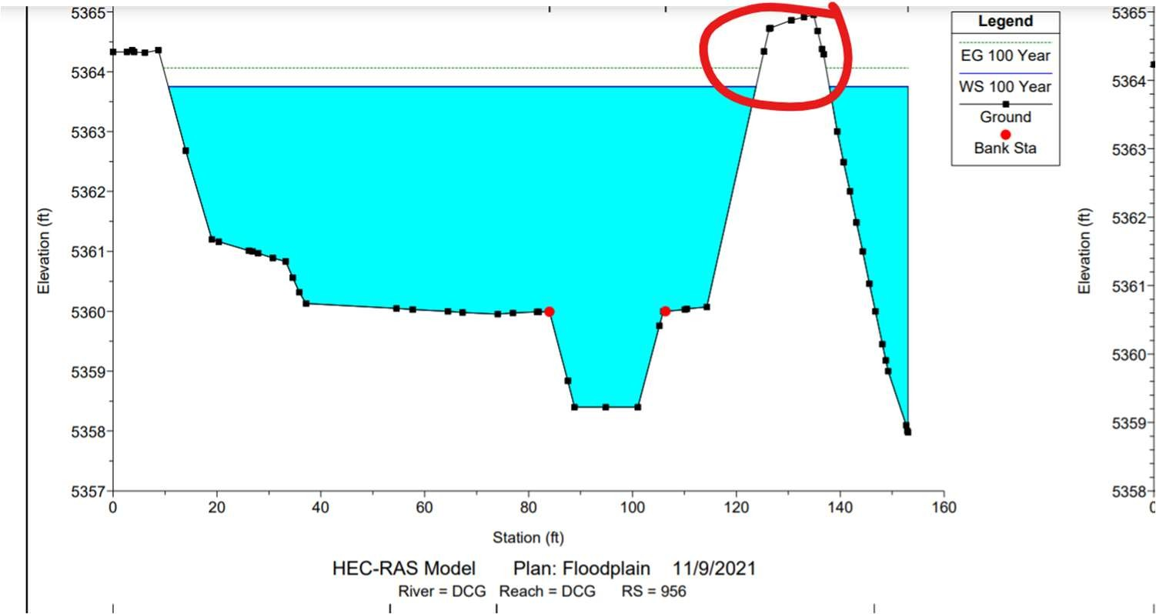
16.New Comment.
The provided HECRAS-2D results for this area shown above, which is currently a “gap” in the graphic/color results. Please show the results all the way through this area where this trail crossing is located. What flow event are these graphics for? Add explanation labels.
Response: The model was separated at this point due to the difficulty in adding culverts to 2d models . The results are valid for both upstream and downstream areas, and the 1d model clearly indicates the correct information for this area.

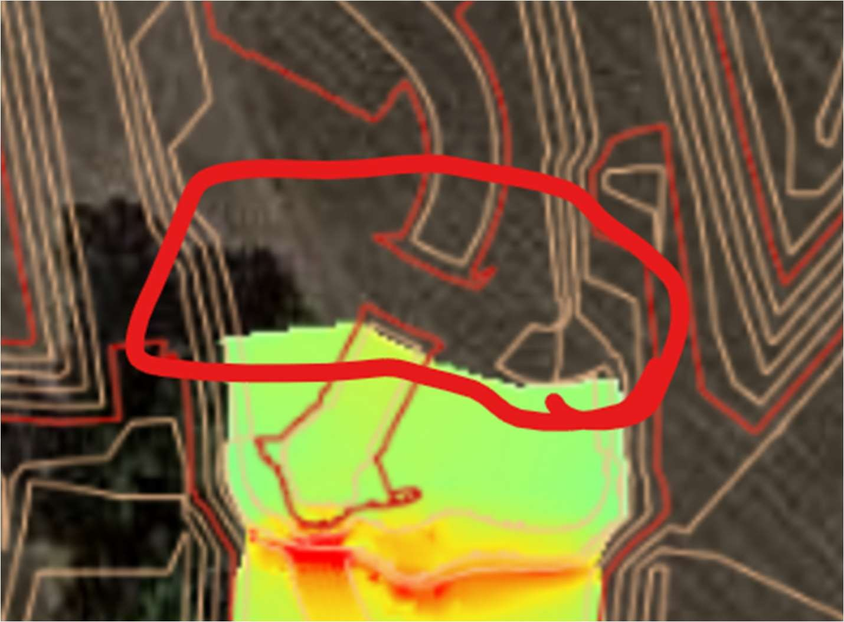

17. New comment.
Comment: The HECRAS model cross sections in the Final Drainage Report Appendix do not have river station s that relate to the plan view Floodplain Study Exhibit in the same Appendix. Please update the HECRAS river station IDs in either plan view on the exhibit, or in the model itself. The updated electronic HECRAS-1D files were not provided with the submittal; send these to the city. The conditionally approved Floodplain Development Permit certainly should be referenced in the report, but it is required that the model and exhibit are updated as design progresses and the most updated HECRAS results and floodplain study exhibit are in the Final Drainage Report. The past conditionally-approved permit materials do not necessarily need to be included (in fact ,it causes confusion) but can just be referenced in the text. Update the Appendix to include the most updated Exhibit showing cross section IDs that correlate to the updated HECRAS, and depicts the updated channel grading and layout and floodplain elevations, and include printouts of the pertinent HECRAS-1D results.
Response: The cross sections and exhibit have been updated to show the correct information. Model files will be provided with the next submittal.

18. New comment.
Comment: Is the proposed grading for this area adequately portrayed in the 2D mesh? It appears to show a closed contour and other grading isn’t evident. One would expect that with flow turning 90-degrees that you would see something more here. This is an area of the current design that needs more attention, see redlines and other comments contained herein.
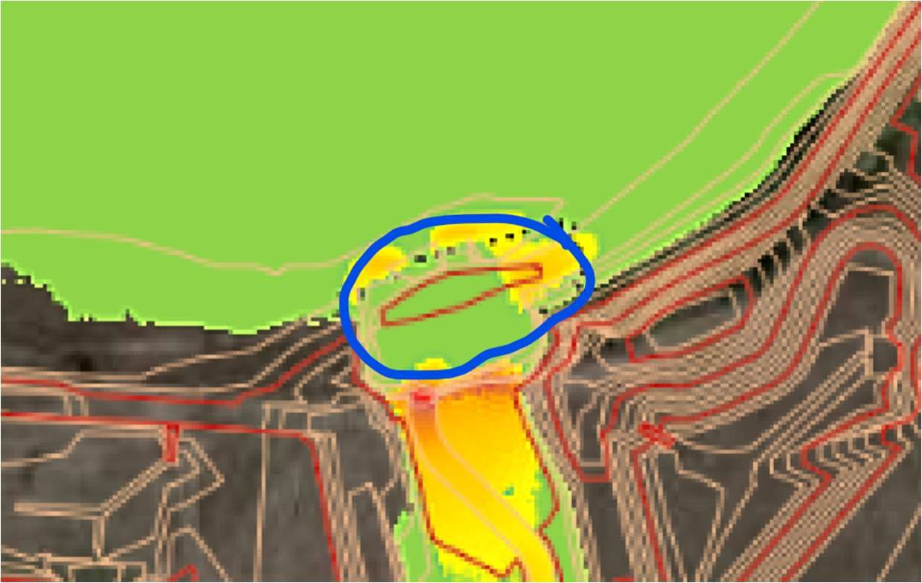

Response: This is the correct grading.
19. COMMENT brought forward from SDP review:

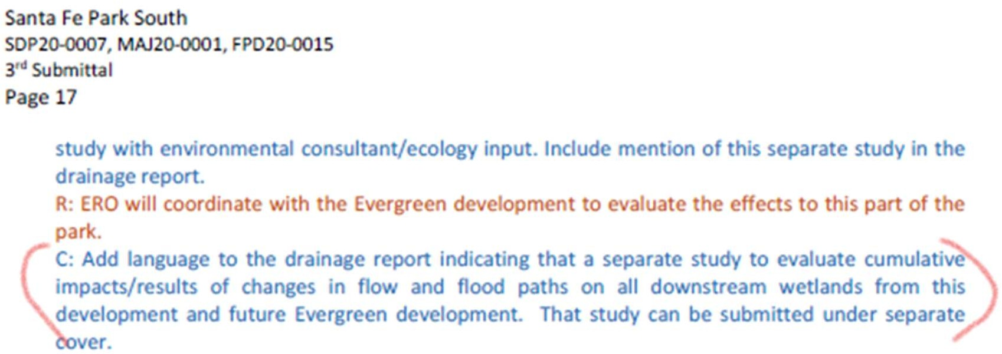
Response: This language will be added.

20. Comment: Refer to the separate Operations and Maintenance document in the final drainage report by title and date. Part of outstanding SDP comment.
Response: This reference is added

21. Comment: Refer to the separate Stormwatter Management Plan (SWMP document and plans) by title and date. Part of outstanding SDP comment.
Response: This reference is added

22. COMMENT BROUGHT FORWARD FROM SDP REVIEW:
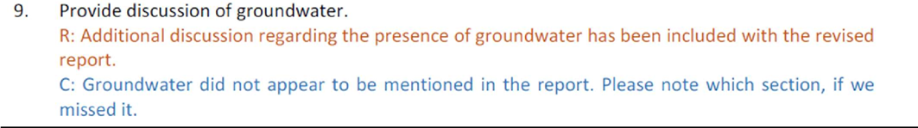
Response: This reference is added

Comment: Add discussion to the report that summarizes the groundwater data collected during the geotechnical report (which was included in report appendix), and general depth of groundwater copared to grading cuts, etc, to verify that groundwater will not be an issue for this development.
Response: This reference is added

23. Report: Comment: Add and engineer’s and owner’s certification page.
Response: This has been provided.

24. Section 2.0.D: Comment: The 100-year volume in the table does not match the calculations.
Response: The table has been revised to show current values.

25. Section 3.0.F.2: Comment: Sub-basin B54 is missing from Table 4.
Response: All sub-basins have been revised. Table updated.

26. Section 3.0.F.3: Comment: Basin D the text and Table 5 do not match the calculations in Appendix B.
Response: All tables have been revised to show the correct values.

27. Appendix B: Comment: Basin D the composite imperviousness calculations does not match the EDB calculations for Forebay 1 and 2.
Response: All tables have been revised to show the correct values.

Stormwater Management Plan (SWMP):
See comments on attached redlines. Comments below are not exhaustive of redlines.
    - Per Section 13.5 of the Littleton Drainage Criteria Manual, the Stormwater Management Plan shall include a narrative describing spill prevention methods with BMPs to prevent potential pollutant spills, contain potential spills to a designated area, and limit ability for storm runoff to reach potential pollutants.
R: Revised plans addressing the provided redlines are forthcoming separately.
C: Included in SWMP report. No further comment.
    - The SWMP shall include notes describing the inspection and maintenance of all BMPs. If the MHFD standard details do not provide this info, please prepare and include in the drawings.
R: Revised plans addressing the provided redlines are forthcoming separately.
C: Included in SWMP report and details in the SWMP plan set. No further comment.
    - Revise the Standard Notes with the latest standard notes from Section 13.5.3 of the Littleton Drainage Criteria Manual.
R: Revised plans addressing the provided redlines are forthcoming separately.
C: These were included in the SWMP Drawings; notes in the Report (Section IX) shall be revised.
Response: Report has been updated with notes included on SWMP Drawings.
    - Provide a detailed summary of work to be completed during each phase and include the sequence of specific items, if they impact the use and installation of certain BMPs. Also clarify which phases will overlap during construction. Also note when landscaping is anticipated to be completed, otherwise the seeding limits shall match the landscaping drawings.
R: Revised plans addressing the provided redlines are forthcoming separately.
C: Included in SWMP report. No further comment.
Response: Acknowledged
    - Specify seed mix, mulch type, and blanket types for the project. If there are multiple material types being used, specify where each is to be used. Ensure that the blanket design within Dad Clark Gulch is sufficient for the anticipated shear stresses.
R: Revised plans addressing the provided redlines are forthcoming separately.
C: Seed mixes are contained in the landscape plans and the SWMP plan details. There may be conflict between permanent seed mixes in SWMP details and the mixes in the landscaping plan that should be reviewed. No information on the type of mulch is provided in plans, details, or the SWMP report. Please specify. Blanket type on the plans is identified in the legend as straw- coconut. This is required to be biodegradable; please add a note on the plans.
Response: Seed mixes provided on SWMP match the MHFD standard details and will be coordinated with the landscaping plans. The standard detail for Mulch has been added to the details. Biodegradables been added to the legend for the ECB.
    - Several Permits from CDPHE may be applicable for this project. Please coordinate with CDPHE and clarify which permits will be obtained. Below are a few that may apply, however there may be others required. Copies of the permits shall be submitted for the City’s Grading Permit application.
      - Air Pollutant Emission Notice Construction Permit (APEN)
R: Revised plans addressing the provided redlines are forthcoming separately.
C: City will look for this with Grading Permit application.
Response: Acknowledged.
      - Stormwater Discharges Associated with Construction Activity
R: Revised plans addressing the provided redlines are forthcoming separately.
C: City will look for this with Grading Permit application.
Response: Acknowledged.
      - Construction Dewatering Discharge Permit
R: Revised plans addressing the provided redlines are forthcoming separately.
C: City will look for this with Grading Permit application.
Response: Acknowledged.
    - Comment: Provide a Stormwater Management Plan Checklist in the report. The checklist can be found on Table 2F of the Drainage Criteria Manual.
Response: Completed.

    - Comment: Provide the following signature blocks on the Cost Estimates.
Prepared by:

Developer’s Engineer (signature and stamp) Date Approved by:
Development Owner Date

Accepted by:

City Engineer Date
Response: Completed.
Supplemental Traffic Study
1. Comments were transmitted to the applicant on September 13, 2021. Until S Platte River Parkway is connected to Mineral Avenue or via Nichols Av, this development is limited to a single access point via W Phillips Av. This traffic study will be used to determine the number of dwelling units and/or commercial s.f. for which building permits can be issued prior to having access to a second access point. Related phasing will be reflected in the Subdivision Improvement Agreement.
R: Acknowledged.
C: The Supplemental Traffic Impact Study dated September 27, 2021 provides an acceptable amount of analysis and information for the development to move forward with the specific type and amount of land use identified in the report. However, any change in the type of land use from residential, the amount of dwelling units proposed, or the parcel location of the land use will require additional analysis and an update to the study prior to construction and occupancy.
Response: Acknowledged.
Landscape and Irrigation Construction Documents:
- Ensure that the landscaping plans have been coordinated with Utility providers and associated easements. Any modifications required by the Utility’s shall be coordinated on the SDP and Civil CD’s.
R: Noted.
C: Acknowledged.
- LF0.1: Water Gap fence must be added to hydraulic HECRAS model as blocked obstruction (assumed debris clogged). See comments above for Sheet 15.2.
R: The Water Gap Fence has been removed from the submittal.
C: The issue of the fence at the boundary of the property and South Platte Park at Dad Clark Gulch is still under discussion. This issue must be resolved before CD approval.
Response: The fence has been added to the floodplain model, which was been submitted to Littleton.
- Please see city comments on SDP20-0007 regarding landscape. All landscaping and vegetation in the channel must be approved by MHFD for maintenance eligibility.
R: Noted.
C: MHFD has submitted comments separately. No further comment here.
- Is irrigation planned for the Dad Clark Gulch channel area? If so, this irrigation system must be maintained by the Metro District even though otherwise the channel is maintained by City/MHFD.
R: Irrigation is planned for the Dad Clark Gulch channel area and will be maintained by the Metro District.
C: Noted. No further comment.
- Landscaping Plans shall show the AASHTO Sight Triangles. Landscaping within the triangles shall conform to LMC 10-4-1 (Rep).
Response: Acknowledged
Parcel Map Check Report:
1. All Lots, Tracts and ROW areas were accounted for and areas match the table on the Plat. No obvious errors in the closure precision were noticed. No further comments.
R: Acknowledged.
C: Comment addressed.
Title Commitment:
- The provided Title Commitment was reviewed against the ALTA survey that was provided with the last SDP submittal dated 5/9/19. See redline comments on the final plat for conflicts found during review of the Title Commitment and ALTA survey.
R: Redlines have been updated.
C: Comment addressed.
Attached Docs:
  - City of Littleton Civil CD Standard Notes
  - Overall Cover Sheet Redlines
  - Final Plat Redlines (Pages 1-52)
  - Roadway and Drainage drawings (Pages 1-98)
  - Stormwater Management Plan (Pages 1-34)

CITY OF LITTLETON CIVIL CD STANDARD NOTES
- These plans were prepared concurrently with a Site Development Plan Project and Subdivision (Case Nos. MAJ20-0001, SDP20-0007, FPD20-0015 and MAJ21-0001) applications to the City of Littleton. Any discrepancies between these drawings and the Recorded SDP or Final Plat shall be immediately brought to the attention of the City of Littleton. Any changes or deviations from these plans require approval from the City of Littleton and its partner agencies.
- City of Littleton Public Works Department, through acceptance of this document, assumes no responsibility for the completeness and/or accuracy of these documents. The Owner and Design Engineer understand that the responsibility for the engineering adequacy of the facilities depicted in these Civil CDs lies solely with the Professional Engineer registered in the State of Colorado whose stamp and signature is affixed to this document.
- All work within the Public Right of Way, to be dedicated to the City of Littleton, shall be constructed in accordance with the City of Englewood Engineering Design Standards. Infrastructure for other Utility Districts shall comply with their respective Standards.
- Prior to requesting TCO or CO of any structures or buildings, the City must receive and approve as-built drawings prepared and certified by a Licensed Engineer. As-built drawings shall include survey information of all drainage sewer, facilities, structures and channels, as well as all public improvements dedicated to the City of Littleton. Such improvements include roadway, sidewalks, trails, pedestrian ramps, bridges, signs, equipment, signals, etc. All roadways, sidewalks, and trails shall be built per plan and in accordance with adopted accessibility standards. A Stormwater Detention and Infiltration (SDI) spreadsheet shall be prepared by an Engineer certifying the as-built condition of the detention facilities.
- A post-construction study of Dad Clark Gulch and the proposed floodplain shall be prepared by an Engineer. The study shall be submitted to Colorado Water Conservation Board (CWCB) for approval and adoption.
- The Contractor is responsible for pulling all necessary permits, including but not Limited to permits from the City of Littleton, Colorado Department of Health and Environment, and CDOT.
- A City of Littleton Grading Permit is required for the project and is required prior to starting work. The Contractor is responsible for obtaining the permit and maintaining a current and active Stormwater Management Plan (SWMP). A SWMP has been prepared at the time of approving the Civil CDs. Any changes to the approved plan shall be tracked on-site.
- Prior to starting work, the Contractor shall have a Preconstruction meeting with Littleton Public Works.

- All required written approvals and copies of executed easements from the adjacent property owner(s), as determined by the city, shall be provided to the City prior to City approval of the construction plans and drainage report and prior to issuance of a building or grading permit for this project. The property owner hereby acknowledges that modifications to the approved and recorded site development plan, the drainage report, and the construction plans may be necessary if these offsite agreements and easements cannot be obtained.
- The Contractor is responsible for scheduling necessary inspections. All Public Works inspections shall be scheduled 24hrs in advance of the needed inspection. All materials and workmanship inspected by Public Works shall conform to the City’s Standards. The City, or its designee, has the right to accept or reject any work that does not conform.
- The Contractor shall provide all signs, barricades, flagmen, lights, or other devices necessary for safe construction traffic control in accordance with the current edition of the MUTCD and as modified by the Colorado Supplement to the MUTCD. A construction traffic control plan shall be submitted to and approved by Public Works prior to the issuance of any Right of Way Permits for work within City Right-of-Way. The Contractor shall obtain necessary permits for work within CDOT Right-of-Way.
- Comment: The Contractor is responsible for locating all existing utilities prior to excavation. All Utility Locating requests shall be submitted through the Colorado 811 system.
- All Landscaping, signage, and improvements shall maintain sight distance triangles to be free of visual obstructions, between a height of two and one half feet and ten feet. The sight distance triangle shall be designed to AASHTO standards, per LMC 10-1-3.9.C.
- The Contractor is responsible for maintaining a clean and organized site in accordance with approved Stormwater Management Plan. Contractor is also responsible for obtaining and maintaining necessary permits associated with Earthwork disturbance.

MHFD, Jon Villines, P.W., CFM / jvillines@mhfd.org
MHFD staff have the following comments to offer:
  - Comment: It is our understanding that the final plat will not be approved until a final determination of the floodplain has been made, which will include completion of the channel design.
Response: Acknowledged

  - Comment: The concern for the downstream tie-in condition remains an outstanding comment. Creating a near perpendicular turn in flow (and possibly within the length of the hydraulic jump of drop #4) can result in more erosive conditions than expected by modeled velocity/shear stress. Further analysis and possibly additional armoring are needed. Alternatively (and preferably), a less abrupt transition can be created in the alignment.
Response: A 2D model was developed and is provided with this submittal to demonstrate flow conditions downstream of the development. The 2D model indicates low shear throughout the area.

  - Comment: Regarding the new alignment of Dad Clark Gulch downstream of the development, we would like to see further analysis to understand the risk in creating about 2000’ of new stream from an existing drainage path. Since the last submittal, you provided a 2D HEC-RAS model, which will likely be helpful in this analysis. To that general goal of understanding new risk, here are some specific requests that should help support the larger concern:
    - Comment: What is the hydrology of the new reach? Primarily we are interested in learning about the regular flows (base flow up to minor flooding) that we know will occur in the future (as opposed to regulatory flood flows, which may be mitigated by the reservoir). The relevant contributing areas include the flows from Dad Clark Gulch project reach, the contributing development (basins A, B, and D), and any contributing area between the development and confluence with Jackass Gulch/SPR.

    - Comment: To what is extent is there a channel downstream of the development? What is that channel’s shape and slope? What flow fills the channel and how often? What are the hydraulic conditions under flow contained in the channel? Is there suitable vegetation to withstand the modeled shear stress? The 2D model may be helpful for answering some of these questions.

    - Comment: What are the flow conditions in the major flood? What are the hydraulics in the channel and in the new floodplain? Is there a risk of a new channel forming more directly west?
Response: Information regarding the channel design and downstream areas has been provided in the revised report. Effective flow values have been provided, calculations and methods are described. The channel upstream of the development is the existing channel and it was included in the floodplain permit model from the original FHAD Hec-2 model. 2D model was developed for the channel and downstream areas to demonstrate flows, depths, and shear stresses. The models are provided with the most recent submittal.
Channel vegetation plan has been developed by ERO and has been implemented into the CDs.

  - We have the following comments to offer on the drainage report:
    - Comment: Please provide calculations for determination of the effective discharge. It would also be helpful to add a table in the report summarizing the design flows (base flow, effective discharge, and minor and major floods).
Response: SF form showing calculations for flows from area between dam overflow and site is provided in Drainage Report Appendix.

    - Comment: Please provide calculations or other documentation supporting channel design (cross section and planform).
Response: Summary of calculations is provided in report and Appendix.

    - Comment: Please provide design information on revegetation and erosion control.
Response: Channel vegetation plan has been developed by ERO and has been implemented into the CDs.

    - Comment: We are uncertain if riprap is needed to line the channel and hopeful that it will not be necessary. In general, one objective of using large drop structures is to create a flat enough bed slope between structures that riprap lining is not needed within the channel. If the threshold criteria of Table 8-3 in the Open Channels chapter are met, we recommend removing the riprap lining (except that required around drop structures). Additionally, given the nearly uniform condition of the channel between drop structures, we would recommend using Manning’s equation to evaluate hydraulic conditions for comparison to Table 8-3 (this approach should be simpler than evaluating across numerous cross sections in the 1D model).
Response: Channel riprap has been modified to areas around drop structures and to provide riffles in channel

    - Comment: Please provide additional information for the trail crossing. Is protection needed on either side of the trail? Is outlet protection necessary? Are there any interactions between the hydraulics of the upstream drop structure and the trail? Note, the HEC-RAS 1D model shows different culverts than the HHFD-Culvert Sheet and the CDs.
Response: The trail crossing details and model have been revised to reflect a crossing with headwalls.

    - We have the following comments on the RAS 1D and 2D models. We understand these models were submitted separately to the City of Littleton. MHFD would like to review the models at the next submittal and can request them from Littleton at the time.
- For the 1D model:
- Comment: Please include a plan view showing location and station numbers of cross sections.
Response: Provided

- Comment: For sections showing split flow (e.g. RS 958), is the flow outside of the channel within the pond? These should be trimmed out of the cross section or shown as ineffective flow area.
Response: Model has been corrected to remove split flow areas.

- Comment: Roughness values for sculpted concrete should be included at relevant sections.
Response: Noted

- For the 2D model:
  - Comment: We appreciate the addition of a 2D model. We expect it will be particularly helpful in understanding flow conditions downstream of the project reach between the development and the South Platte River.

  - Comment: Please provide further explanation of selection of roughness values and perhaps a roughness map if different values are ultimately selected.
Response: Roughness values selected are the same as recommended in the MHFD criteria for the 1D model. Most recent documentation for 2D models indicates that typical Chow values should be used therefore we selected the shear values from the criteria.

  - Comment: Please clarify what flows are being shown in output maps. It may make sense to provide maps for different events.
Response: Model provided to demonstrate flow progression.

  - Comment: For the output maps, values are hard to determine from selected symbology. Please update.
Response: Noted.
    - Comment: In the appendix, the design of the large drop structures assumes the simplified design procedure. This determination needs to be reviewed since the unit discharge value should be taken for the discharge over the bottom of the bankfull channel (w+12’), where the unit discharge is highest. This discharge may exceed 35 cfs/ft, in which case the full analysis will be required. Also, per criteria, drop structures located near a bend should not follow the simplified procedure (pertains to drop #4)
Response: A 2D model was provided to MHFD to show the detailed shear stresses were within tolerance.

- We have the following comments to offer on the construction drawings:
- Comment: We submitted redlines on the CD’s with a previous submittal. Those comments remain outstanding.
Response: Previous redlines have been obtained and responses provided

- Comment: Is there a reason for the steep slope from approximately station 21+50 to 24+00? It seems the design slope should be 0.2% to be consistent with other sections of the reach.
Response: This channel section has been revised using step pools to achieve uniform 0.2% slope.

- Comment: At the trail crossing, how will the 4:1 slope be achieved off of the concrete box culverts?
Response: The trail crossing has been modified to use headwalls.

- Comment: For the drop structures, there are inconsistencies across details (plan view, sections) between location of edge wall versus cutoff wall. Please review and make consistent.
Response: Drop structure detail comments have been addressed

- Comment: Please show weep drain locations in plan view.
Response: Weep drain locations indicated.

- Comment: In areas outside of the channel bottom, it is better to use soil riprap (instead of void-filled) because it provides a better growing medium for revegetation (it is also cheaper).
Response: Noted

- Comment: It may be helpful on the plans to consolidate the details and notes that apply to all drop structures on a single page. It will allow more paper space for details specific to each structure.
Response: Acknowledged.

- Comment: The location/extent of the notch wall varies between structures. Please update or provide explanation in the design report.
Response: The notch wall has been placed at the flow line.

CITY OF ENGLEWOOD

General
- Comment: Response to City comments from 11/3/21 must be provided and appropriate changes made to plans and documents.
Response: Comments from 11-3-21 have been provided and responses are given.

- Comment: Responses provided on Englewood comments did not include responses to City comments on Landscape CDs or Sanitary Sewer Construction Plans.
Response: Acknowledged.

- Comment: Existing piped City Ditch leading to the pump station is not shown in plan sets. Location of existing City Ditch must be verified prior to the approval of construction plans to ensure there are no conflicts with proposed utilities or infrastructure.
Response: This pipe has been flagged by Englewood and surveyed by Westwood. It is now shown on the plans and labeled accordingly.

- Comment: Confirm the Englewood 30-inch Waterline Standard Notes and Englewood City Ditch Standard Notes have been read and incorporated into all plan sets.
Response: Acknowledged.

- Comment: Existing City Ditch piped section appears to be mislabeled as an “EXISTING 15” WL” in multiple plan sets. City Ditch label and size must be corrected. City Ditch must be located prior to the approval of construction plans to ensure there is no conflict with the proposed waterline crossing.
Response: It is now labeled as EXISTING 48” PIPED CITY DITCH.

- Comment: Proposed Xcel Energy Regulator Station is shown on top of the existing piped City Ditch. No infrastructure can be built within the existing City Ditch easement or on top of City Ditch.
Response: Xcel Regulator Station has been moved out of the easement.

- Comment: A note in multiple plan sets indicates that “separation between water and storm, and storm & sanitary sewer may be less than 10’ if pipes are installed in separate trenches.” Note does not apply to Englewood infrastructure. There must be 10’ minimum horizontal separation between Englewood infrastructure and sanitary lines. Where lines cross, the sanitary mains must be placed below the water lines.
Response: We have 10’ clear from the proposed Englewood drain line, that note on our cross section only applies to the infrastructure within our private street section when storm sewer is present.

- Comment: Operations staff is currently reviewing plans. Additional feedback may be provided after Operations review.
Response: Acknowledged.

Responses to Westwood Comments
- Add City Ditch manhole symbol to legend.
Westwood Response: Storm drain manhole is already included in the legend.
Response: Completed, updated the manholes to say “RW” for raw water.

- In profile on Sheet 2, there doesn’t appear to be sufficient separation between 16” water line crossing at 30” drain line. Ensure there is 18” of vertical separation.
Westwood Response: This is an existing 16" watermain crossing. It has not been potholed and just shown graphically. Because there is an existing crossing of this 16" with the existing 31" drain line, we do not anticipate a pipe conflict here.
Englewood Response: It is unknown that the existing crossing meets the required separation. Developer/contractor is responsible for ensuring there is 18” of separation.
Response: Acknowledged. A note has been added to the plan.

- On Sheet 6, new infrastructure is proposed within the City of Englewood’s easement for the 30’ drain line. City requires access to water line for maintenance and repairs. Westwood Westwood Response: Access to the Englewood easement may be made from South Platte River Parkway, Chestnut Avenue or the ten foot concrete maintenance access path west of Chestnut Avenue. Access to the Englewood easement within Lots 261 and 262 shall be coordinated with the multi-family developers, as they create their site plan.
Englewood Response: There are structures shown in the City’s easement for the 30” drain line. Also confirm Englewood will have access to drain line in Lots 261 and 262 (Tract F) prior to and during design and construction of multi-family development.
Response: As discussed during virtual meetings, there is a shallow water quality pond and ten foot concrete access path proposed within Englewood’s easement. As understood, those are acceptable encroachments. Access to the drain line easement within the multi-family development shall be coordinated with the multi-family development team, as their entitlement application materials are submitted to the jurisdictional agencies.

- Ensure adequate cover over City Ditch for all roadway crossings.
Westwood Response: A minimum of 2” is provided for the entire piped section.
Englewood Response: Demonstrate the pipe can withstand all anticipated surface loadings, particularly under the roadway crossing.
Response: To clarify we have a minimum of 2 feet of coverage in the grass section and 4.5 feet of coverage under West Phillips Road which meets AASHTO standards. Please see their specification below.

In accordance with Section 12.6.6 of the AASHTO LRFD Bridge Design Specifications, 9th Edition, the minimum cover for a rigid pipe such as reinforced concrete pipe (RCP) is the greater of 1/8 the outside diameter of the pipe or 12 inches, when there is only soil or flexible pavement above it. When a rigid pavement is over the concrete pipe, the minimum cover is 9 inches from the bottom of the pavement.

- On sheet 3.8, comment for retaining wall next to the Englewood pump station indicates it will be removed. City has no plans to remove retaining wall.
Westwood Response: Retaining wall shall remain.
Englewood Response: Littleton Roadway and Drainage plans and Sanitary Sewer Construction plans still indicate the retaining wall will be removed.
Response: We’ve reviewed the various plan sets for this project site and ensured the consistency throughout that the wall will remain.

Comments to Questions from Westwood
1.Comment: Configuration of the drain line near the drainage swale, maintenance road, and associated slopes is acceptable.
Response: Acknowledged.

2.Comment: Based on analysis from Westwood, a 48” pipe can hold 43.7 CFS. City Ditch pipe size may be reduced to 48”. However, it may need to be designed for a pressurized condition.
Response: The pipe has been reduced to a 48 inch, as directed by Englewood.

3.Comment: The City will be providing the developer with CAD drawings for the two proposed pump station configurations.
Response: Acknowledged. At the time of this Civil CD resubmittal, we are awaiting these CAD files.

4.Comment: Per Westwood’s request, the City will review the SWMP. Please provide the plan for City review.
Response: The SWMP should be on Littletons ETrakit portal and Englewood has accessibility to this portal. This SWMP has been updated and included with this resubmittal.

5.Comment: The City will be meeting with the developer on 1/24/22 to discuss the proposed water augment wye.
Response: Discussions were had and was told that the entire augment water needs to flow into proposed Dad Clark Gulch and flow to the north. WYE must be removed.

Englewood Infrastructure Improvements:
- Comment: Sheet 10.3 Profile: Location of existing drain line must be verified prior to the approval of construction plans.
Response: This line has been potholed and surveyed based on field flagging, pothole data has been added to the plan set.

- Comment: Ensure proper cathodic protection on the proposed drain line and connections to existing drain line as necessary.
Response: A note has been added that states “contractor to comply with capital projects construction standards section 33 05 19 – ductile-iron pipe and fittings for water transmission and distribution”

- Comment: Sheet 10.3: Confirm existing water manholes will not conflict with proposed 30” drain line.
Response: The existing water manholes are part of the interconnect with the Centennial Water and Sanitation District 48 inch. This interconnect will be modified with the proposed 30 inch drain line. Please refer to the detail on the plans.

- Comment: Manholes and/or valves may need to be placed on the Englewood drain line, pending plan review from Operations staff.
Response: Acknowledged.

- Comment: Label ownership of existing water manholes. Will manholes be abandoned/removed?
Response: Please refer to the response to comment #3 above.

- Comment: City Ditch is labeled as a “60” SD.” City Ditch is a raw water conveyance pipeline. Remove all references to drainage or stormwater.
Response: Relabeled 60" SD to 48" RW and the proposed swale immediately north of the northern boundary to “proposed raw water conveyance ditch”.

- Comment: City Ditch will be operating continuously from April 1 - October 31. Grass may not be suitable in this location. The city Ditch swale shall be designed to minimize maintenance requirements.
Response: Steve Simon agreed that native grass is suitable for this area.

- Comment: Ensure there is a smooth connection between the City Ditch pipe and flared end section on the north side of the property. Ensure there is no excessive erosion.
Response: The pipe and FES have been updated to show a smooth transition from FES to raw water conveyance ditch.

- Comment: Englewood Infrastructure Improvements indicates “EXISTING DIRT ROAD TO RECONFIGURED” and Denver Water Plan Set indicates “EXISTING DIRT ROAD TO REMAIN FOR PUMP HOUSE ACCESS.” Please confirm road will remain for Englewood access (passenger vehicles, equipment, and cranes).
Response: Portions of this existing road will remain and portions will be removed & replaced with this plan set. The Multi Family development may further modify this alignment.

- Comment: Explain how Englewood will access the relocated City Ditch. How will City staff, vehicles, and equipment access the line? Will the proposed retaining wall impede access?
Response: There's a 25' easement proposed for access, sloped at 2%. The retaining wall is 10' outside the easement.

- Comment: Per Englewood 30-Inch Waterline Standards Notes, the existing 31” drain line must “remain active, in place, and not impacted, while the new 30” waterline is being constructed.”
Response: Acknowledged. That is the intent, since the new line is shown offset from the existing alignment.

- Comment: The City would like to preserve the opportunity to install a flow measurement device in the realigned portion of City Ditch. City would cover the additional design and construction for the installation.
Response: Acknowledged. Englewood to inform the development team if the flow device is not intended to be placed within the proposed easement.

Final Plat:
1. Comment: City Ditch easement is labeled a “Drainage and Utility Easement.” Remove all references to drainage or stormwater.
Response: Plat labels have been revised to refer to the realigned City Ditch to UTILITY EASEMENT.

2. Comment: Future development in Tracts B and C must not impede Englewood’s access to City Ditch and easement.
Response: Acknowledged. Entitlement applications for the mixed use parcels will be routed to Englewood, as they are a referral agency. The development of these mixed use parcels is a separate application process.

3. Comment: Easements must be approved by Englewood City Council and Water and Sewer Board.
Response: Acknowledged.

4. Comment: Page 19: Pump station appears to be in proposed floodplain and is not shown in the existing floodplain. Pump station cannot be in a floodplain.
Response: The pump station is not in the proposed floodplain.

5. Comment: Page 20: Access easement on maintenance path should also be granted to Englewood.
Response: Please see the revised plat annotation, which provides access to Englewood.

6. Comment: Page 24: Englewood must maintain access to old pump station building, drain line outlet, and related infrastructure on the western edge of the property. Show easements in plat.
Response: Please see the revised plat annotation, which provides access to Englewood, as well as note 3 under the Tract Table regarding Tract G.

7. Comment: An easement must be provided along the access road to the pump station if the road is not in public ROW.
Response: A proposed easement will cover the existing dirt access road and be dedicated to Englewood by separate document.

8. Comment: Proposed easement for the City Ditch swale is outside of the project boundary and appears to be in Evergreen Zoning A-1. Developer is responsible for ensuring permanent easement is granted to Englewood and working with Evergreen developers to obtain easement(s) if necessary.
Response: Acknowledged. The application is actively working with Evergreen to secure this offsite easement.

Landscape CDs:
- Comment: Plans shows trees and shrubs overlapping with 25’ City Ditch easement. No trees/plantings are permitted within easements.
Response: Trees are not proposed in the easement, but shrubs are, as discussed with Englewood previously.

Denver Water Plan Set:
- Comment: Proposed water main and water stub for future Parcel J appears to overlap with 30” waterline easement. No infrastructure can be built within Englewood easements.
Response: A proposed 8 inch domestic water is located within the Englewood easement, as the Englewood easement is not exclusive. Adequate separate has been provided between the proposed 30 inch drain line and the 8 inch domestic watermain.
- Comment: Englewood 30” drain line does not appear to be shown in this plan set. There are callouts for the drain line where the drain line is not shown. Callouts indicate the line is PVC. Drain line shall be DIP.
Response: Denver Water requires a Denver Water Only Plan, which does not show Englewood's drain line. Labels referring to the drain line have been removed from those DW Only sheets.

- Comment: Sheet 11.7: Proposed City Ditch easement is labeled as “PROPOSED SANTA FE DRIVE ROW.” City Ditch shall have a dedicated 25’ easement.
Response: The annotation is correct as it relates to the proposed ROW for Santa Fe Drive. The proposed City Ditch easement is outside the proposed ROW. It is labeled 25' UTILITY EASEMENT, as requested in the most recent SDP comments from Englewood.

- Comment: Sheet 12.5: Key map does not match location shown in plans.
Response: This has been revised.

- Comment: Sheet 12.5: City Ditch is mislabeled as a storm drain.
Response: The 60" SD label has been revised to be 48" RW.

Littleton Roadway and Drainage Construction Plans:
- Comment: Proposed culvert and storm outfall near Englewood’s drain line and western edge of property are not shown in Littleton Roadway and Drainage plan set. They are shown in the Santa Fe Park South Parcel J drawing that was emailed separately to Englewood. Update plans for consistency and to show proposed infrastructure near the drain line.
Response: The water quality swale is proposed for Parcel J, which is why it is not included in the Roadway & Drainage plan set. At this time, it is only included in the Parcel J SDP.

Sanitary Sewer Construction Plans:
- Comment: Cross section J-J does not appear to be in plan set.
Response: J-J has been added to this plan set.

Final Drainage Report:
- Comment: Page 9 indicates that City Ditch “will sheet flow until the Platte River.” City Ditch must not be routed to the South Platte River.
Response: Narrative has been revised.

- Comment: Remove all references to City Ditch as historic designation. It has no such designation.
Response: Designation has been removed.

LITTLETON COMMUNITY DEVELOPMENT, Michael Sutherland, AICP, msutherland@littletongov.org
Comment: Review comments and Additional Review Comments
** CDOT returned comments from the first review in early January, but has not yet commented on the second review. Please provide responses to the first review comments with the 3rd submittal.
Response: Responses to CDOT’s comments are included herein.

Comment: Comments may be found as attachments in eTRAKiT under project number MAJ21-0001.
Response:
Planning and Neighborhood Services – Mike Sutherland
- Comment: The blue line comments provided by Elizabeth Kay Marchetti on 9/29/2021 have been sufficiently addressed with the following general notes to be addressed:
Response: Acknowledged.

  - Comment: Please increase the font size of the sheet number (example SHEET 1 OF 52) to make sure when we record the plans, it is easy to reference the sheet numbers and verify that all sheets are present.
Response: Completed.

  - Comment: In providing dimension of off-site easements, responses are noted that the easements are not a part of this plat. However, some of these easements are still shown (see sheet 6, for example). If the easement must be shown on this plat, it must include dimensions. Presumably, easements shown on city property that are necessary for the development of this subdivision must be shown.
Response: Easements shown to be dedicated by separate document are not dimensioned, as discussed with Littleton, so there are no potential discrepancies between the plat and the recorded separate instruments.

  - Comment: Even given the proper dedication language provided, please show the term “public right-of-way” for each dedicated city street.
Response: As discussed with Elizabeth Kay Marchetti “public” has not been added to right-of-way designations.

  - Comment: The number of sheets and match lines is extraordinary for this size subdivision. Please investigate whether the initial pages could have a smaller scale (and thus a reduced number of sheets) as opposed to the detail sheets.
Response: As discussed, the sheet count has been reduced.

  - Comment: Assign Tract I a lot number since it will require a building permit to reconstruct the barn building. Any tract that is anticipated to have a building located within it must be converted to a lot.
Response: Completed. The mixed use parcels are now lots as well.

- Comment: [Previous Comment] Any unique information on sheets twenty-seven (27) through fifty- one (51) should be included on the appropriate page from two (2) through twenty-six (26). There doesn’t appear to be a need for a 51-page plan set.
Response: Acknowledged. As discussed, annotation has been consolidated and the overall sheet count reduced.

Comment: Applicant response: Acknowledged, the duplicate sheets were to display the information that’ now being asked to be removed per comment #6.
Response: Acknowledged. As discussed, annotation has been consolidated and the overall sheet count reduced.

Comment: Although it is understood that the detail sheets provide easement dimensions and information that may not be legible at the scale of sheets 4 through 27, but if information is being removed per comment 6, it is still unclear if sheets 27 through 52 are necessary.
Response: Acknowledged. As discussed, annotation has been consolidated and the overall sheet count reduced.

Comment: None of these comments are intended to approve or provide consent to any aspect of the plans that is not in strict conformance with the Littleton City Code. Please revise and resubmit all relevant documents along with a written response to the points raised in this letter through the eTrakit system. Remember to send me an email letting me know your upload is done so that I can do a completeness check.
Response: Acknowledged.

DENVER WATER, watersalesplanreview@denverwater.rg
Section 1
A.Project Requirement
Water Service
- Comment: Main must be 10’ from row/easement. Also on private drives with domestic services, confirm if the District is okay with the distance between the water line and easement boundary. Verify with the District if under 10’ is acceptable and have them submit a variance. Please note that each individual distance under 10’ must be called out on the variance, including an exhibit showing each instance. In addition to call out all distances from main to row/easement on the plan.
Response: A variance letter has been written to allow less than 10’ from easement lines.

- Comment: Hydrants must have 5’ of clearance on all sides from center nut. Either move the hydrant or provide the 5’ minimum or submit a variance completed by the District.
Response: Acknowledged, moved the hydrant at the south west corner of Canyon Ave and Irving Street to have 5’ clearance.

- Comment: Sheet 11.2, is the District ok with this hydrant only being 5’ away from this house foundation? Location is at the intersection of Lowell St and Lowell Ct. Also, the easement alignment is off at this location.
Response: Moved the hydrant closer to the back of sidewalk, now have a 7’ clearance from foundation.

- Comment: DW plan sheet 11.4. Missing the easement est of Chestnut Ave & S Platte River Pkwy, will this be completed with this plan?
Response: Easement was just not labeled, a label and dimension has been added, we will be constructing this water line in this phase.

- Comment: Plan sheet 11.6, location east of Irving St. Do the retaining wall & other crossings shown encroach into the 50’ easement? (1) Does the District approve? (2) If yes, it must be written into ‘special provisions’ section of the easement and approved by the District.
Response: The easement package was submitted to SWMWSD on January 11, 2022. The applicant recognizes that the walls will need to be included in the special provisions.

- Comment: Plan sheet 11.6, missing 50’easement.
Response: Easement has been added.

- Comment: Plan sheet 11.7, 1) clearly label the existing Santa Fe Dr. ROW, call out dimensions. 2) submit documents proposing 30’ ROW (per CDOT) and comment repeats on sheet 11.8.
Response: The existing Santa Fe ROW is clearly shown and we call out the dimensions that we’re proposing ROW.

- Comment: Submit easements as shown on sheet 11.9, for the 50’SWMWSD. Also, the gate will need to be written into ‘special provisions’ section of the easement document and expressly approved by the District Exhibit B plan and profile needed to show water line in relation to gate and other utilities.
Response: The easement package was submitted to SWMWSD on January 11, 2022. The applicant recognizes that the gates will need to be included in the special provisions. The gates are shown and labeled on the overall utility sheets and water only sheets within the Water CDs. Since the gates are over eight-inch watermains, and eight-inch watermains are not profiled, there is no profile to add the referenced gates to.

Comment: Also important to note: Multiple taps on the same side of the main shall be a minimum of 5 feet apart, measured longitudinally along the centerline of the main. Stagger multiple taps on opposite sides of the main by a minimum of 2 ½ feet, measured longitudinally along the centerline of the main. Do not make taps within 3 feet of any main line pipe fitting. Please ensure this annotated throughout plan set.
Response: All water service taps meet these criteria.

General
Comment: This document is intended to help guide developers on issues that are more likely to impact project success. All developments are required to have an approved water plan in accordance with Denver Water Operating Rules and Engineering Standards and this is not intended as a substitute. Details on Denver Water’s Plan Review Process are located at: https://wwwdenverwater.org/contractors/construction-information/plan-reviews
Response: Acknowledged.

Comments from April 14th on Plat:

Comment: Add this not to the Cover Page: “A Utility and Roadway Purposes Easement is hereby conveyed to the City of Littleton for purposes to construct, reconstruct, operate, remove, repair utilities and maintain traffic signalization, signage, and all reasonable and necessary appurtenances, and for the purpose of clearing, laying, constructing, and reconstructing sidewalk, trails, multi-use paths, curb and gutter, handicap ramps, roadway pavement and related appurtenances, on, through, and under the easement shown on this Plat. The Property Owner, its heirs, successors and assigns, agrees that it shall not, in any manner, prevent said improvements or interfere with the above stated objects, nor disturb, injure or molest the clearing, laying, construction, reconstruction, operation, removal or repair of same.
Response: Note has been added to the cover sheet.

Comment: Note 12 on the first sheet should be updated to reference LMC 10-7-1.5(E)4.

Response: Note has been fixed on the cover sheet.

Thank you for providing these comments. If you have any questions regarding our application, please do not hesitate to contact me at 720.249.3539.

Sincerely,
Westwood Professional Services, Inc.


Melinda E. Lundquist, PE
Director, Private Development Colorado

