FROM: Matt Knight, Development Services Manager
Carolyn Roan, Water Resources Manager
Gary Welp, Development Review Engineer
Aaron Heumann, Transportation Engineering Manager

DATE: October 11, 2022

SUBJECT: 7875 S Santa Fe Dr
Santa Fe Park South
Final Plat (MAJ21-0001) – 3rd Submittal
Civil Construction Documents (MAJ21-0001) – 3rd Submittal

Public Works has reviewed the following documents for the above-referenced project:

- Roadway & Drainage Construction Plans, dated 04/06/2022
- Final Plat, dated 06/08/2022
- SDP, dated 08/22/2022
- Pedestrian Route Plan, dated 09/15/2020
- CDOT Access Permit Application, (file) dated 9/22/2021
- CDOT Plan Set, dated 08/2022
- Final Drainage Report, dated 04/2022
- Stormwater Management Plan, dated 04/2022
- Stormwater Management Plan Report, dated 04/08/2022
- O & M Manual, dated 04/2022
- Dad Clark Gulch Bridge Scour Analysis, dated 06/20222
- Supplemental Traffic Study, Dated 9/27/2021
- Traffic Signal Construction Plans, dated 02/14/2022
- SIA, undated
- Other Documents submitted, referenced and/or reviewed by other agencies:
  - Denver Water Plan Set Plans, dated 08/17/2022
  - Sanitary Sewer Construction Plans, dated 01/12/2022
  - Englewood Infrastructure Plans, dated 08/17/2022
  - Superstructure Calculations Santa Fe South Vehicular Truss, dated 06/30/2022
  - Superstructure Santa Fe South Vehicular Truss Plans, dated 06/30/2022
  - Centennial Water and Sanitation District Plans, dated 08/2022
  - Review Comments and Revised Calculations Dad Clark Bridge, dated 07/27/2022
  - Santa Fe Bridge Abutments and Foundation Plans, dated 07/27/2022

General Comments:

- Comments on the SDP and Preliminary Plat (PPlat) were issued on 9/7/2021. This current submittal of the Final Plat and Civil CD’s was made during the review period for SDP and PPlat. Comments made on the SDP and PPlat shall be addressed and incorporated into resubmittals of the Final Plat and Civil CD’s. It is recommended that a resubmittal of the SDP be held until later submittals of the Final Plat/Civil CD’s to incorporate all final changes. The SDP cannot be recorded until after the Final Plat is approved and is also a recorded document, so construction shall exactly match the approved, recorded SDP.
R: Acknowledged.
C: Comments from the last SDP submittal still apply.
Response: Acknowledged. The PPlat has since been approved. The SDP resubmittal has been submitted concurrently with the Final CDs.
C: Comment resolved.

- Storm sewer system – Currently, all storm sewer is proposed to be owned/maintained by the Metro District. It is recommended that segments in the public ROW and/or associated with the public roadway shall be dedicated as public for City of Littleton ownership/maintenance. The city will work on identifying those segments that would be accepted as public and will provide under separate cover. Subsequent submittals shall incorporate this notation for portions that will be public.
R: Notes have been added to the plan accordingly.
C: Sheets 2.4, 2.5, and 2.6 have been redlined to show the portions of the storm network that shall be dedicated to the City. These ownership assignments shall be clearly shown on all utility plans, and profiles. Notation shall also be included in the SDP. An exhibit showing all storm lines and associated ownership/maintenance responsibilities shall be prepared and provided as an exhibit to the Subdivision Improvement Agreement.
Response: Completed, redlines have been addressed to clearly show ownership assignments. A note has been added to the SDP Utility Plan. This note generally states that all storm drain within ROW shall be public and all storm drain within Tract G shall be privately owned, unless otherwise noted. These notations are per the City’s redlines. An exhibit for the SIA has been prepared, and will be submitted with the SIA.
C: Comment resolved.

- The following items were not submitted, but required for review:
  - Bridge plans for roadway bridge crossing Dad Clark Gulch, including structural design.
R: Structural design is in progress and submission will be forthcoming.
C: Bridge and Structural plans will be required prior to approval of the Civil CDs.
Response: Bridge and structural plans are included within this submittal.
C: Bridge and structural plan review/comments.

  - Traffic signal plans for W Phillips Av and S Santa Fe Drive
R: Design is in progress and submission will be forthcoming.
C: Traffic Signal design will be required prior to approval of the Civil CDs.
Response: Acknowledged. Toll Brothers is working with the City of Littleton, as they are the CDOT access permittee. Traffic signal design is provided with this submittal.
C: See redline comments on Traffic Signal plans.

  - Pavement designs – Pavement design for S Platte River Parkway and W Phillips Ave shall be coordinated with Quad Road design and property owner to the north.
R: Acknowledged.
C: The City’s consultant is continuing to work through the Quad Road design.
Response: Acknowledged.
C: Comment resolved.

  - Engineers Cost Estimate for financial surety. Cost estimates shall cover all Public Improvements (including storm sewer and ponds) and Construction BMPs. Cost estimates shall include 25% contingency.
R: To be submitted after the 2nd CD review.
C: Financial Surety amount shall be determined prior to approving the Civil CDs. Financial Surety shall be posted prior to issuing a Permit.
Response: A draft cost estimate for the SIA is included with the SIA submittal.
C: Comment resolved.

  - Stormwater Facility Operation and Maintenance Plans (see comments under Final Drainage Report).
R: Completed.
C: O&M Plan received. Comments herein.
Response: Completed.
C: Comment resolved.

- It is our understanding that while several subsets of the Civil CDs were submitted, it is intended that the sheet numbering represents a comprehensive set of Civil CDs. Please provide a full Index of sheets to create the Civil CDs with the resubmittal.
R: Please see the separate document which lists all civil sheets.
C: Master index received. Prior to final approval of the CDs, one compiled document shall be prepared and submitted to the City.
Response: Acknowledged.
C: Comment resolved.

- City of Littleton Standard Notes shall be included in the front end of the Civil CD plan set. List of standard notes to be included under separate cover.
R: Completed.
C: City of Littleton Standard Notes are attached to this memo and shall be included in the front of the Civil CDs.
Response: Completed. Notes have been added to the cover sheet.
C: Comment resolved.

- Comment: The site shall conform to the Sight Distance requirements of LMC 10-4-1 (Rep). Triangles will need to be shown on the next submittal of the Site Development Plan.
Response: Completed, all sight distances conform to AASHTO’s requirements.
C: Comment resolved.

Lighting Plans:

- Comment: Base maps of the lighting plans are not current and do not match actual site layout. For example, removed driveways on Platte River Parkway are shown.
Response: Basefiles updated.
C: Comment resolved.

- Comment: Label dimensions between lights on Platte River Pkwy and Phillips Ave.
Response: Dimensions added.
C: Comment resolved.

- Comment: All lighting on Platte River Parkway and Phillips Avenue shall be 250 Watt equivalent.
Response: Fixtures shown are the Xcel Energy replacement for the 250W HPS lamps.
C: Comment resolved.

Final Plat Comments:
See comments on attached redlines. Comments below are not exhaustive of redlines. Some redline comments on the Plat are duplicate/carryover from the Preliminary Plat.

- The full plan set shall receive a QC Review before resubmitting. Not all easements, property lines, and legends were labeled or updated correctly. Most missing information was flagged in the redline comments, however it is the Applicant’s responsibility to make sure the plan set is appropriately prepared.
R: Acknowledged.
C: There continues to be easements and linework missing appropriate labels. Please review redlines and document prior to resubmitting.
Response: Please refer to the latest final plat that was resubmitted March 18, 2022.
C: Comment resolved.

- Pages 27 through 50 were not reviewed. These sheets shall be merged with the rest of the plan set. If there is a reason that they are separate, please explain.
R: Pages 27 through 50 are details of easements that cannot be properly detailed within the 1st half of the plat set.
C: Due to the detail of the easements, duplicated viewports are acceptable; however, callouts of lots and easements need to be consistent. For example, the first set of views shall label all lots, and the second shall label all easements. It was noted in the redlines that some easements are labeled twice within the plan set. Duplicating information creates the concern that there could be conflict between dimensions and callouts.
Response: As discussed, we have consolidated annotation and removed several sheets from the plat.
C: Comment resolved.

- Dedicated easements, ROW, and Vacations that are exclusive to an individual owner require additional signatures by the grantee. This plat shall be generated in such a way that only Littleton is signing the Plat. All easements to other districts and owners shall be dedicated by separate instrument. Proof of vacated easements shall be provided prior to approving the Final Plat.
R: Acknowledged, all easements to other districts and owners will be dedicated by separate document. Reception number lines added to said easements.
C: Similarly to dedicated easements, easements vacated through this project shall be done by separate instrument. Recording of such vacation shall be referenced, by number, on the Final Plat.
Response: As discussed, there are several easements dedicated to SWMWSD and Englewood separately. These are noted as such on the plat. Reception number blanks have been removed, as discussed, to allow for the plat to be recorded in advance of these separate easements been recorded. CDOT ROW is now being dedicated to Littleton, as discussed with both Littleton and CDOT.
C: Comment resolved.

- Comment: Add this note to the Cover Page: “A Utility and Roadway Purposes Easement is hereby conveyed to the City of Littleton for purposes to construct, reconstruct, operate, remove, repair utilities and maintain traffic signalization, signage, and all reasonable and necessary appurtenances, and for the purpose of clearing, laying, constructing, and reconstructing sidewalk, trails, multi-use paths, curb and gutter, handicap ramps, roadway pavement and related appurtenances, on, through, and under the easement shown on this Plat. The Property Owner, its heirs, successors and assigns, agrees that it shall not, in any manner, prevent said improvements or interfere with the above stated objects, nor disturb, injure or molest the clearing, laying, construction, reconstruction, operation, removal or repair of same.”
Response: This note has not been added to the plat, as the right-of-way dedicated to Littleton for Platte River Parkway and Phillips Avenue allows Littleton to conduct the listed activities. Any disturbance within the ROW not permitted by Littleton will be in violation. As such, this note is not necessary.
C: Comment resolved.

Roadway and Drainage Construction Plans:
Also see comments on attached redlines. Comments below are not exhaustive of redlines.

- Identify the roadway design speeds for each roadway type. Verify compliance with AASHTO standards for horizontal curves, vertical curves, and stopping sight distance.
R: All proposed roadways are signed at 25 MPH, with the exception of Phillips and Platte River Parkway are 30 MPH and were designed per 35 MPH.
C: Signage plan needs to be modified to specify where “SPEED LIMIT 25” signs and “SPEED LIMIT 30” signs are located.
Response: Completed.
C: Comment resolved.

- Utility Plans 2.1 to 2.6: Per “Table 8E Manhole Requirements” of the Littleton Drainage Criteria Manual several of the manholes appear to undersized and should be increased from 5-foot to 6- foot or from 6-foot to box based either due to pipe sizes or having multiple pipes entering the same manhole.
R: Manhole sizes have been updated.
C: Sheets 7.1 to 7.14: Evaluate the following manholes as they appear to need to be upsized (#19, #23 #37 from 4-foot to 5-foot) (#15, #16, #27, #53, #61 from 5-foot to 6-foot) (#5, #7, #24, #47, #63 from 6-foot to box based). Additionally, add manhole sizes to plan view on Sheet 7.3.
Response: All manholes have been checked for proper sizing and updated as needed.
C: Comment addressed.

- Sheets 2.6 and 3.6 - Pond outfall shows conflicts with “existing trail” in South Platte Park. It is likely this is the access easement for SW Metro Sanitary Line. The proposed Drainage and Utility Easement conflicts with the existing easement. Approval of encroachment is required from SW Metro W&S District.
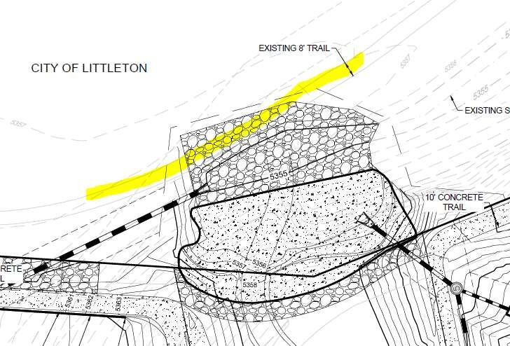

R: This is an existing 2-track and not a gravel access path.
C: Provide approval from SW Metro.
Response: We have provided a license agreement legal description and exhibit to the district on 02-28-22, and are actively working with them to reference the proper contact information on the agreement.
C: Awaiting SW Metro approval.

- Sheet 3.7 – The access from W Phillips onto S Santa Fe Dr should provide concrete curb return through radii at a minimum (or further as required by CDOT).
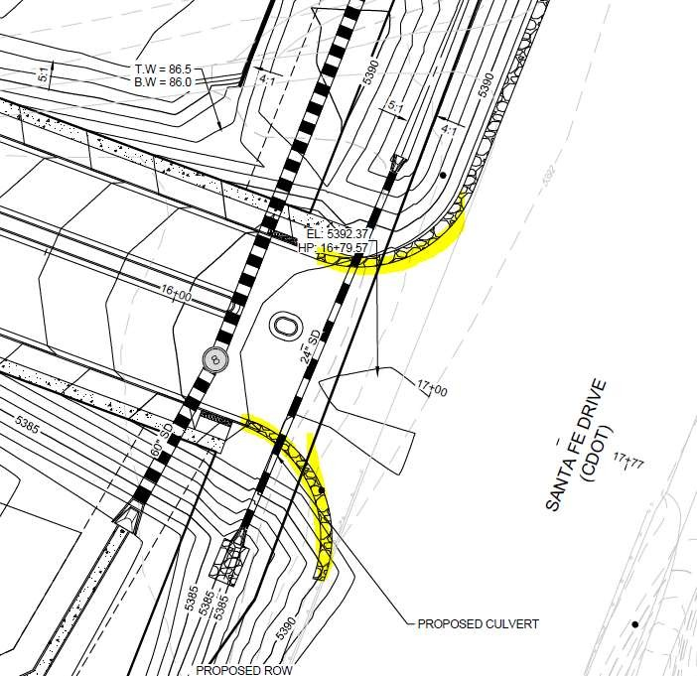
R: There is no concrete curb on Santa Fe Drive, so this should not be necessary.
C: Curb and gutter should be continued around radii. Where no curb is provided, other protection is necessary for the signal poles.
Response: As requested by CDOT, the curb and gutter ends at the handicap ramps. Asphalt shoulders are proposed at the returns.
C: Indicate what protection is proposed for the signal poles where no curb will be provided.

- Sheets 4.12 to 4.19: The private alley to private road transition looks difficult to implement and could lead to flow into lots as inverted crown section is all being directed to one side with a mountable curb transiting from 4-inches to 0-inches. It is recommended to transition to a zero inverted crown at the back of sidewalk to create a sheet flow condition (ex from Castle Rock) or if directed to one side a mountable curb that ends in a 45-degree chamfer thereby directed concentrated flow across the sidewalk.
R: [No response provided.]
C: Provide a response on how concentrated flow from the alley across the sidewalk has been prevented or mitigated.
Response: The inverted crown transitions in advance of the sidewalk to a sheet flow condition. In this transition, the mountable curb also diminishes. Please refer to the detail on the Civil CDs.
C: Comments addressed.

  - The cross slopes of the driveways where the sidewalk or multipurpose trail cross needs to be ADA compliant.
R: Additional spot tags have been added to demonstrate 2%.
C: Slope labels not provided on Sheet 4.21.
Response: Completed.
C: Comment resolved.

  - The truncated domes for the pedestrian ramp in the northwest corner at Platte River Pkwy and Canyon Ave should be perpendicular to the sidewalk.
R: Revised.
C: Truncated domes shall be modified.
Response: Completed.
C: Comment resolved.

  - Align the west curb line along Platte River Pkwy north and south of Canyon Ave. The taper for southbound traffic should either occur prior to or after the intersection, but not through the intersection.
R: Revised.
C: Include a Platte River Pkwy center raised median on the south side of Canyon Ave to guide vehicles through transition and around median on north side of intersection.
Response: Completed.
C: A raised center median is not included on Sheet 4.21.

  - Add mountable center median on Chestnut Ave west approach to Platte River Pkwy to narrow the residential entrance while still allowing truck turnaround.
R: As discussed during the 9/30 city meeting, the applicant has elected not to provide this median since pedestrians are crossing farther west.
C: Given that S Platte River Parkway has sidewalk adjacent to the road within the Right of Way, the City would like a pedestrian crossing across Chestnut Ave, in addition to having a mountable median.
Response: We have added a pedestrian crossing at the intersection of Chestnut Ave and Platte River Parkway however we did not include a raised median. We excluded the raised median so that if a large truck were to accidentally travel down this section of Platte River they have an easy back up path to exit the site, please see our Turning Radius Exhibit for more detail.
C: Comment resolved.

  - No pedestrian pass through or ramps are shown on the east and north side splitter islands for the roundabout.
R: Revised.
C: The trail approaches need to be designed with sweeping curves and the crossing as straight through the center median. See sketch on Sheet 6.1 for reference.
Response: Completed, updated sidewalk so that is crosses straight through the median.
C: Comment resolved.

- (NEW COMMENT) Sheet 4.21 – P&P
  - See redline comments.

- Sheet 4.23- Phillips Av at Santa Fe Drive
  - Slope shall be revised to provide maximum of 3% slope, 200’ from intersection for a Collector approaching an arterial/highway. Also, pending and comments from CDOT.
R: Profile has been updated and exhibits have been provided and signed off on by the city per emails on 11-1-21.
C: Littleton approves of this design. Any comments from CDOT still apply.
Response: Acknowledged.
C: Noted.

  - Review vertical curve at Santa Fe to provide minimum K value (crest) per AASHTO standards.
R: Profile has been updated and exhibits have been provided and signed off on by the city per emails on 11-1-21.
C: Littleton approves of this design. Any comments from CDOT still apply.
Response: Acknowledged.
C: Noted.

  - The 94’ cross section does not accurately represent Phillips Ave immediately east of the roundabout. Need to see a potential design for two westbound lanes extended through the roundabout.
R: Westwood has discussed this potential condition through several email exchanges with the City. Two westbound lanes are not warranted at this time. If and when they are, there is now ample right-of-way to accommodate the extra lane and transportation easement to cover the adjusted sidewalk. Exhibits have been shared and approved by City staff via the aforementioned emails for the design of this potential, future infrastructure.
C: Easement geometry has been approved through prior exhibits. The proposed easement for these improvements shall be labeled as a Utility and Roadway Purposes Easement.
Response: Acknowledged.
C: Noted.

- (NEW COMMENT) Sheet 4.24 – Handicamp Ramp Details
  - See redline comments
  - Need to include green crossbike striping in addition to pedestrian crosswalk markings for cycle track crossings.
  - Need to provide detectable warning devices in the splitter islands for the roundabout crossings.

- (NEW COMMENT) Sheet 4.25 – Handicap Ramp Details
  - See redline comments
  - Need to include green crossbike striping in addition to pedestrian crosswalk markings for cycle track crossings.
  - Match crosswalk marking lengths with 6’ pedestrian ramp widths.

- Sheets 5.2 and 5.3 depict a significantly deep ditch in CDOT ROW adjacent to S Santa Fe Drive. The need for guardrail should be evaluated. Also, pending CDOT review.
R: The adjacent slopes to the right turn lane are 4:1, which does not typically warrant a guard rail. Once review comments from CDOT are received, this area may be re-evaluated.
C: Comment addressed pending comments from CDOT.
Response: Acknowledged.
C: Comment resolved.

- Sheet 6.0 Signage - Overall Development
  - Some sign locations are indicated with a symbol and others simply by an arrow or the hexagon sign number. Provide sign symbols for each location to verify where signs are to be placed.
R: Sign symbols have been added in all locations.
C: See additional redline comments regarding signs on Sheet 6.0.
Response: Completed.
C: See additional redline comments regarding signs on Sheet 6.0.

  - Modify striping for westbound Phillips Ave outside lane to be dots from Santa Fe Dr to necessary deceleration length for the right turn lane, where the paint stripe should become solid.
R: [No response provided].
C: Comment still applies and needs to be addressed.
Response: Completed.
C: The striping notes are not clear related to the right turn lane striping, so the requested change cannot be verified.

  - Add “RIGHT LANE MUST TURN RIGHT” sign along westbound Phillips Ave where striping changes from dots to solid, prior to driveway.
R: Added.
C: Sign not shown.
Response: Completed.
C: Comment resolved.

  - Relocate “SPEED LIMIT 25” sign along eastbound Phillips Ave to the west part way between Platte River Pkwy and the first driveway.
R: Revised.
C: Make sure sign is revised to “SPEED LIMIT 30”.
Response: Completed.
C: Comment resolved.

  - Identify dimensions of on-street parallel parking stalls along Platte River Pkwy.
R: Added.
C. Parallel parking stalls shall be 8’x20’ minimum. Revise parking layout.
Response: Completed.
C: Comment resolved.

  - Because on-street parking is permitted in some sections of Platte River Pkwy, need to sign the remainder of the roadway with “NO PARKING” signs.
R: Added.
C: Signs on Platte River Parkway are provided. Additional signs are needed on the wide section of Chestnut Ave just west of Platte River Pkwy.
Response: Completed.
C: A “NO PARKING” sign was added on the center median but not along the north and south sides of the roadway.

  - Need to sign the two crosswalks for crossing Platte River Pkwy immediately north of Canyon Ave and south of Chestnut Ave with pedestrian signs 10 and 11 (without the “AHEAD” plaque).
R: Added.
C: Crosswalk signs are not provided at the crossing south of Chestnut Ave.
Response: Completed.
C: Additional modifications are required based on the type of signs indicated and locations shown.

  - Are “ADVANCED PEDESTRIAN CROSSING” signs proposed to be provided along Platte River Pkwy prior to the two crosswalks across Platte River Pkwy?
R: A response from the traffic engineer is forthcoming.
C: Response not yet received, and signs are not shown. Include for crossing north of Canyon Ave as shown on Sheet 6.0.
Response: Completed.
C: Comment resolved.

  - Sign 11 should be separated from the “AHEAD” plaque, and in the legend should be referenced as just “PEDESTRIAN CROSSING W11-2” without the “ADVANCE”. In addition, this sign should be indicated to be 30”x30”. The arrow plaque (10) and “AHEAD” plaques should not be used together at the same location.
R: Revised.
C: Need to include the “AHEAD” plaque also, just separately.
Response: Completed.
C: Remove the “AHEAD” plaque all together to avoid confusion as the plaque is not required.

  - Stripe crosswalk and crossbike markings for the multiuse trail along the east side of Platte River Pkwy across all of the driveways.
R: Revised.
C: No such striping has been shown and detailed with green paint.
Response: Completed.
C: No green crossbike striping has been added.

  - Show pedestrian ramps and crosswalk for the west approach to the Platte River Pkwy and Chestnut Ave intersection.
R: Not applicable, per 9/30 meeting discussion, pedestrians are crossing farther west.
C: Given that S Platte River Parkway has sidewalk adjacent to the road within the Right of Way, the City would like a pedestrian crossing across Chestnut Ave, in addition to having a mountable median.
Response: Completed.
C: Comment resolved.

  - Street name signs (2) must match Littleton standard, show example.
R: Revised.
C: Did not see sign detail in plans.
Response: Completed.
C: Need to indicate on what sheet the street sign detail has been added.

  - Where is the “NO OUTLET” sign (4) proposed to be used?
R: Located west of alley on the western limit of Canyon Drive and the western limits of Elmhurst Ave.
C: Neither location is necessary due to the distance from the intersection to the end of the roads.
Response: Removed the signs.
C: Remove the sign in the legend if this sign is not utilized.

  - The number of parking stalls within the lot immediately north of Canyon Ave is not indicated, nor are any dimensions provided for the layout. Clearly label stalls that are for ADA access.
R: Completed.
C: Parking stalls are not dimensioned nor is a count provided on Sheet 6.0. Also, need to sign ADA stalls and compact stalls. Clearly sign and label the van accessible stalls.
Response: Completed.
C: ADA stalls should be located more conveniently along the edge of the parking lot with the associated ped ramps?

  - Move the “KEEP RIGHT” sign for southbound Platte River Pkwy to the north to the end of the center median.
R: Completed.
C: See redline comments on the signage sheet.
Response: Completed.
C: Comment resolved.

  - Why is a “STREET NAME” sign indicated in the sidewalk in the southeast corner of the intersection?
R: Completed.
C: See redline comments on the signage sheet.
Response: Completed.
C: Comment resolved.

  - Move the “SPEED LIMIT 25” sign along westbound Phillips Ave to the east closer to Santa Fe Dr.
R: Completed.
C: Still needs to be moved further east as indicated on Sheet 6.0.
Response: Completed.
C: Comment resolved.

  - Add dot extensions for the roundabout across access approaches along with shark teeth markings prior to entering roundabout on all three approaches.
R: Completed.
C: Still not shown on plans.
Response: Completed.
C: The shark teeth markings should be perpendicular to the travel lane, and the dot extensions go across the entrances to the roundabout, not the exits.

  - Remove “ONE WAY” signs (6) around the roundabout and just use the chevrons (8).
R: Completed.
C: Signs still shown on plans.
Response: Completed.
C: Comment resolved.

  - Replace the “PEDESTRIAN CROSSING” signs (11) on the east side of the roundabout for the crosswalk on either side of the splitter island to be W11-15 with a bicycle and pedestrian symbol and a size of 30”x30”.
R: Completed.
C: Still not corrected on plans.
Response: Completed.
C: Move the signs closer to the crossing.

  - Stripe crosswalk and crossbike markings for the multiuse trail across Phillips Ave on the east side of the roundabout.
R: Completed.
C: Still not corrected on plans.
Response: Completed.
C: No green crossbike striping has been added.

  - (NEW COMMENT) See redline comments.

  - (NEW COMMENT) Cleanup required around the Platte River Parkway/Phillips Avenue roundabout design for the location of pedestrian crossing signs, street name signs, and ensure all regulatory sign locations are included.

  - (NEW COMMENT) Where multiple signs are proposed on a shared post, ensure the appropriate sign order is provided.

  - (NEW COMMENT) Need details for the proposed parking lot striping adjacent to the park.

- Sheet 6.1
  - All crosswalk markings should be 9’ long by 2’ wide.
R: Completed.
C: Still incorrect on plans.
Response: Completed.
C: The length of the crosswalk markings associated with a 6’ ped ramp should match at 6’ also.

  - None of the striping around the roundabout is labeled.
R: See newly added annotation.
C: There is still additional striping that has not been labeled.
Response: Completed.
C: There continue to appear to be stripes that are not labeled.

  - The striping along Platte River Pkwy north of the splitter island for the roundabout is incorrect. Some of the lines that should be labeled “8” SOLID WHITE STIPE” are labeled as “DOUBLE 8” CENTERLINE YELLOW STRIPE” and vice versa. In addition, the striping connecting to the splitter island is incorrect and should connect to both sides of the island.
R: Revised.
C: There are still several corrections needed as identified on Sheet 6.1 of the redlines.
Response: Completed.
C: Comment resolved.

  - Some of the centerline double yellow striping is labeled incorrectly as 8” and should be “DOUBLE 4” CENTERLINE YELLOW STRIPE”.
R: Revised.
C: Some have been corrected but other annotations are still incorrect as identified on Sheet 6.1 of the redlines.
Response: Completed.
C: Comment resolved.

  - Move the arrow markings in the eastbound and westbound Phillips Ave left turn lanes for the driveways to the center of the storage area.
R: Revised.
C: Still not done.
Response: Completed.
C: Comment resolved.

  - The arrow in the westbound left turn lane along Phillips Ave to the driveway on the south side of the roadway is mislabeled as a “RIGHT TURN ARROW” rather than correctly as a “LEFT TURN ARROW”.
R: Revised.
C: Still labeled as RIGHT.
Response: Completed.
C: Comment resolved.

  - Neither the striping for the south portion of Platte River Pkwy nor for Canyon Ave and Chestnut Ave are provided.
R: No striping is proposed.
C: On-street parking and crosswalks are proposed.
Response: Completed.
C: Comment resolved.

  - (NEW COMMENT) See redline comments.

  - (NEW COMMENT) Cleanup required around the Platte River Parkway/Phillips Avenue roundabout design for the yield markings (shark teeth), extension lines across the access lanes, and crosswalk/crossbike markings.

  - (NEW COMMENT) Need to add turn hooks for right and left turn lane lines.

  - (NEW COMMENT) Cleanup notes to avoid overlapping blocking readability.

- Sheet 6.2
  - Need to show how striping coordinates with Santa Fe Drive paint markings immediately to the north of the SB right turn lane, and shadowing the NB left turn lane on the north side of the intersection.
R: [No response provided.]
C: Awaiting a response.
Response: Completed.
C: Comment resolved.

  - Need to provide a “PHILLIPS AVENUE NEXT SIGNAL” sign for both northbound and southbound Santa Fe Dr.
R: Added.
C: Where are the signs located as they are not on the signing or striping sheets?
Response: Completed.
C: Comment resolved.

  - Need to include a “RIGHT LANE MUST TURN RIGHT” sign.
R: Added.
C: Do not see any such signs on the appropriate sheet.
Response: Completed.
C: Comment resolved.

  - The southbound right turn lane striping should identify the required deceleration length with a “8” SOLID WHITE STRIPE” and either a taper entering or “8” DOT WHITE STRIPE” as the extension to the north.
R: Revised.
C: Not completed as requested.
Response: Completed.
C: Comment has not been addressed.

  - Need to include arrow markings in the appropriate locations within the turn bay following CDOT standards.
R: Revised
C: Additional arrows needed.
Response: Arrows have been added.
C: Comment resolved.

  - Label the taper required into the northbound left turn lane.
R: Added.
C: No taper rate provided.
Response: Taper rate now provided on plan.
C: Comment resolved.

  - (NEW COMMENT) See redline comments.

  - (NEW COMMENT) Need to account for a Santa Fe Drive raised center median.

  - (NEW COMMENT) Ensure striping is consistent with and matches to the design for the new Santa Fe Drive/Phillips Avenue signalized intersection.

DRAINAGE

- Sheets 7.1 to 7.17: Label the inverts of the outfall pipes.
R: Completed
C: Label the outfall invert on Sheet 7.11.
Response: Invert on Sheet 7.11 has been labeled.
C: Comment addressed.

- Sheets 14.1 to 14.9: A trickle channel with an inside width of 3-feet may be hard to clean with most types of equipment and may have to be cleaned by hand. May want to consider the maintenance aspect of the trickle channel.
R: Trickle channel width has been revised, a 8-foot wide v shaped channel will be proposed to also act as a maintenance path.
C: Sheets 14.1, 14.4 & 14.7: Indicate the width and thickness of the concrete in the trickle channel detail.
Response: Trickle channel dimensions have been added to all plan sheets.
C: Comment addressed.

- Sheet 14.3: The restrictor plate is no shown on the details.
R: Detail has been added to all sheets.
C: Label the height of the restrictor plate above the invert of the outlet pipe.
Response: The height of the restrictor plate has been labeled.
C: Comment addressed.

- Sheets 14.1 to 14.9: WSEL need to be added to the outlet structure details.
R: Summary table with WSELs has been added to each sheet.
C: Update the pond summary table on Sheet 14.7 to match Sheets 14.8 and 14.9.
Response: All pond summary tables have been updated and match calculation sheets.
C: Comment addressed.

- Sheet 15.1:
  - Label the bridge as “South Platte River Parkway” in profile view of the channel. The location cannot be “approximate”, so remove that label. Bridge plans for this structure must be submitted for review.
R: Label has been updated. Bridge structures will be submitted separately.
C: Labels added/modified. That portion of comment is completed. However, the requested bridge plans are still pending.
Response: Bridge plans are included with this resubmittal.
C: See separate comments/responses on Bridge Design.

- Sheet 15.2:
  - The change in cross section (overall side slopes where trail benched into sides) located where the trail crosses the floodplain bottom was not included in the Floodplain Development Permit model; add this to the HECRAS and update WSE profiles, etc. as needed.
R: HECRAS modeling is provided in report appendix.
C: It appears that the change in grading within the proposed channel/floodplain has been incorporated.
C: Comment addressed.

  - Confirm how the trail crosses the low flow- it is matching the typical section with 3:1 slope? Is there a pipe? Any changes to the cross section at this location must be included in the HECRAS model. Show the location of the low flow crossing in the channel profile. Label elevation of the proposed crossing and confirm that fall protection or railings are not required.
R: There are 2-2’x8’ RCBC culverts under the crossing as proposed currently.
C: See comment above. It appears that the elements have been incorporated into the model as requested, however will railing be required at this culvert? please confirm. Railing would need to be included as blocked obstruction in the model if so.
Response: No railing is included in the design. A roughened edge (rumble strip) has been added to warn path users.
C: Comment addressed.

  - The downstream property fence was not included in the Floodplain Development Permit model; add as a blocked obstruction assuming it accumulates debris. Note; neither the city nor MHFD recommend a fence across a 100-yr floodplain, however, this fence as its designed is required by South Suburban Parks and Recreation District to prevent access to the park at this location, OR the entire channel area must be fenced off at top of channel slopes to prevent access. This would eliminate the trail crossing at this location, and force the regional trail to cross at Platte River Parkway bridge.
R: This discussion is ongoing and will be resolved by CD approval.
C: This issue needs to be addressed before CD approval.
Response: The proposed location of the fence based on conversations will be located at the high point downstream of the final drop structure that is not included in the floodplain. An exhibit is included in model files to show fence location.
C: Comment addressed.

- Sheets 16.1-16.4 General:
  - Change references to “urban drainage and flood control district” to Mile High Flood District.
R: Labels have been updated.
C: References to “urban drainage and flood control district” remain on these sheets. Revise the references. See redlines.
Response: Notes have been updated to MHFD
C: Comment addressed.

  - Soil riprap or void filled riprap or Type M Riprap labels need to be consistent. City prefers void fill riprap within the bottom of the channel.
R: All riprap within the drop structures are proposed void riprap. Labels have been updated.
C: The labels on the sheets remain inconsistent, not all identify “void filled riprap”. Review and revise the labels as needed. See redlines.
Response: All riprap sections are properly labeled.
C: Comment addressed.

  - Add weep drains to the drop structures, and add a typical detail.
R: Detail added.
C: Details are added, but weep drains are not shown on the plan views to show where they are to be located. Add this information.
Response: Plan views have been updated to show weep drain locations
C: Comment addressed.

- Sheet 16.1 (Drop 1)
  - Clarify where cutoff wall, edge wall, notch wall apply in plan view. Edge wall label in plan view says Detail C, when Edge Wall is detail D.
R: Revised.
C: labels and locations of Cutoff Wall vs. Edge Wall in plan view and details remain inconsistent on all sheets for all Drop structures. Review and update accordingly. See redlines.
Response: All redlines have been address to clarify and add consistency.
C: Comment addressed.

  - Clarify 2*D50 thickness of Type M riprap on all details.
R: Revised.
C: It is not evident on the plans that the 2*D50 is the thickness dimension, although that is the
intent. A simple note on each plan stating that Type M Riprap has a D50=12”, and all Type M riprap is to be 24” thick, will suffice. this applies to all Drop structure sheets. See redlines.
Response: All redlines are addressed and notes have been added.
C: Comment addressed.

  - Edge wall or notch wall or cutoff wall on downstream end? Make consistent across all details/sections.
R: An edge wall is along the upstream side of the drops, a cutoff wall is along the downstream ends, and a notch wall is above grade on the downstream side of the drops. All detail sheets have been updated.
C: the labels are not updated or consistent on all sheets for all drops. Review and update. See redlines.
Response: All redlines are addressed and labels have been corrected.
C: Comment addressed.

- Sheet 16.2 (Drop 2)
  - Clarify where edge wall detail vs. cutoff wall detail apply in plan view.
R: An edge wall is along the upstream side of the drops, a cutoff wall is along the downstream ends, and a notch wall is above grade on the downstream side of the drops. All detail sheets have been updated.
C: See comment 32.
Response: All labels have been corrected to clarify locations and types.
C: Comment addressed.

  - Clarify 2*D50 thickness of Type M riprap on all details.
R: Revised.
C: See comment 32.
Response: Notes have been added to clarify riprap depths.
C: Comment addressed.

  - Edge wall or notch wall or cutoff wall on downstream end? Make consistent across all details/sections.
R: An edge wall is along the upstream side of the drops, a cutoff wall is along the downstream ends, and a notch wall is above grade on the downstream side of the drops. All detail sheets have been updated with more detail.
C: See comment 32.
Response: Details have been labeled to clarify.
C: Comment addressed.

- Sheet 16.3 (Drop 3)
  - Clarify extents of Cutoff Wall detail C vs. D in plan view. Clarify where Edge Wall detail applies.
R: An edge wall is along the upstream side of the drops, a cutoff wall is along the downstream ends, and a notch wall is above grade on the downstream side of the drops. All detail sheets have been updated with more detail.
C: See comment 32.
Response: This has been addressed
C: Comment addressed.

  - Clarify 2*D50 thickness of Type M riprap on all details.
R: Revised.
C: See Comment 32.
Response: This has been addressed
C: Comment addressed.

  - Edge wall or notch wall or cutoff wall on downstream end? Make consistent across all details/sections.
R: An edge wall is along the upstream side of the drops, a cutoff wall is along the downstream ends, and a notch wall is above grade on the downstream side of the drops. All detail sheets have been updated with more detail.
C: See Comment 32.
Response: This has been addressed.
C: Comment addressed.

  - The trail bench coming into the floodplain bottom from the east is constricting flows and may need erosion protection. Is this crusher fines? This constriction in cross section must be added to the HECRAS model to determine impacts. How does the downstream constriction affect drop structure function in larger floods?
R: The pedestrian crossing along the low flow of the channel has been added to the HECRAS modeling. In the larger flood events the crossing will flood and will not impact the downstream drop structures.
C: Label and show thickness of trail surface material on the drawings. See redlines.
Response: Thickness and material has been added to the plan and detail in accordance with redlines. Details including a headwall have been added to provide erosion protection at the crossing. Modeling indicates that the effective flow will pass through the culverts, and the flood elevations will not be adversely impacted.
C: Comment addressed.

  - Label the line going through middle of structure in plan view with “4” inside a circle on east end.
R: This is a sanitary sewer line, it has been removed for clarity in this detail sheet.
C: This feature remains on the plan view, please label it, or remove it.
Response: The drop structure has been relocated so this line no longer passes under it.
C: Comment addressed.

- Sheet 16.4 (Drop 4 – downstream end):
  - It appears that flows are forced to make a 90 degree turn at downstream extents of the channel, within the riprap. What type of riprap is this, what is its thickness, and is it sufficient for those velocities/forces. Verify adequate protection of the Sanitary Sewer in this area.
R: Additional analysis (HECRAS 2D) has been run for this area and adequate protection has been provided for velocities/forces in this area.
C: The type of riprap and its thickness has not been added to the plans. See redlines. The 2D analysis does not appear to reflect the proposed grading/contours within this area where water is to turn. Please review and revise as needed. Whether or not this riprap is adequate cannot be determined since the design is not complete and type of riprap here is not identified on plans, and calculations for its sizing is not in the report appendix. This is true of all riprap proposed. There is a sanitary sewer in this area that must also be protected from erosion. The riprap encroaches into that sanitary sewer easement; permission to do so much be obtained by SWMETRO (provide in response to this comment).
Response: The 2d model provided indicates the shear stress downstream of the sculpted concrete structure and not significant and the type M riprap is adequate to withstand the estimated shear stress. This area is included in the O&M plan to be regularly inspected so that any deficiencies can be corrected.
C: Comment addressed.

  - Notch wall or edge wall at downstream end? Make consistent. Typical detail A says its edge wall, flow channel profile says edge wall, plan view has 2 different labels of notch wall and edge wallow flow notch detail shows it 6’ “cutoff wall”. Note: only edge wall should have topsoil covered riprap next to it.
R: An edge wall is along the upstream side of the drops, a cutoff wall is along the downstream ends, and a notch wall is above grade on the downstream side of the drops. All detail sheets have been updated with more detail.
C: See comment 32.
Response: All redlines are addressed and labels have been corrected.
C: Comment addressed.

  - Clarify extents of cutoff wall, edge wall, and notch wall in plan view. Clarify thick black line versus thick gray line.
R: An edge wall is along the upstream side of the drops, a cutoff wall is along the downstream ends, and a notch wall is above grade on the downstream side of the drops. All detail sheets have been updated with more detail.
C: See comment 32.
Response: All redlines are addressed and labels have been corrected.
C: Comment addressed.

  - Flows above about 5358’ within Section 1-1 will spill out to the west outside of the riprap boundary. Indicate what design frequency of flow this is.
R: Riprap has been updated to include these flows.
C: Indicate the design frequency for when flows spill out the west side of riprap and that it will not be erosive when it does so. Ensure the proposed grading is in the 2D modeling – it doesn’t seem to be.
Response: All redlines are addressed and labels have been corrected.
C: Comment addressed.

  - Clarify that all type M riprap thicknesses are 24” or add labels of 2*D50 to correspond to table of drop structure dimensions.
R: Revised.
C: See comment 32.
Response: All redlines are addressed and labels have been corrected.
C: Comment addressed.

- Include truck turning movement diagrams for the Phillips Ave and Platte River Pkwy roundabout, as well as the Platte River Pkwy and Chestnut Ave intersection turn around maneuver.
R: Provided in the SDP.
C: Need to provide updated exhibits for the WB-50 and WB-67 vehicles based on revised design.
Response: Completed.
C: The firetruck route does not follow the emergency roadway and the truck routes requested have not been provided.

- Many of the private drives are showing steep profile of 5% at the ends. The steep slope immediately before the sidewalk can be problematic during icy conditions. Please explain why these sections are so steep. Revisions may be required to reduce this slope.
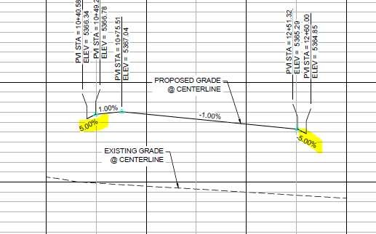
R: Private drives are steep for a short distance to raise the elevation so that the intersection Private Streets contain the entire 100-year storm plus freeboard through their street corridor. This makes sure no water overtops and flows into the Private Drives.
C: See comment 8, above.
Response: Acknowledged.
C: Comment resolved.

- Provide a construction detail of the proposed retaining walls. Walls over 2-ft require a separate building permit. Construction details shall specify footers and a reinforcing plan, if applicable. Footings shall be shown in plan view to confirm there are not any utility conflicts.
R: Structural design is in progress and submission will be forthcoming.
C: Design plans and report for Wall 1 were provided. Elevations in the wall profiles shall match the elevations called out on the Grading Plans (C3.7 & C3.10). Retaining walls surrounding Ponds A, B, and D were not provided. Retaining wall typical details shall be provided in the Civil CDs.
Response: Plans have been updated that provide all walls and their heights, it has been included with the submittal.
C: Wall structural design pending.

- Railings shall be provided where there is a drop off of 30 or more inches within 36 inches of a walking surface. If railings are to be included as part of the retaining wall, include this information on the retaining wall structural details.
R: A railing detail has been added and callouts have been included for all retaining walls over thirty
(30) inches.
C: Railing callouts and details were not found in the drawings. Please identify which sheet these are apart of.
Response: Railing callouts have been provided in locations where the wall is 30 inches and higher, a detail of the wall is shown on page 18.6.
C: Comment resolved.

- Segments of the internal sidewalks are 5-ft in width. Please clarify where these segments are to be called out in the drawings. These can be labeled on sidewalk/trail drawings, the grading plans, the roadway P&Ps (and associated typical sections). A construction detail of the Curb, Gutter and Sidewalk shall also be included in the plan set.
R: [No response provided].
C: Provide an overall trail and sidewalk plan showing proposed sidewalk widths. This sheet shall be consistent with labels provided on all roadway plan and profile sheets. An exhibit was prepared during the SDP submittal; however, it appears that some sidewalk widths have changed from what was previously approved. The project is responsible for incorporating pedestrian connections to the parks and trails.
Response: A standalone plan sheet indicating sidewalk widths and their connection to recreational amenities will be included with the SDP. Generally, where sidewalks could be widened, e.g. when outside the typical private roadway section that provides parking, they were widened to five feet, from four feet.
C: Comment resolved.

- Identify where maintenance access to the channel and drop structures is located.
R: Maintenance access will be determined when the pedestrian crossing and fence is resolved.
C: CDs for the channel will not be accepted until adequate maintenance access is depicted in the plans.
Response: An eight foot grass maintenance access path has been provided to the bottom of all drop structures, the maintenance team will also utilize the low flow crossing to gain access to one of the downstream drop structures.
Comment addressed.

- Add the profile of the water surface for the flow channel design discharge, and label with the CFS value.
R: Label updated.
C: Profile of water surface of this flow event is not added, and other labels are not updated. Clarify what this detail is referring to. Are soils “cohesive”? This is a typical detail that needs to be updated for the specific project. See redlines.
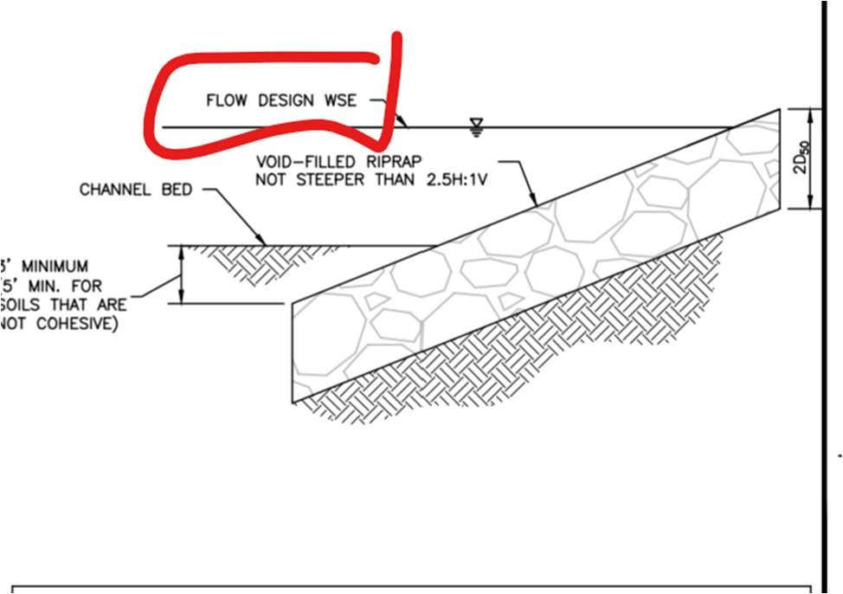
Response: This detail is not considered relevant to the design and has been removed. The effective flow profile has been added to the channel profile sheets.
C: Comment addressed.

- Dad Clark Gulch Typical section(s): add discharge values (CFS) for 100-yr and the design discharge (CFS) for the low flow channel sizing.
R: Label has been updated.
C Labels are not updated. Add proper notation to the labels.
Response: These are typical sections that are no longer relevant to the construction of the channel. All proposed grading is shown on the plan sheets. Typical sections have been removed.
C: Comment addressed.

- Show all proposed riprap in both plan and channel profile views of Dad Clark Gulch.
R: Riprap is proposed around the areas of high shear per 2D HECRAS model (in the drop structures). No additional riprap is necessary for this channel. HECRAS modeling has been provided with this submittal.
C: Riprap has been shown and labeled on profile and plan views. There remain clarifications needed on what type of riprap goes where. see redlines.
Response: All redlines are addressed and labels have been corrected.
C: Comment addressed.

- Missing items:
  - Roadway and sidewalk construction details (i.e. curb and gutter, sidewalk, trails, ADA ramps)
R: Detail sheet has been added.
C: All pedestrian ramps within the Public ROW shall have details showing spot elevations and slopes. Standard notes and details are not sufficient. Ramps will be surveyed for as-built drawings prior to City acceptance.
Response: Spot elevations and slopes have been included at all pedestrian ramps within the Public ROW.
C: Comment resolved.

  - Construction specifications for all work in the public ROW.
R: Contractor shall adhere to the 2019 Arapahoe County Infrastructure design and construction standards.
C: The City is undergoing an adoption of Design Standards which are not currently approved. In the absence of these standards, the City’s preference is for the Public Infrastructure to be constructed according to the City of Englewood’s Design Standards.
Response: Acknowledged, Contractor shall adhere to the City of Englewood’s Design Standards. A reference to these specifications has been added to the cover sheet of the Civil CDs.
C: Comment resolved.

- Sheets 14.1, 14.4 & 14.7: Comment: Please use a different color for the WSEL for the 100-year, EURV and WQ elevations and add that to the legend.
Response: Pond sheets have been updated to show different colors for the WSEL.
C: Comment addressed.

- Sheets 14.1, 14.4 & 14.7: 14.2, 14.5 & 14.8: Comment: Reference or add details for the appropriate M&S Standards for the forebay walls, railing, etc.
Response: All headwall and wingwall structures have CDOT M standard number called out.
C: Comment addressed.

- Sheet 14.3: Comment: Label the width of the overflow outlet box (in appear to be 12-feet).
Response: The overflow box structure has been properly labeled.
C: Comment addressed.

- Sheet 14.3: Comment: Label the slope of the outlet structure walls.
Response: Outlet structures have wall slopes labeled.
C: Comment addressed.

- Sheet 14.6: and Appendix C: Comment: Confirm the horizontal width of the overflow weir box. The detention spreadsheet shows 8-feet – the plans show 4-feet.
Response: The width has been corrected in the spreadsheet to reflect design width of 4 feet.
C: Comment addressed.

- Comment: Show and label all dry utilities (Electric, Gas, Communications, etc.) on the Utility Plans. No new overhead utilities are allowed.
Response: No overhead utilities are being proposed, gas and electric line will be placed within their easement limits, please see cross section A-A and F-F for more detail on where the easement is located.
C: Comment addressed.

- Comment: Medians shall have the transitional curb height at the front/nose of all medians in the Public Right of Way. See detail in redline drawings.
Response: Acknowledged.
C: Comment addressed.

- (NEW COMMENT) Sheet 18.1 – Cross Sections
  - See redline comments

- (NEW COMMENT) Sheet 18.12 – Phasing Plan
  - The off-site improvements on Santa Fe Drive need to be included in Phase 1B (i.e., Phillips Ave traffic signal, SB right turn lane, NB left turn lane, raised center median) and associated cost estimates included in the SIA.
  - All of the internal infrastructure should be shaded and included as part of Phase 1B as the southeast corner of the Platte River Pkwy/Phillips Ave intersection are not currently included.

- (NEW COMMENT) Sheet 19.3 – Traffic Signal Notes
  - See redline comments
  - Signal poles must satisfy CDOT standards since this traffic signal is located along a CDOT owned roadway.

- (NEW COMMENT) Sheet 19.5 – Traffic Signal Plan
  - See redline comments
  - Need to determine with CDOT if the east side driveway to Coventry Farms will be controlled by the new traffic signal or stop controlled as a right-in/right-out, and what associated design is required.
  - Need to pothole for signal pole locations to ensure no conflict with underground utilities. Also need to verify with Douglas County Santa Fe Drive South project and Littleton’s Santa Fe/Mineral Intersection Improvements project to ensure no underground utilities are planned to be relocated through this intersection.
  - North-south left turn signal heads should be able to accommodate both protected only phasing and protected-permissive flashing yellow arrow phasing.
  - Signal cabinet, meter, and any associated equipment should be located in the southwest corner of the intersection, if possible, and set back from roadway to minimize potential exposure to Santa Fe Drive traffic.
  - Control the southbound right turn movement as part of the signal to minimize potential for conflict with pedestrians crossing the west approach. This should include a right turn overlap during the eastbound left turn phase.
  - Need to show how the signal poles in the northeast, northwest, and southwest corners are intended to be protected from being hit by traffic if no curb is to be provided.
  - GridSmart detection will be utilized with one camera in the southwest corner adjacent to the relocated signal cabinet and a second camera in the northeast corner.
  - No equipment included for connecting fiber into the signal cabinet.

- (NEW COMMENT) Sheet 19.6 – Traffic Signal Signing & Striping
  - See redline comments
  - Mark the southbound right turn movement as part of the signal to minimize potential for conflict with pedestrians crossing the west approach.
  - Condense the intersection by shifting the northbound and southbound stop bars closer into the intersection.
  - No equipment included for connecting fiber into the signal cabinet.

- (NEW COMMENT) Sheet 19.7 – Traffic Signal Quantities
  - See redline comments
  - Specify appropriate signal equipment based on CDOT standards (i.e., signal poles, mast arms, luminaires, etc.) and Littleton preferences (i.e., signal cabinet, Cobalt signal controller, GridSmart detection, MMU, UPS, pedestrian push buttons, etc).
  - No equipment included for connecting fiber into the signal cabinet.

Final Drainage Report:

- 1.0(D) should also reference the past master plan study.
R: Section has been revised to reference the previous OSP. Discussions about the previous master plan are ongoing.
C: A reference to the OSP has been added, but the appendix contains excerpts to a preliminary version of an alternative evaluation, not the final published version that shows the selected master plan design for this section of Lower Dad Clark Gulch. Update the reference and appendix contents. See also comment 12 below. The OSP is a pertinent prior study that needs to be referenced in this report, and that is purpose of this section in the drainage report outline. This report is available from MHFD and is referenced here:
Response: The correct approved OSP has been provided.
C: Comment addressed.

- 2.0 (B) should reference the Master plan study not the FHAD study.
R: Section has been revised to reference the previous OSP. Discussions about the previous master plan are ongoing.
C: See above comment 3.
Response: Reference has been updated to the correct document.
C: Comment addressed.

- Text 2.0 D and Appendix: The table for the detention ponds does not match the calculations for the weighted imperviousness or the UDFCD spreadsheet calculations.
R: Revised.
C: Comment addressed.
C:The elevations and volume for Pond D do not match between Table 1 and the Appendix.

- 2.0 (E) the mentioned maintenance agreement for the downstream areas of S Platte Park must be submitted and executed before approval of the plat and final Dad Clark Gulch channel design.
R: Acknowledged.
C: The City is working with South Suburban Parks and Recreation District to identify the terms of the Maintenance Agreement. Once defined, the City will execute the Agreement with the Metro District(s).
Response: Acknowledged.
C: In progress. This agreement must be executed before final approval of channel design and plat.

- 2.0(e) floodplain development permit has already been obtained, but this does not approve construction. A grading permit application is required.
R: Acknowledged.
C: Grading Permit application is pending final review and approval of the channel design CDs.
Response: The final channel model is provided in the Final Drainage Report.
C: The final drainage report exhibits do not reflect the most current channel design and HECRAS model. Revise the floodplain exhibit with the latest HECRAS cross section ID, located in the correct location to match the HECRAS model. Show the current proposed design grading and drop structure locations om this exhibit, and display the most current floodplain delineation and water surface elevation callouts per the latest HECRAS modeling results.

- Text 2.0 E: The please clarify the responsibility of the Metropolitan District as some the roadways (South Platte River Parkway and Phillips Avenue) may be dedicated to the City of Littleton and the maintenance responsibility needs to be clearly defined. See General Note #4 above.
R: Section updated.
C: Comment addressed. Agreements are being drafted and will be executed with the Metro District(s).
C: Noted

- 3.0(C) please identify in the report the 2-year CFS and the “effective” discharge CFS. Suggest putting these design discharge values into a table.
R: Pond release rates have been listed in the pond summary table in section 2D.
C: The comment is not referring to pond release rates, it is referring to the Dad Clark Gulch channel design values. See comment 12 below. Please include the design values for various flow levels for the proposed channel design in a summary table.
Response: This information has been provided in the report and the model has been updated to show the correct flows.
C: This information is provided in Section 3.0 G, table 6. The 2yr flow is listed as 42 CFS and references the OSP study. The OSP study lists 42 CFS as the direct 2-yr runoff from Basin 375 which is 34 acres in size. This is a portion of the area between McLellan spillway and the project site. In section 3.0B) the report states that the effective channel of Dad Clark Gulch is designed for a “60 acre basin between McLellan Reservoir and the site”, in addition to the augment water. Please clarify the determination of the design 2-yr value (which is being used for the effective/bankfull design flow).

- (New Comment) Text 3.0-F-1 and Appendix: The areas for Sub-Basin D2 and D3 do not match the calculations.

- 3.0(G) The discussion of the design of the Dad Clark Gulch channel and drop structures needs to be expanded to include, but not limited to, the following: proposed velocities/shear stresses compared with MHFD standards for grass channels, need for riprap and/or riprap sizing or other channel erosion protection measures, drop structure design/are MHFD simplified methods are used, reasoning and documentation of why Army Corps permit not required, why the channel design does not follow that of the master plan, how was sinuous low flow channel layout designed, types of drop structures/materials to be used, how final vegetation provides necessary erosional stability.
R: A section for drop structure and riprap details and calculations has been added to the report in a new section. An Army Corps permit is required and is ongoing with ERO.
C: Design team has previously stated before that a Army Corps permit is NOT required. Has this changed? Clarify. The GeoHECRAS 2.0 description in the drainage report is unclear. Was 10% of 100-yr used for this analysis, even though it also states that the 100-yr was used in analysis? What is the CFS associated with bankfull and/or low flow channel (?) that is referenced and where are those results? The original floodplain study said that low flow channel is designed for 70% of the 2-yr flow. HECRAS output in that study shows 2 other flow values besides the 100-yr value, but does not define what they are representing (see clip below). But this new report also brings up a 10% of 100-yr value used in design. As requested before, list the various design discharges used for the overall composite channel design; a table form would be helpful. And support these various values and their selection with references to MHFD standard criteria and clarify what is actually being used to design the channel elements (100-yr, bankfull, “effective”, low flow channel, etc.) The text states that riprap and drop structure calculations are contained in Appendix, but they are not. Riprap calculations to support the design are required.
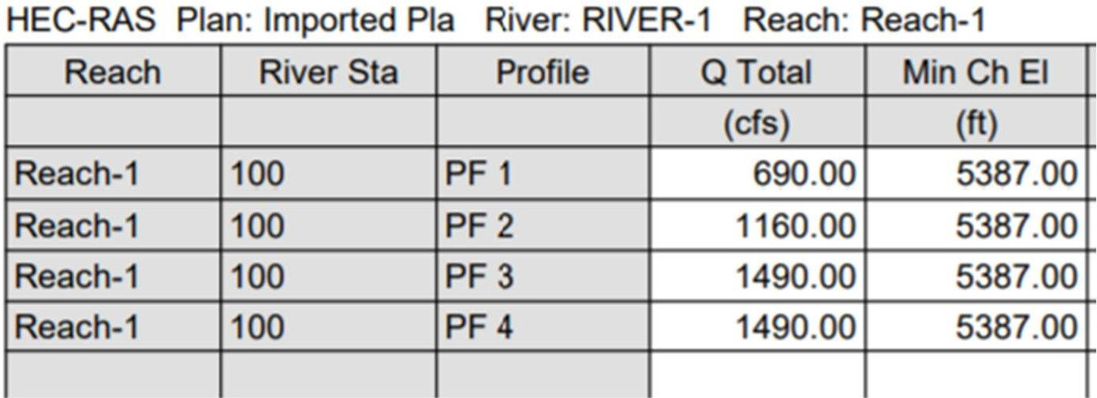
The description of why the channel design is not following that of the 1991 Outfall Systems Study (OSP) study is not included in the report; please add. There are numerous pages included in the Appendix of this Final Drainage Report that are from a preliminary alternatives evaluation that predicated the published 1991 OSP for Lower Dad Clark Gulch, and these materials serve no value. Please include the pages from the published OSP that actually show the selected master plan elements for this segment of Dad Clark Gulch, and reference this when explaining why the proposed design deviates from the OSP design, as mentioned above in this comment.
Response: Additional design information and parameters have been provided in the drainage report.
C: Riprap calculations are described in the report text with reference to the Appendix, but there are no riprap calculations in the appendix. There is a colored output page (2D model?) located after the HECRAS output in Appendix C with “Access Fence” labeled. The text makes reference to this fence in section 3.0(G)(3). What is this colored figure presenting? Provide a legend for the colors. In previous conversations, the fence location was intended to be placed in an area where the depth of flow is below the bottom rail of fence, and therefore the fence isn’t acting as a potential flow blockage that requires modeling. But a detail of the fence isn’t included in this report or plan set to verify this condition.

13. Add to the report that construction specifications for channel and drop structures will follow those of the Mile High Flood District.
R: Report has been updated.
C: See above discussion.
Response: The most recent note from MHFD has been added to all channel sheets.
C: Comment addressed.

14. Add design information for the bridge at Platte River Parkway.
R: Bridge design information will be submitted separately.
C: Bridge design drawings are required. Pending.
Response: Bridge design plans to be submitted in this submittal.
C: Bridge plans are being reviewed separately, comments under separate cover.

Final Drainage Report Appendix:

- Floodplain study information (in appendix) needs to be updated based on changes that have occurred since the approved Floodplain Development Permit: the trail crossing of the channel and associated grading modifications/constriction of the hydraulic section, and the downstream property fence. See Comments regarding Sheet 15.2 below.
R: Discussion about the downstream property fence is ongoing.
C: Add a section in the final drainage report that explains the changes and refinements to the Dad Clark Gulch channel/floodplain design SINCE the floodplain development permit was conditionally approved. The corresponding additional calculations/HECRAS model revisions/floodplain map updates/etc. must be included in this drainage report. See comment 17 below.
Response: This information and updated model information has been added to the report. The flood map sheets in the CDs have been revised to the most recent model information.
C: The floodplain exhibits must be revised to reflect HECRAS model and most recent grading and drop structure design. See comment 8 above.

- HECRAS output should also include the “effective” discharge used for low flow channel
design.
R: An updated HECRAS output has been added to the appendix. Explanation of flows used are in the narrative.
C: HECRAS output shows other profiles (flow values) but there is no corresponding explanation in the report text of what those values are representing. The text discussion has various terms used such as “effective” , low flow, 70% of 2-yr, 10% of 100-yr, etc. and these need to all be clarified as to how they are used and how it corresponds to the flow sin the HECRAS model. See comment 10 above.
Response: The model has been updated to show the latest channel geometry and both effective and base flood flows.
C: Comment addressed.

- (New Comment) Drainage Maps: Sub-Basin B13 is not labeled. The sub-basin line work for Sub-Basin B18a is not shown.

- Include the updated Wetland Areas and Water Demand Calculations in the appendix (see comments on SDP20-0007).
R: Wetland areas and water demand calculations for this area are provided by ERO, their calculations and report are provided in Appendix A of this report.
C: The water demand calculations that support the hydrology supply to the wetlands, and edits/clarifications previously requested by the city, are not included in Appendix A. This is the basis of outstanding comment 18 on the 9/2/21 city review of SDP20-0007. Comment is on next page:
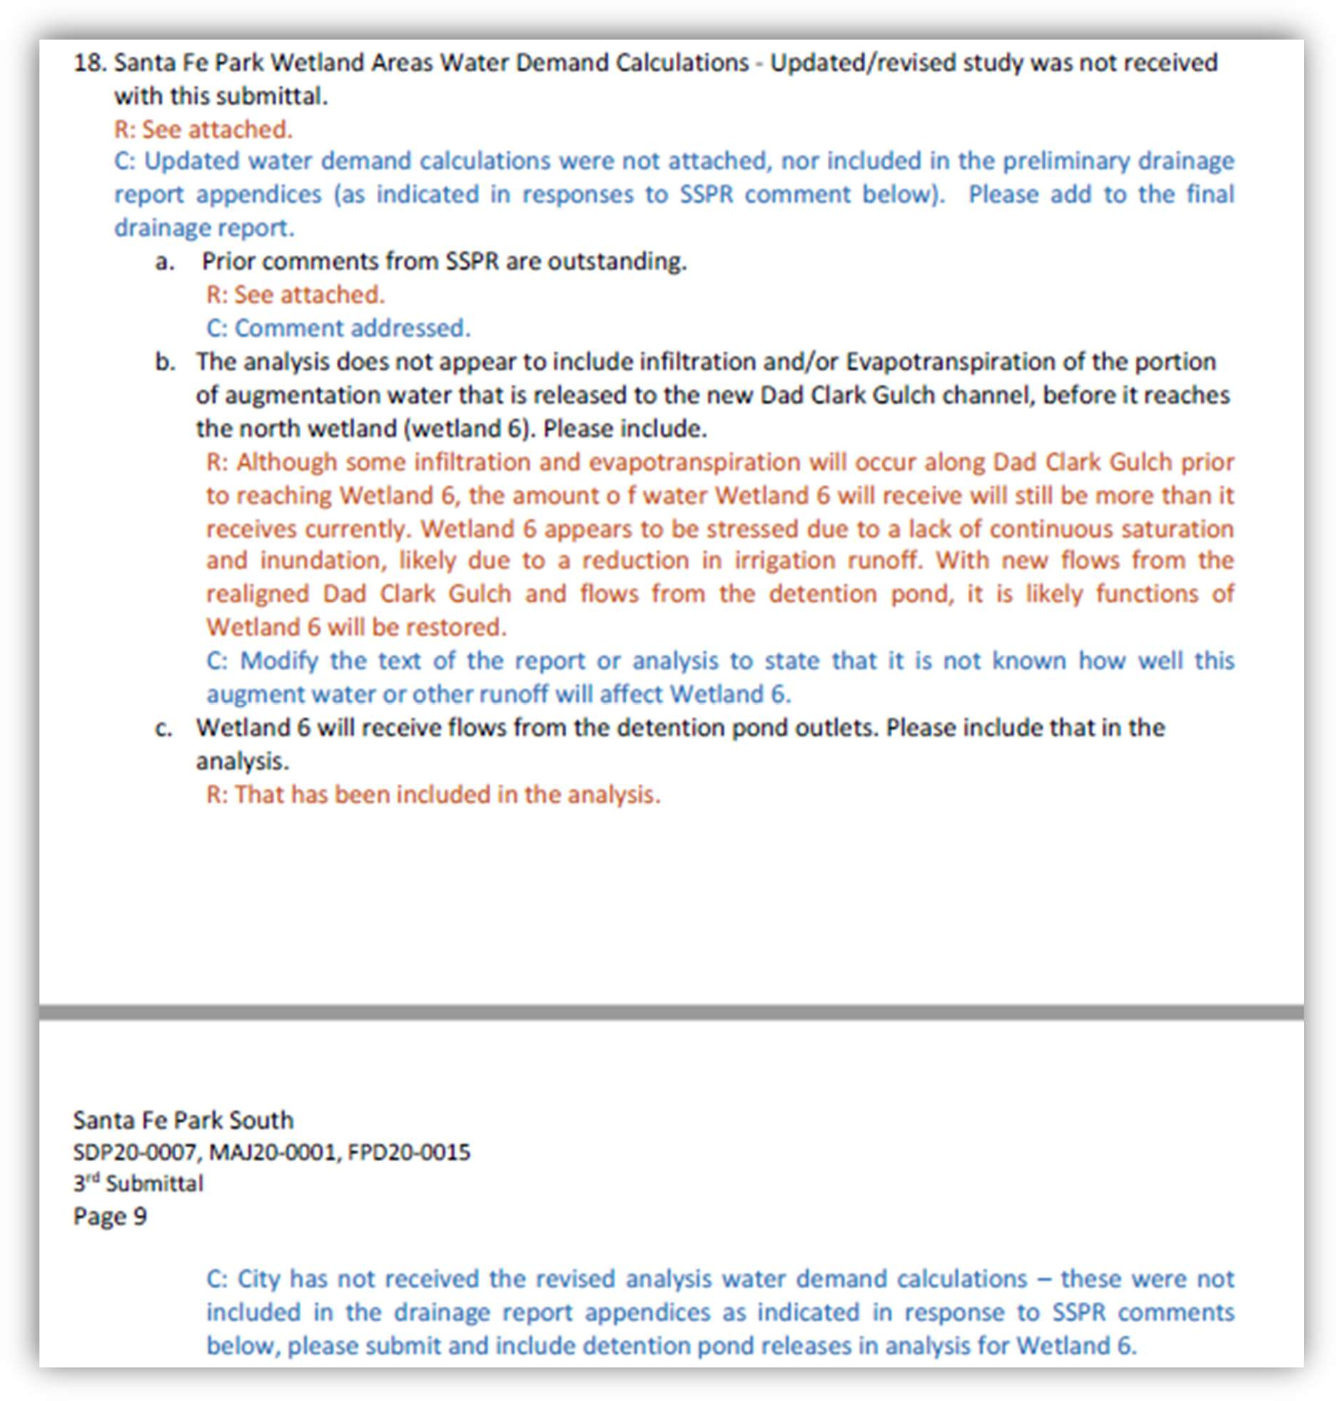
Response: The updated calculations have been provided by ERO. Since this information was obtained, the City of Englewood has indicated that all augment water flow will be directed to the revised channel based on their legal responsibilities.
C: Provide revised Water Demand Calculations memo from ERO. Current one in Appendix still references piping augment water to Wetlands 4 and 5.

- Submit updated HECRAS files to the city.
R: HECRAS files have been submitted.
C: Electronic HECRAS 1D files have not been submitted. These are required when the HECRAS-1D floodplain model is updated/modified.
Response: HECRAS files will be provided.
C: Comment addressed, and ongoing for future submittals.

- Appendix: The values shown as inlet flow in the rational calculations do not match the “known” flows in the inlet calculations (especially major basin A and D).
R: The inlet known flows are matching the Q (Intercept) flows calculated in the rational method.
C: Please confirm all flow from inlets is being accounted for the system (it appears SDIN40 and SDIN44 were not included).
Response: All inlet flows have been updated to rational method calculated flows.
C: Comment addressed.

- Appendix: Include a schematic map for each StormCAD run.
R: An overall map has been added to the appendix.
C: The plan the shows on the storm sewer schematic is very helpful and so a comprehensive view of the system. Please include the schematic from Storm CAD as the pipe numbers are not shown for reference and pipe run cannot be fully evaluated or revise the conduit table so the upstream and downstream manholes are listed (same format as used for Basin A& D).
Response: The maps have been revised to show labels for all pipes and structures.
C: Comment addressed.

- Appendix: The tables need to include what is being the loss coefficient is each junction, not just what the amount of loss is at each junction. This will require the standard table to be customized to include the loss coefficient.
R: The system is set to run for HEC 22 Third edition, this accounts for entrance loss, additional structure losses and exit loss. This is customized within the system so it is not calculated by hand for ever structure.
C: Confirm the manhole loss coefficients are in accordance with MHFD Chapter 7 Section 4.4 especially Table 7.11. The standard or HEC-22 energy may not replicate the same results. There are areas of abrupt manhole changes in direction. A greater change in HGLs would be expected. Headloss coefficients do not need to be hand calculated and can be entered as a Kj (manhole junction loss coefficient). Add a column to the headloss and headloss coefficient to the manhole table.
Response: The HEC 22 Third Edition (2009) is the method referenced in MHFD Chapter 7 Section 4.4. SewerGems calculates the coefficient for each structure as part of the simulation run based on inlet velocity, outlet pipe velocity, and pipe angle. Unfortunately, the coefficients are not provided in the output table, so a hand calculation would be required for each structure. We chose a limited number of structures and calculated the Kj and found them to be in conformance with the tabulated Kj values in MHFD criteria. We are satisfied that the provided storm sewer systems are in conformance with the requirements of the City of Littleton and good engineering practices as evidenced by the Professional Engineer Seal on the plans and report.
C: Comment addressed.

- Appendix: There are numerous discrepancies between the plans and the HGL calculations (see attached). An overall QA/QC needs to be done to ensure the plan and HGL calculations match.
R: HGLs have been updated and QC’d.
C: The CDs and HGL profiles do not match exactly but appear to be close. Please confirm
that the inverts, rims, slope and pipe length agree between the HGL calculations and the CDs.
Response: All storm profiles are updated to most recent calculated HGLs.
C: Comment addressed.

- A levee condition needs to be corrected in the HECRAS cross sections included in the Appendix, an example shown below. There cannot be adjacent ground lower than the 100-yr water surface elevation on opposite side of a “levee.” Please correct the cross section and resultant WSE.
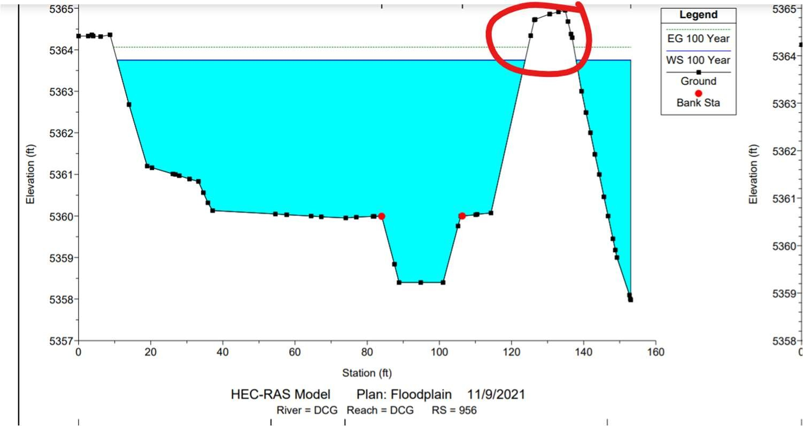
Response: This condition has been corrected and revised cross sections provided.
C: Comment addressed.

- The provided HECRAS-2D results for this area shown above, which is currently a “gap” in the graphic/color results. Please show the results all the way through this area where this trail crossing is located. What flow event are these graphics for? Add explanation labels.
Response: The model was separated at this point due to the difficulty in adding culverts to 2d models . The results are valid for both upstream and downstream areas, and the 1d model clearly indicates the correct information for this area.
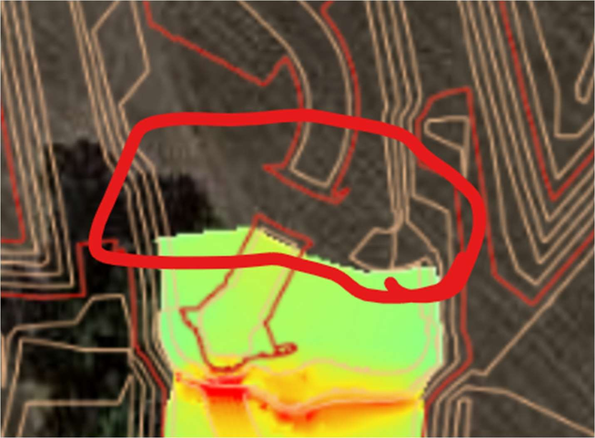
C: Comment addressed. However, this information from 2D model has been removed from the report? I assume the 2D model is no longer being used for design? If it is, include output and label as such.

- The HECRAS model cross sections in the Final Drainage Report Appendix do not have river station s that relate to the plan view Floodplain Study Exhibit in the same Appendix. Please update the HECRAS river station IDs in either plan view on the exhibit, or in the model itself. The updated electronic HECRAS-1D files were not provided with the submittal; send these to the city. The conditionally approved Floodplain Development Permit certainly should be referenced in the report, but it is required that the model and exhibit are updated as design progresses and the most updated HECRAS results and floodplain study exhibit are in the Final Drainage Report. The past conditionally-approved permit materials do not necessarily need to be included (in fact ,it causes confusion) but can just be referenced in the text. Update the Appendix to include the most updated Exhibit showing cross section IDs that correlate to the updated HECRAS, and depicts the updated channel grading and layout and floodplain elevations, and include printouts of the pertinent HECRAS-1D results.
Response: The cross sections and exhibit have been updated to show the correct information. Model files will be provided with the next submittal.
C: The floodplain exhibit has not been updated with the latest HECRAS model cross section ID labels. The cross section IDs in the HECRAS files, the output printouts and plan view floodplain exhibit must all match. See also comment 8.

- Is the proposed grading for this area adequately portrayed in the 2D mesh? It appears to show a closed contour and other grading isn’t evident. One would expect that with flow turning 90-degrees that you would see something more here. This is an area of the current design that needs more attention, see redlines and other comments contained herein.
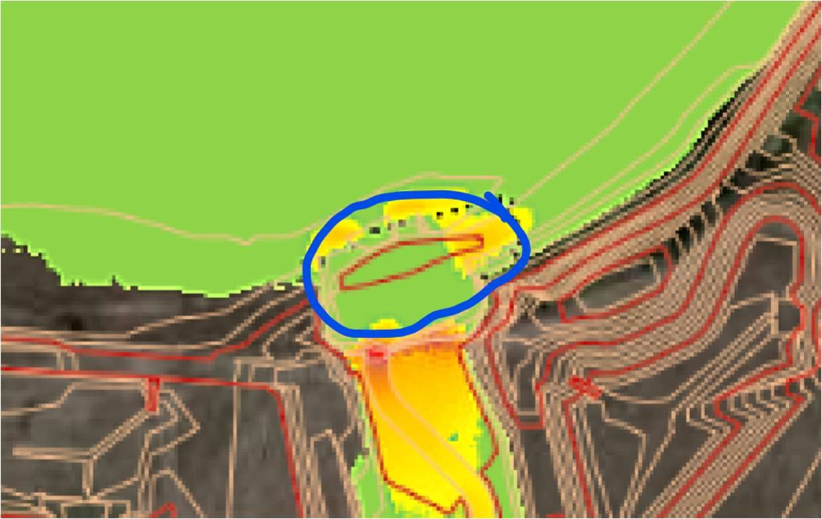

Response: This is the correct grading.
C: This area has not been adequately addressed; include velocities and riprap calculations to represent the turning flow.

- COMMENT brought forward from SDP review:
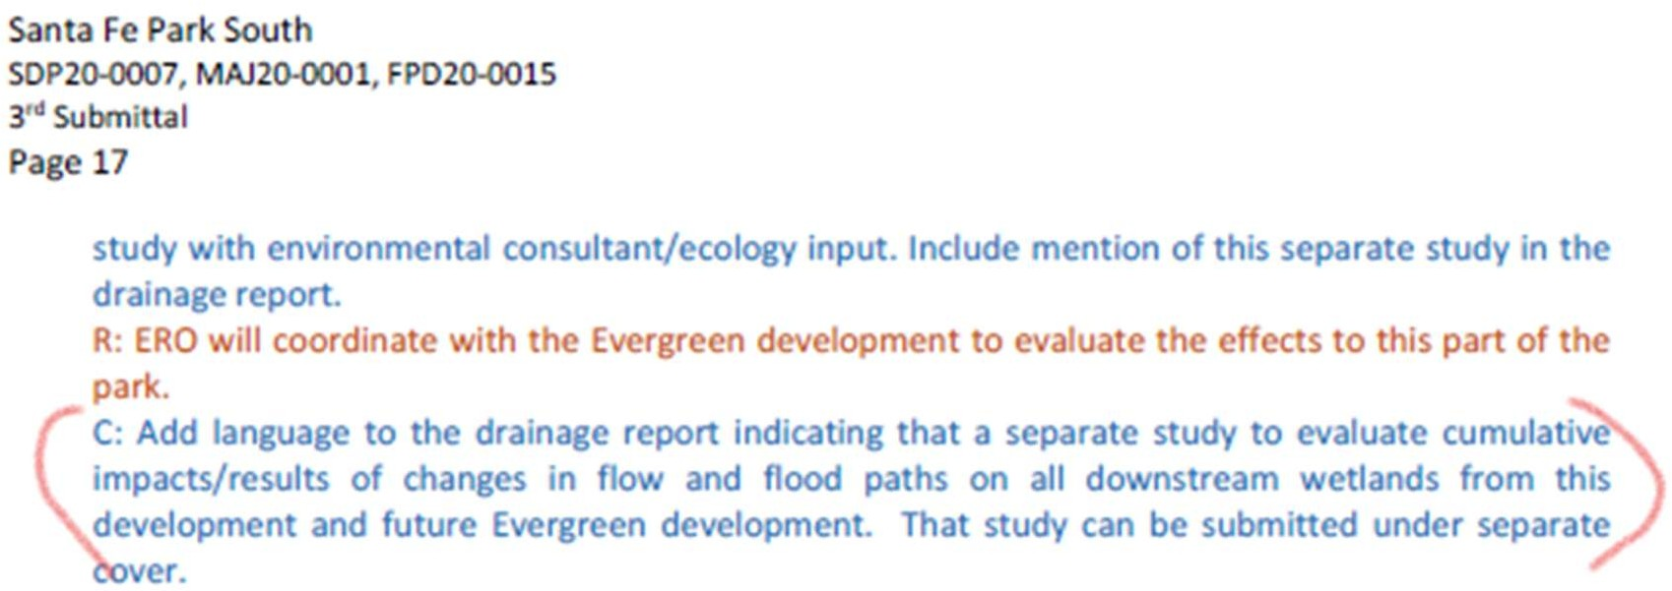

Response: This language will be added.
C: Comment addressed. However, this particular report will be condition of final maintenance agreement approval.

- Comment: Refer to the separate Operations and Maintenance document in the final drainage report by title and date. Part of outstanding SDP comment.
Response: This reference is added.
C: Comment Addressed.

- Comment: Refer to the separate Stormwater Management Plan (SWMP document and plans) by title and date. Part of outstanding SDP comment.
Response: This reference is added.
C: Comment addressed.

- COMMENT BROUGHT FORWARD FROM SDP REVIEW:
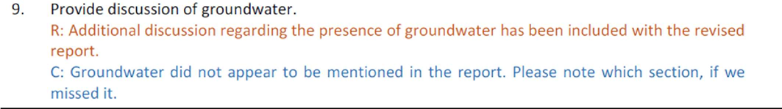
Response: This reference is added.
C: Comment addressed.

- Add discussion to the report that summarizes the groundwater data collected during the geotechnical report (which was included in report appendix), and general depth of groundwater compared to grading cuts, etc., to verify that groundwater will not be an issue for this development.
Response: This reference is added.
Comment addressed.

- Add and engineer’s and owner’s certification page.
Response: This has been provided.
C: Comment addressed.

- Section 2.0.D: Comment: The 100-year volume in the table does not match the calculations.
Response: The table has been revised to show current values.
C: Pond D does not match the calculations in the appendix.

- Section 3.0.F.2: Comment: Sub-basin B54 is missing from Table 4.
Response: All sub-basins have been revised. Table updated.
C: Comment addressed.

- Section 3.0.F.3: Comment: Basin D the text and Table 5 do not match the calculations in Appendix B.
Response: All tables have been revised to show the correct values.
C: The values still do not match.

- Appendix B: Comment: Basin D the composite imperviousness calculations does not match the EDB calculations for Forebay 1 and 2.
Response: All tables have been revised to show the correct values.
C: Comment addressed.

Stormwater Management Plan (SWMP):
See comments on attached redlines. Comments below are not exhaustive of redlines.

    - Revise the Standard Notes with the latest standard notes from Section 13.5.3 of the Littleton Drainage Criteria Manual.
R: Revised plans addressing the provided redlines are forthcoming separately.
C: These were included in the SWMP Drawings; notes in the Report (Section IX) shall be revised.
Response: Report has been updated with notes included on SWMP Drawings.
C: Comment addressed.

    - Provide a detailed summary of work to be completed during each phase and include the sequence of specific items, if they impact the use and installation of certain BMPs. Also clarify which phases will overlap during construction. Also note when landscaping is anticipated to be completed, otherwise the seeding limits shall match the landscaping drawings.
R: Revised plans addressing the provided redlines are forthcoming separately.
C: Included in SWMP report. No further comment.
Response: Acknowledged
C: Comment addressed.

    - Specify seed mix, mulch type, and blanket types for the project. If there are multiple material types being used, specify where each is to be used. Ensure that the blanket design within Dad Clark Gulch is sufficient for the anticipated shear stresses.
R: Revised plans addressing the provided redlines are forthcoming separately.
C: Seed mixes are contained in the landscape plans and the SWMP plan details. There may be conflict between permanent seed mixes in SWMP details and the mixes in the landscaping plan that should be reviewed. No information on the type of mulch is provided in plans, details, or the SWMP report. Please specify. Blanket type on the plans is identified in the legend as straw- coconut. This is required to be biodegradable; please add a note on the plans.
Response: Seed mixes provided on SWMP match the MHFD standard details and will be coordinated with the landscaping plans. The standard detail for Mulch has been added to the details. Biodegradables been added to the legend for the ECB.
C: Comment addressed.

    - Several Permits from CDPHE may be applicable for this project. Please coordinate with CDPHE and clarify which permits will be obtained. Below are a few that may apply, however there may be others required. Copies of the permits shall be submitted for the City’s Grading Permit application.
      - Air Pollutant Emission Notice Construction Permit (APEN)
R: Revised plans addressing the provided redlines are forthcoming separately.
C: City will look for this with Grading Permit application.
Response: Acknowledged.
C: City will look for this with Grading Permit application.

      - Stormwater Discharges Associated with Construction Activity
R: Revised plans addressing the provided redlines are forthcoming separately.
C: City will look for this with Grading Permit application.
Response: Acknowledged.
C: City will look for this with Grading Permit application.

      - Construction Dewatering Discharge Permit
R: Revised plans addressing the provided redlines are forthcoming separately.
C: City will look for this with Grading Permit application.
Response: Acknowledged.
C: City will look for this with Grading Permit application.

    - Comment: Provide a Stormwater Management Plan Checklist in the report. The checklist can be found on Table 2F of the Drainage Criteria Manual.
Response: Completed.
C: The checklist will need to completed and signed.

    - Comment: Provide the following signature blocks on the Cost Estimates.

Prepared by:
Developer’s Engineer (signature and stamp) |  | Date
Approved by:
Development Owner |  | Date
Accepted by:
City Engineer |  | Date

Response: Completed.
C: A copy signed by the owner and stamped/signed by the engineer will need to be provided prior to approval and issuance of a grading permit.

    - New Redline Comment: Sheet 13.26 needs to have proposed contours.

    - New Comment: The earthwork quantities do not match between the CDs and SWMP.

    - New Comment: The GESC cost estimate needs to have a 25-percent contingency and the “collateral BMP cost” is not need and can be removed.

Supplemental Traffic Study

- Comments were transmitted to the applicant on September 13, 2021. Until S Platte River Parkway is connected to Mineral Avenue or via Nichols Av, this development is limited to a single access point via W Phillips Av. This traffic study will be used to determine the number of dwelling units and/or commercial s.f. for which building permits can be issued prior to having access to a second access point. Related phasing will be reflected in the Subdivision Improvement Agreement.
R: Acknowledged.
C: The Supplemental Traffic Impact Study dated September 27, 2021 provides an acceptable amount of analysis and information for the development to move forward with the specific type and amount of land use identified in the report. However, any change in the type of land use from residential, the amount of dwelling units proposed, or the parcel location of the land use will require additional analysis and an update to the study prior to construction and occupancy.
Response: Acknowledged.
C: Comment resolved.

Landscape and Irrigation Construction Documents:

- LF0.1: Water Gap fence must be added to hydraulic HECRAS model as blocked obstruction (assumed debris clogged). See comments above for Sheet 15.2.
R: The Water Gap Fence has been removed from the submittal.
C: The issue of the fence at the boundary of the property and South Platte Park at Dad Clark Gulch is still under discussion. This issue must be resolved before CD approval.
Response: The fence has been added to the floodplain model, which was been submitted to Littleton.
See comment re fence in drainage/roadway plans comments.

- Landscaping Plans shall show the AASHTO Sight Triangles. Landscaping within the triangles shall conform to LMC 10-4-1 (Rep).
Response: Acknowledged
C: Comment resolved.

Site Development Plan (New Comments)

- Sheet 2 – Overall Site Plan
  - See redline comments.
  - Any signage and striping shown should be consistent with and updated to reflect comments addressed in the CD’s.

- Sheets 4–10, 12–13, 20–21 – Private Area Site Plans [APPLY THESE COMMENTS TO THE CD’S AS APPROPRIATE]
  - See redline comments for modification considerations on the private roadway system.
  - Ensure all sidewalks across driveways are ADA compliant, especially where the sidewalk is attached.
  - Ensure all pedestrian ramps are designed to be standard directional ramps and the ramping required along the sidewalk is clearly shown.
  - Provide roadway width dimensions.
  - Midblock pedestrian crossings should be marked and signed appropriately to provide safer conditions.
  - If no parking will be allowed in the alleys, the appropriate signage will be necessary for enforcement.
  - Why are none of the signs identified and only some of the striping?
  - Remove sight triangles from area site plans as too difficult to view on separate sheets.

- Sheets 11, 14–19, 22 – Public Area Site Plans [APPLY THESE COMMENTS TO THE CD’S FOR CONSISTENCY]
  - See redline comments for modifications on the public roadway system.
  - Match crosswalk markings to width of pedestrian ramps.
  - Remove sight triangles from area site plans as too difficult to view on separate sheets.

- Sheet 23 – Sight Triangles Plan
  - See redline comments.
  - Sight triangles not reviewable with multiple overlapping areas. Need to separate areas by color or on multiple sheets.

- Sheet 35 – Cross Sections
  - See redline comments.

- Sheet 36 – Phasing Plan
  - See redline comments.

- Sheet 37 - AutoTURN
  - See redline comments.
  - Need to provide turning movements for WB-50 on the public roadways and the ability for a WB-63 to negotiate the Platte River Parkway/Phillips Avenue roundabout.

CITY OF LITTLETON CIVIL CD STANDARD NOTES

- These plans were prepared concurrently with a Site Development Plan Project and Subdivision (Case Nos. MAJ20-0001, SDP20-0007, FPD20-0015 and MAJ21-0001) applications to the City of Littleton. Any discrepancies between these drawings and the Recorded SDP or Final Plat shall be immediately brought to the attention of the City of Littleton. Any changes or deviations from these plans require approval from the City of Littleton and its partner agencies.
- City of Littleton Public Works Department, through acceptance of this document, assumes no responsibility for the completeness and/or accuracy of these documents. The Owner and Design Engineer understand that the responsibility for the engineering adequacy of the facilities depicted in these Civil CDs lies solely with the Professional Engineer registered in the State of Colorado whose stamp and signature is affixed to this document.
- All work within the Public Right of Way, to be dedicated to the City of Littleton, shall be constructed in accordance with the City of Englewood Engineering Design Standards. Infrastructure for other Utility Districts shall comply with their respective Standards.
- Prior to requesting TCO or CO of any structures or buildings, the City must receive and approve as-built drawings prepared and certified by a Licensed Engineer. As-built drawings shall include survey information of all drainage sewer, facilities, structures and channels, as well as all public improvements dedicated to the City of Littleton. Such improvements include roadway, sidewalks, trails, pedestrian ramps, bridges, signs, equipment, signals, etc. All roadways, sidewalks, and trails shall be built per plan and in accordance with adopted accessibility standards. A Stormwater Detention and Infiltration (SDI) spreadsheet shall be prepared by an Engineer certifying the as-built condition of the detention facilities.
- A post-construction study of Dad Clark Gulch and the proposed floodplain shall be prepared by an Engineer. The study shall be submitted to Colorado Water Conservation Board (CWCB) for approval and adoption.
- The Contractor is responsible for pulling all necessary permits, including but not Limited to permits from the City of Littleton, Colorado Department of Health and Environment, and CDOT.
- A City of Littleton Grading Permit is required for the project and is required prior to starting work. The Contractor is responsible for obtaining the permit and maintaining a current and active Stormwater Management Plan (SWMP). A SWMP has been prepared at the time of approving the Civil CDs. Any changes to the approved plan shall be tracked on-site.
- Prior to starting work, the Contractor shall have a Preconstruction meeting with Littleton Public Works.
- All required written approvals and copies of executed easements from the adjacent property owner(s), as determined by the city, shall be provided to the City prior to City approval of the construction plans and drainage report and prior to issuance of a building or grading permit for this project. The property owner hereby acknowledges that modifications to the approved and recorded site development plan, the drainage report, and the construction plans may be necessary if these offsite agreements and easements cannot be obtained.
- The Contractor is responsible for scheduling necessary inspections. All Public Works inspections shall be scheduled 24hrs in advance of the needed inspection. All materials and workmanship inspected by Public Works shall conform to the City’s Standards. The City, or its designee, has the right to accept or reject any work that does not conform.
- The Contractor shall provide all signs, barricades, flagmen, lights, or other devices necessary for safe construction traffic control in accordance with the current edition of the MUTCD and as modified by the Colorado Supplement to the MUTCD. A construction traffic control plan shall be submitted to and approved by Public Works prior to the issuance of any Right of Way Permits for work within City Right-of-Way. The Contractor shall obtain necessary permits for work within CDOT Right-of-Way.
- Comment: The Contractor is responsible for locating all existing utilities prior to excavation. All Utility Locating requests shall be submitted through the Colorado 811 system.
- All Landscaping, signage, and improvements shall maintain sight distance triangles to be free of visual obstructions, between a height of two and one half feet and ten feet. The sight distance triangle shall be designed to AASHTO standards, per LMC 10-1-3.9.C.
- The Contractor is responsible for maintaining a clean and organized site in accordance with approved Stormwater Management Plan. Contractor is also responsible for obtaining and maintaining necessary permits associated with Earthwork disturbance.
C: Comment resolved.

