
COMMUNITY DEVELOPMENT DEPARTMENT
2255 West Berry Avenue Littleton, Colorado 80120

August 11, 2023

Tim Westbrook
10 Inverness Drive East, Suite 125
Englewood, CO 80112
twestbrook@tollbrothers.com

Dear Mr. Westbrook:

On June 30, 2023, the City of Littleton received your complete application for a administrative replat of the Santa Fe Park South Subdivision. Thank you for your request. The first review of the administrative plat is complete, and the following agencies have submitted comments. A second review is required. Please see submittal instructions at the end of the comments.

Planning comments by Mike Sutherland 10/11/23 corrections required
- Please change the title to “Santa Fe Park South Subdivision Filing No. 1 Replat A” Title updated.
- Sheet 1, Certification of Dedication and Ownership: if a affidavit of correction has not been recorded, please remove the statement. If an affidavit of correction has been recorded, please provide the recordation number in the blank. It was my understanding that this Replat replaces the need for an affidavit of correction. Reception number added.

Engineering comments by Gary Welp 10/10/23 corrections required
The Public Works Department has reviewed the following documents for the above project:
• Letter of Intent, SDP21-0016, dated June 16, 2023 (no comments)
• Title Report, dated June 6, 2023 (no comments)
• Closure Report, dated October 11, 2022 (revise and resubmit)
- The report appears to be referencing the previous Tract T and not the new Parcel C. Provide a report for Parcel C. Reports attached.
- Provide reports for Parcel A and Parcel B. Reports attached.
• Santa Fe Park South Subdivision Filing No. 1 Final Plat, Plat Amendment No. 1, revision dated June 23, 2023 (revise and resubmit)
- Format the “Lot Area Table” in the same fashion as was used on the Santa Fe Park South Subdivision Filing No. 1 Final Plat which shows the “purpose”, “owner”, “maintenance” for the newly created Tracts (see below). Lot area table format updated.
- The created Tracts should not duplicate those Tract numbers already created. Continue with sequential letters from the Santa Fe Park South Subdivision Filing No. 1 Final Plat or start over with “AA” (see below) Tract names updated.

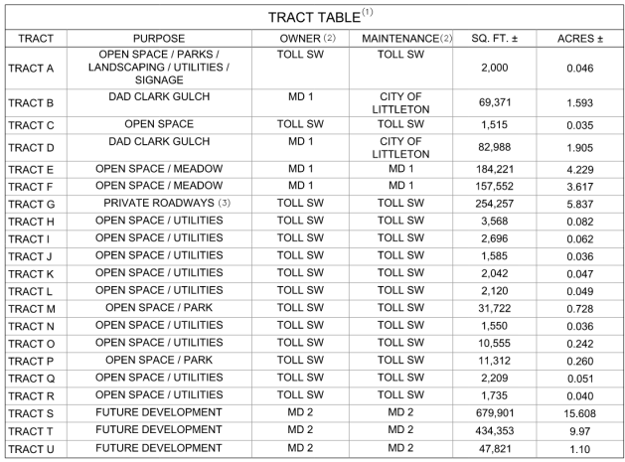

Xcel Energy comments by Donna George July 27, 2023 corrections required
- Public Service Company of Colorado’s (PSCo) Right of Way & Permits Referral Desk has reviewed the minor plat and requests 10-foot-wide utility easements around the perimeter of the tracts where perimeter easements for dry utilities are not already present. Per conversation with Donna George from Xcel, we will not be providing 10’ Xcel Utility easement at this time, will be coordinating with Xcel to provide a blanket easement over the whole site.

The property owner/developer/contractor must complete the application process for any new natural gas or electric service, or modification to existing facilities via xcelenergy.com/InstallAndConnect. It is then the responsibility of the developer to contact the Designer assigned to the project for approval of design details.

For additional easements that may need to be acquired by separate document for new facilities, the Designer must contact a Right-of-Way and Permits Agent.

CenturyLink (Lumen) comments by Veshon Sheridan / Andrew Schlitt 7/13/23 review complete
Qwest Corporation d/b/a CENTURYLINK, QC (“CenturyLink”) has reviewed the request for the subject vacation and has determined there are no CenturyLink facilities within the easement area as shown and/or described on Exhibit “A”, said Exhibit “A” attached hereto and incorporated by this reference
It is the intent and understanding of CenturyLink that this vacation shall not reduce our rights to any other existing easements or rights we have on this site or in the area.

This No objection response is submitted WITH THE STIPULATION that IF CenturyLink facilities are found and/or damaged within the area as described, the Applicant will bear the cost of relocation and repair of said facilities.

Comcast no comments received as of 8/11/23 review complete

Arapahoe County no comments received as of 8/11/23 review complete

City of Englewood 7/18/23 corrections required
- Englewood/Toll Purchase and Sale agreement should be finalized and signed by both parties prior to the plat update being finalized. City of Littleton may request this documentation to aid in their review of the plat. The signed agreement has been provided.
- Englewood/Toll City Ditch easement agreement should be finalized and signed by both parties prior to the plat update being finalized. City of Littleton may request this documentation to aid in their review of the plat. The signed agreement has been provided.
- As discussed in previous meetings and noted in the City Ditch easement agreement, the City is planning on burying the existing above ground flume and intends to obtain new easement through Lot 261 and Tract A. Please confirm plat revisions will not impact Englewood’s ability to gain a new easement through this area and relinquish the old easement where the box culvert is planned to be constructed. There are no revisions proposed on this plat that would preclude the alteration of the flume.
- Include the following note on the plat that was included on the original approved plat: “Englewood’s review of this plat in no way implies Englewood approval of relocation of or changes to City Ditch, the drain line, or the easements as shown.” Note has been added.

All resubmittals are through eTRAKiT. Once all necessary items are uploaded to eTRAKiT, send an email to msutherland@littletongov.org to notify LIttleton of the resubmittal. The following items are necessary for second review:

- Response letter giving specific responses to each numbered item in this review.
- Revised plat
- Closure report
- Finalized and signed purchase and sale agreement
- Finalized and signed ditch easement agreement

Thank you for your patience with these comments and thank you for your development application with the City of Littleton. If there are any questions about these comments or processing, please let me know. If an in-person or virtual meeting is necessary to review or resolve comments, I am happy to coordinate and schedule at your request.

Sincerely,

Michael Sutherland, AICP
Deputy Director of Community Development
Community Development Department
msutherland@littletongov.org
303-795-3763 (direct)

cc: Patrick Steenburg, Westwood
Melinda Lundquist, Westwood
Brad Dixon, Toll Brothers
Gary Welp, RS
Matt Knight, Littleton

