
COMMUNITY DEVELOPMENT DEPARTMENT
2255 West Berry Avenue Littleton, Colorado 80120

September 19, 2023

Tim Westbrook
10 Inverness Drive East, Suite 125
Englewood, CO 80112
twestbrook@tollbrothers.com

Dear Mr. Westbrook:

On August 30, 2023, the City of Littleton received your resubmittal for an administrative replat of the Santa Fe Park South Subdivision. Thank you for your request. The second review of the administrative plat is complete, and the following agencies have submitted comments. A third review is required. Please see submittal instructions at the end of the comments.

Planning comments by Mike Sutherland 9/8/23 corrections required
- [New Comment] Please revise the title to include the case number: APL23-0005.

Case number has been added to the plat.

Engineering comments by Gary Welp 9/18/23 corrections required

- Segment #2 of the “Exception Parcel” does not match between the Plat and the closure report.

Updated this distance to 15.90’.

- Segment #10 Curve of Tract V does not match between the Plat and the closure report.

Previous versions page 2 overall curve table was incorrect, it has been updated to show the correct length which matches the closure report of 219.97’.

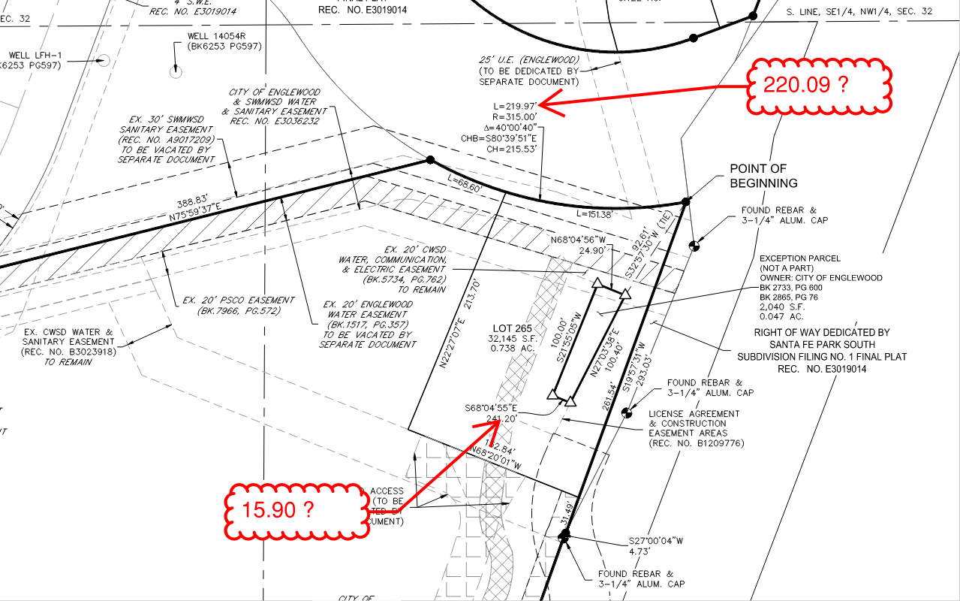

Xcel Energy comments by Donna George 9/14/23 conditionally approved (review complete)
PSCo acknowledges the comment response and advises the developer to continue working with Robyn Martinez at robyn.m.martinez@xcelenergy.com

Acknowledged.

City of Englewood 9/13/23 corrections required
- The existing City Ditch easement south of the McLellan Pump station does not align with City records. It appears the easement was shifted to the east to be off the property and in the Santa Fe ROW as compared to the previous plat. The easement shown on the revised plat is shown too far to the east and within the Santa Fe ROW. Please contact Stephanie Ellis sellis@englewoodco.gov for documentation showing the correct easement location.

Based on previous ALTAs which were completed in 2008 & 2011 and recorded documents the easement is in the correct location. The ALTAs have been attached and CAD files can be provided to show that this easement is in the correct location. If Englewood has remaining concerns, please let us know an appropriate time to set up a meeting to review files.

- The plat indicates that a City Ditch waterline and access easement south of the McLellan PS will be vacated by separate document. This is incorrect, as the existing City Ditch easement in this area is not being vacated.

Label has been removed.

- All recently executed agreements should be recorded. It is recommended that these be recorded, and the recordation number added to the plat before finalization of the revised plat.

Reception numbers have been added to plat.

- The proposed 15-foot access easement to the east of the garages should parallel the existing City Ditch easement per previous discussions and exhibits.

Easement has been removed. This easement shall be dedicated by separate document, and is subject to review with Littleton Case Number APL23-0001.
- The plat indicates that the drain line easement will be vacated but does not show the proposed drain line easement for the relocated drain line.

Reference to the City of Englewood easement being vacated has been removed.

All resubmittals are through eTRAKiT. Once all necessary items are uploaded to eTRAKiT, send an email to msutherland@littletongov.org to notify LIttleton of the resubmittal. The following items are necessary for second review:

- Response letter giving specific responses to each numbered item in this review.
- Revised plat
- Closure report

Thank you for your development application with the City of Littleton. If there are any questions about these comments or processing, please let me know. Prior to a third review, a meeting with Englewood, Littleton, and the applicant team is suggested. I am happy to coordinate and schedule at your request.

Sincerely,

Michael Sutherland, AICP
Deputy Director of Community Development
Community Development Department
msutherland@littletongov.org
303-795-3763 (direct)

cc: Patrick Steenburg, Westwood
Melinda Lundquist, Westwood
Brad Dixon, Toll Brothers
Gary Welp, RS
Matt Knight, Littleton

